Press release

Liebherr at Ecomondo 2023

⸺

Liebherr presents the group's first battery-electric wheel loader at Ecomondo

Cable-connected Liebherr electric material handling machine LH 26 M Industry E with Mobility Kit

Liebherr T 60-9s telescopic handler with HVO drive and smart assistance systems

Liebherr's products will be on show at Stand 402 in Hall C5

Liebherr will be represented at Ecomondo in Rimini from 7 to 10 November 2023. At Stand 402 in Hall C5, the company will exhibit numerous innovations and products from the field of material handling technology. Ecomondo is one of the largest and most important trade fairs for the recycling industry in Europe.

Kirchdorf an der Iller (Germany), 23 October 2023 – Liebherr develops numerous machines and equipment options for applications in a wide range of recycling and waste management sectors. Liebherr will be presenting some examples of these powerful, economical and at the same time reliable machines to the trade public at the Ecomondo trade fair in Rimini.

**First battery-electric wheel loader L 507 E from Liebherr**

The L 507 E battery-electric wheel loader is the Liebherr Group's first electrified wheel loader. It combines the proven advantages of a Liebherr stereo loader with a battery-electric drive system developed by Liebherr. The L 507 E offers the same performance as a conventional wheel loader in the same class, but without local CO2 emissions. In addition, the new wheel loader's low noise emissions make it ideal for use in areas where low noise and exhaust values are particularly important, such as on roads, in the city or in production facilities.

LH 26 M Industry E with battery-powered Mobility Kit

At Ecomondo 2023, Liebherr will present the cable-connected Liebherr electric material handler LH 26 M Industry E. For temporary, mains-independent operation, the machine can be optionally equipped with a battery-powered Mobility Kit. The Liebherr electric handling machine is designed for use in the recycling industry.

The set-up for the trade fair exhibit includes a straight 6.60 m-long boom and a 4.50 m-long stick with tilt kinematics. The equipment also includes the Liebherr SG 25 sorting grab with a capacity of 0.75 m³ and 1,000 mm wide, perforated tongs. The demonstration machine also includes a hydraulic, infinitely height-adjustable cab. The cable routing is provided via a cable winding system, which allows the machine to be moved safely within a working radius of 40 metres, or even further on request.

Liebherr T 60-9s telescopic handler with HVO drive and smart assistance systems

In view of the increasing demand for efficient and sustainable solutions, Liebherr is continuing its commitment in this area and will present its updated telescopic handlers at Ecomondo, using the T 60-9s as an example. The T 60-9s impresses thanks to its versatility and innovative drive system. At the same time, it can already make an important contribution to environmental protection thanks to the use of HVO (hydrotreated vegetable oil), a fuel that can be used to operate internal combustion engines in an almost climate-neutral manner. The use of HVO as a substitute for diesel fuel leads to a drastic reduction in emissions of greenhouse gases and air pollutants. Liebherr telescopic handler can be operated with HVO without any conversion of the engine components. The advantages of a more environmentally friendly fuel can thus be fully exploited without having to compromise on efficiency and performance. With the new EVO stage now available, Liebherr has further expanded the capabilities of its telescopic handlers. A special highlight are the new assistance functions: "EcoMotion" and "MultiMotion", which act as efficiency boosters.

About the Liebherr Group

The Liebherr Group is a family-run technology company with a widely diversified product range. The company is one of the largest manufacturers of construction machines in the world. However, it also supplies high quality, user-focused products and services in many other sectors. The group currently comprises more than 140 companies based in every continent of the world. In 2022, it had a workforce of over 50,000 and recorded a consolidated total turnover of more than 12.5 billion euros. The company was founded in 1949 in Kirchdorf an der Iller in southern Germany. Since then, its aim has been to win customers by supplying high quality solutions and to contribute to technological progress.

Images

Ein Bild, das Gelände, Gebäude, Rad, Reifen enthält.

liebherr-l507e-indoor-application-96dpi.jpg  
The Liebherr L 507 E is also suitable for indoor use as it produces zero CO2 emissions on site.

Ein Bild, das Transport, Gebäude, Baugeräte, Bagger enthält.

liebherr-lh-26-m-industry-e-1-96dpi.jpg  
Ideal for use in recycling facilities: Liebherr will present the cable-connected Liebherr LH 26 M Industry E electric material handler at Ecomondo 2023.

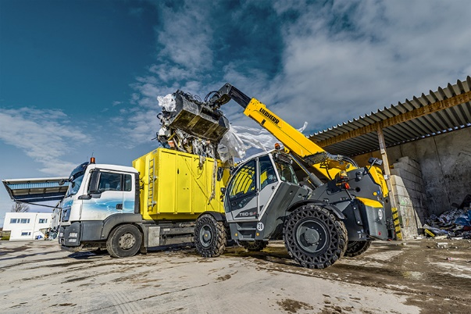

liebherr-T60-9s-recycling-e-96 dpi.jpg  
Liebherr will showcase the T 60-9s telescopic handler with environmentally friendly HVO drive and smart assistance functions at Ecomondo 2023.

**Contact**

Nadine Willburger  
Marketing  
Phone: +49 7354 / 80 - 7332  
Email: [nadine.willburger@liebherr.com](mailto:nadine.willburger@liebherr.com)

Martin Koller   
Marketing and Public Relations  
Phone: +43 50809 11475  
Email: [martin.koller.lbh@liebherr.com](mailto:martin.koller.lbh@liebherr.com)

Lisa Kahlig

Marketing and Public Relations

Phone: +43 69050 064496

Email: [lisa.kahlig@liebherr.com](mailto:lisa.kahlig@liebherr.com)

Published by

Liebherr-Hydraulikbagger GmbH  
Kirchdorf an der Iller / Germany  
www.liebherr.com