Press release

Liebherr and Yuchai Celebrate 10 Years of Partnership

⸺
Several Yuchai platforms for high-performance and large engines in the genset and marine sectors are already equipped with Liebherr injection solutions
Development is also progressing in hydrogen combustion technology
Both companies intend to continue their long-term business relationship
Liebherr's components product segment and Guangxi Yuchai Marine and Genset Power Co, Ltd. are celebrating a decade of successful partnership. This groundbreaking collaboration has yielded high-performance and large engines, along with innovative injection solutions. Together, they continue their partnership to provide innovative solutions in propulsion technology, meeting the demands of both the Chinese and international markets.
Nussbaumen (Switzerland) / Shanghai (China), 24.10.2023 – Liebherr-Components and Guangxi Yuchai Marine and Genset Power Co., Ltd. jointly look back on a highly successful ten years of strategic partnership. Yuchai is a leading manufacturer and distributor of engines for on- and off-road applications in China, while Liebherr has established itself as a provider of advanced injection solutions for high-performance engines. The collaboration extends across the high-performance off-highway and large engine sectors as well as alternative powertrain solutions with significant joint developments in the field of propulsion technology.
In August 2013, both companies initiated their first joint project, the development of the 6-cylinder in-line diesel engine, 6TD, used in Genset applications. In the following years, the partnership expanded to include additional engine platforms in the high-performance sector and the diesel large engine domain. Responding to the changing needs in drive technology regarding emission reduction, Yuchai and Liebherr continue their successful cooperation. In 2022, for example, the first firing of the Yuchai hydrogen engine, which is equipped with a Liebherr injection solution, was celebrated. This underscores their capacity for innovation and technological excellence in the development of eco-friendly propulsion solutions.
Guangxi Yuchai Marine and Genset Power Company is one of the leading players in the marine and power generation equipment sector in the Chinese market today. At the same time, Liebherr Group's Fuel Injection product line has established itself as one of the largest suppliers of fuel injection systems for Yuchai Marine and Genset over the past decade. This fruitful collaboration is intended to continue in the best interest of both companies, and corresponding declarations of intent are currently being jointly formulated. "Yuchai and Liebherr are two powerful companies that, over the past ten years, have jointly delivered powerful products to the market. Together, we have mastered all previous challenges and are also facing the new demands of drive technology with the same determination.", summarizes Richard Pirkl, Managing Director of fuel injection technology and development at Liebherr-Components Deggendorf GmbH.
"Over the past ten years of co-operation both teams have always had very good communication, both teams have worked together as a family to overcome many difficulties and problems, and have completed the matching and batch production of many projects very well. Yuchai has a very high degree of trust in Liebherr, and decided to equip the most important engine platforms with Liebherr's common rail system at the early stage of cooperation." concludes Ning Xingyong, General Manager of Guangxi Yuchai Marine and Genset Power Company and points out that "we are confident and looking forward to the future cooperation to deal with various challenges in the market."
At the end of the celebration, the two parties signed a new strategic co-operation framework agreement to launch the next ten years of partnership.
About the China Yuchai International Limited
China Yuchai International Limited, through its subsidiary, Guangxi Yuchai Machinery Company Limited ("GYMCL"), engages in the manufacture, assembly, and sale of a wide variety of light-, medium- and heavy-duty engines for trucks, buses, passenger vehicles, construction equipment, marine and agriculture applications in China. GYMCL also produces diesel power generators. The engines produced by GYMCL range from diesel to natural gas and hybrid engines. Through its regional sales offices and authorized customer service centers, GYMCL distributes its engines directly to auto OEMs and retailers and provides maintenance and retrofitting services throughout China. Founded in 1951, GYMCL has established a reputable brand name, strong research and development team and significant market share in China with high-quality products and reliable after-sales support. In 2021, GYMCL sold 456,791 engines and is recognized as a leading manufacturer and distributor of engines in China.
About the Liebherr Group
The Liebherr Group is a family-run technology company with a highly diversified product portfolio. The company is one of the largest construction equipment manufacturers in the world. It also provides high-quality and user-oriented products and services in a wide range of other areas. The Liebherr Group includes over 140 companies across all continents. In 2022, it employed more than 50,000 staff and achieved combined revenues of over 12.5 billion euros. Liebherr was founded in Kirchdorf an der Iller in Southern Germany in 1949. Since then, the employees have been pursuing the goal of achieving continuous technological innovation, and bringing industry-leading solutions to its customers.

Images
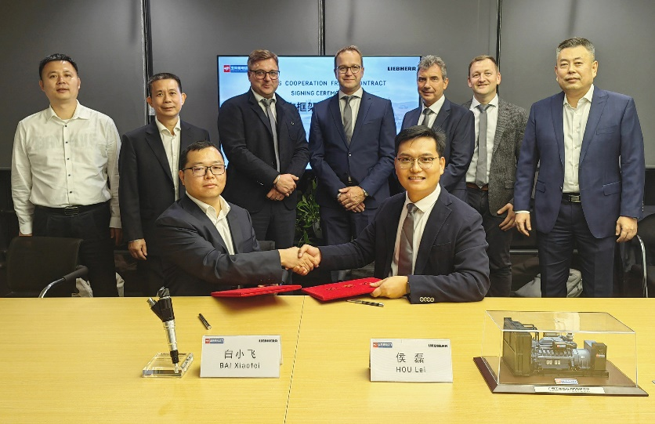
liebherr-10 years partnership event.jpg
After 10 successful years, Liebherr and Yuchai will continue their partnership in the future.

Contact
Alexandra Nolde
Senior Communication & Media Specialist
Phone: +41 562 / 9643 - 26
E-mail: alexandra.nolde@liebherr.com
Published by
Liebherr-Components AG
Nussbaumen / Switzerland
www.liebherr.com

