Press release

Liebherr supplies sustainable technology to SNCF

⸺

**Liebherr-Transportation Systems has been selected by SNCF to equip the Occitania Region’s fleet trains with new air cycle air-conditioning systems. Delivery will start in November 2023 and end in 2030. Liebherr will provide customer services throughout the whole life cycle of the units. The HVAC system technology uses only natural ambient air for cooling. No refrigerant is needed.**

Korneuburg (Austria), October 2023 – Liebherr-Transportation Systems GmbH & Co. KG and SNCF have signed a contract covering the delivery of up to 291 heating-, ventilation- and air-conditioning (HVAC) systems for the integration in SNCF’s Autorail à Grand Capacité (AGC) trains by Bombardier, which will be operated in the Occitania Region (France).

The air-conditioning system based on environmentally friendly air cycle technology uses only ambient air as a coolant instead of conventional chemical refrigerants. It had been tested very successfully by the Occitania Region and SNCF in France within the frame of SNCF’s “Eco-Clim” research program on an AGC TER train from 2015 to 2019.   
“Our air cycle air-conditioning technology is the next step on the way to tomorrow’s trains and we are proud to be able to contribute to eco-friendly travelling as well as to the comfort of the passengers onboard Occitania AGC trains”, said Dr. Klaus Schneider, Chief Technology Officer, Liebherr-Aerospace & Transportation SAS.

The units are manufactured at Liebherr-Transportation Systems Marica EOOD in Radinovo (Bulgaria), which is home to Liebherr’s series production of HVAC systems for railway vehicles operated worldwide.

**Major advantages proven in field-tests**

Already in 2002, Liebherr-Transportation Systems fitted an ICE 3 train from German operator Deutsche Bahn AG (DB) with air cycle air-conditioning systems for test runs. Additional fittings for the first model series and 13 eight-car trains of the second model series of the ICE 3 soon followed. In 2018, DB and Liebherr-Transportation Systems presented the very good results of a joint project comparing Liebherr's air cycle air-conditioning system with a traditional vapor cycle system operating with the refrigerant R134a.

The UBA, Germany’s Federal Environmental Agency based in Dessau-Rosslau, supported the project   
because of its environmental advantages compared with traditional vapor cycle systems with fluorinated refrigerants. The air cycle system uses only natural ambient air for cooling. No refrigerant is required.

Additionally, as the system only consist of a few components, it is not only of low weight, but also simple and inexpensive to service. It is characterized by very low operating costs and low energy consumption.

**About Liebherr-Transportation Systems**

Liebherr’s transportation systems division supplies cab and saloon heating, ventilation and air conditioning (HVAC) systems, thermal management systems for diverse mobile and stationary e-mobility applications, hydraulic actuation systems, dampers and hydraulic load levelling equipment for rail vehicles of all kinds. Liebherr has many years of experience in the development, manufacture, and field service of these technologies, offering support throughout the entire product lifecycle. The company invests continuously in its R&D activities in order to offer its customers new generations of diverse transportation systems solutions.

Liebherr-Transportation Systems has three production plants in Korneuburg (Austria), Marica (Bulgaria) and Pinghu (China). In addition to its own sales and service centers, the division has access to the Liebherr Group’s extensive and unique technologies as well as development and service facilities around the world. This global set-up means that Liebherr-Transportation Systems is there for its customers wherever they may be.

About the Liebherr Group

The Liebherr Group is a family-run technology company with a highly diversified product portfolio. The company is one of the largest construction equipment manufacturers in the world. It also provides high-quality and user-oriented products and services in a wide range of other areas. The Liebherr Group includes over 140 companies across all continents. In 2022, it employed more than 51,000 staff and achieved combined revenues of over 12.5 billion euros. Liebherr was founded in Kirchdorf an der Iller in Southern Germany in 1949. Since then, the employees have been pursuing the goal of achieving continuous technological innovation and bringing industry-leading solutions to its customers.

Image

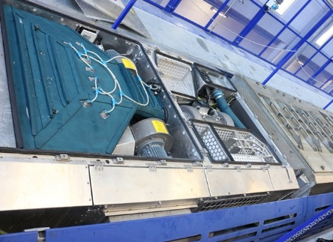liebherr-air-cycle-air-conditioning-system-on-board.jpgAir cycle air conditioning system by Liebherr – © Liebherr

Contact person

Ute Braam  
Corporate Communications  
Phone: +49 8381 / 46 - 4403  
E-mail: ute.braam@liebherr.com

**Published by**

Liebherr-Aerospace & Transportation SAS   
Toulouse / France  
www.liebherr.com