Press release

On-Site Concrete acquires the first THP 80 LP in the USA

⸺

Liebherr’s THP 80-LP city pump makes its U.S. debut with On-Site Concrete.

This pump offers a compact, mobile, and high-quality concrete pumping option for commercial work, urban environments, and compact job sites.

On Site Concrete acquires the first THP 80 LP truck mounted concrete city pump in the US. This pump allows for greater mobility with the same excellent performance and quality of Liebherr’s entire concrete technology product range.

Newport News, VA (USA), Liebherr USA, Co. Concrete Technology, November 7, 2023 – Recently established in 2022, On-Site Concrete of Minot, North Dakota was the first US customer to take delivery of Liebherr’s [THP 80-LP city pump](https://www.liebherr.com/en/usa/products/construction-machines/concrete-technology/concrete-pumps/city-pumps/details/649748.html). This innovative machine is Liebherr’s strategic response to the distinct demands of the U.S. market.

“Liebherr's newly unveiled city pump demonstrates our commitment to the U.S. market. Specifically designed to address inner-city pumping challenges and the demands of those using truck-mounted trailer pumps, this addition completes our concrete pump portfolio,” said Sean Gallagher, Liebherr Regional Sales Manager. “It’s more than just a product, it signifies Liebherr's dedication to understanding and fulfilling U.S. market needs, ensuring we remain a trusted partner for customers like On-Site Concrete.”

On Site Concrete specializes in high quality line pumping, trailer pumping, and ICF construction. They continually meet their customers unique needs and preferences with high quality workmanship as well as creating safe and strong structures. The THP 80-LP city pump is the largest addition to their fleet. This pump was designed for diverse project scales, from urban environments to expansive commercial ventures, making it a versatile machine for On-Site Concrete to utilize.

“The THP 80-LP perfectly caters to our customers’ demands whether it be concrete footings, walls or large commercial flatwork projects, this pump can handle it all. The accessible control panel, all-in-one features, and built-in emergency mode set this pump apart from any other model on the market,” said Kevin Cross, Owner of On-Site Concrete. “Controlling the surge and flow of concrete is flawless. Whether using 300 feet of 2.5” hose or pumping directly out the back end, this pump excels in all scenarios. And the pressure washer feature is a game-changer for end-of-day cleanups.”

Pumping concrete with precision

The [THP 80-LP city pump](https://www.liebherr.com/en/usa/products/construction-machines/concrete-technology/concrete-pumps/city-pumps/details/649748.html) is a compact and powerful pump designed specifically for the North American market. It is the smallest pump in the truck mounted concrete pump product line, but still maintains the same high performance, quality, and offers many of the same features as the larger truck mounted concrete pumps. It is the perfect solution for jobs in urban environments, residential jobs and compact job sites where space is limited.

The pump offers greater flexibility and mobility for operators to move around the job site. The unit was designed for quick and easy set up and is equipped with the HBC remote control for operator convenience. The THP 80-LP city pump also incorporates Liebherr's proven open-loop hydraulic circuit, showcasing the machine’s reliability, power, and ease of maintenance. Additionally, the pump features ample storage with wide spaces for the concrete tubes and accessories on the deck and plastic water tanks for saving weight.

The THP 80-LP City Pump is mounted on the International MV607 with the Allison Automatic transmission weighing in under 23,000 lbs. This is convenient for customers because it does not require a CDL to operate, which means there is more flexibility and allows more of their staff to operate the equipment.

Gallagher noted, “This isn't just a product launch; it's a testament to Liebherr's dedication to the U.S. market. The THP 80-LP leverages shared technology and design elements from our wider product range, ensuring consistency and quality.”

Liebherr USA’s Concrete Technology product segment is committed to serving customers across the country by providing a diverse range products and technologies including concrete pumps, mixing plants and mixing systems, as well as a highly trained customer service team to support each customer’s needs.

**About Liebherr USA, Co.**

[Liebherr USA, Co.](https://www.liebherr.com/en/usa/start/start-page.html) based in Newport News, VA provides sales and service on behalf of nine different Liebherr product segments: earthmoving, mining, mobile and crawler cranes, tower cranes, concrete technology, deep foundation machines, maritime cranes; components, and refrigeration and freezing.

About the Liebherr Group

The [Liebherr Group](https://www.liebherr.com/en/usa/about-liebherr/about-liebherr.html) is a family-run technology company with a highly diversified product portfolio. The company is one of the largest construction equipment manufacturers in the world. It also provides high-quality and user-oriented products and services in a wide range of other areas. The Liebherr Group includes over 140 companies across all continents. In 2022, it employed more than 50,000 staff and achieved combined revenues of over 12.5 billion euros. Liebherr was founded in Kirchdorf an der Iller in Southern Germany in 1949. Since then, the employees have been pursuing the goal of achieving continuous technological innovation and bringing industry-leading solutions to its customers.

Images

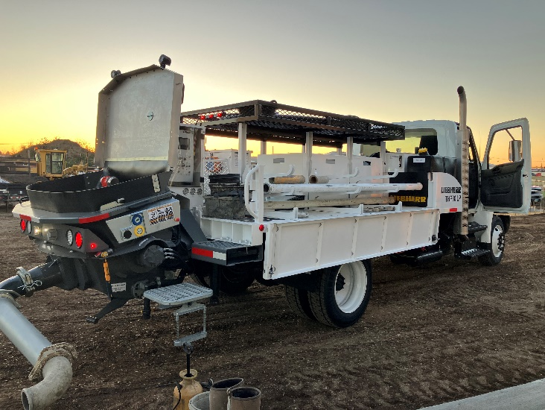

Liebherr THP80-LP_City-OnSite_Startup_Oct23-1.jpg  
Designed specifically for the North American market, the THP 80 is the smallest pump in the truck mounted concrete pump product line, but still maintains the same high performance and quality as the larger truck mounted concrete pumps.

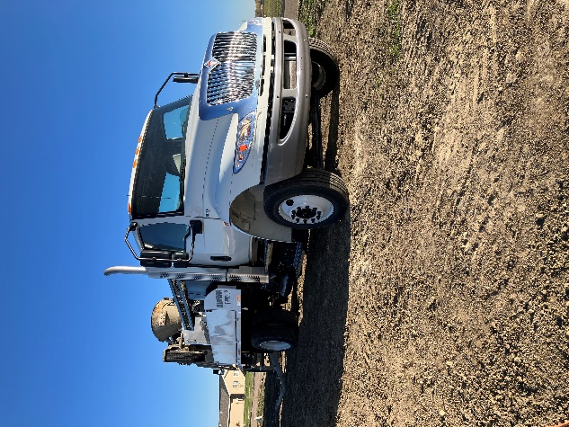

Liebherr THP80-LP_City-OnSite_Startup_Oct23-2.jpg  
The THP 80 This is convenient for customers because it does not require a CDL to operate, which means there is more flexibility and allows more of their staff to operate the equipment.

Contact

Ana Cabiedes Uranga  
Head of Marketing   
Liebherr USA, Co. Phone: +1 757 240 4250  
E-mail: ana.cabiedes@liebherr.com

Published by

Liebherr USA, Co.   
Newport News / USA  
www.liebherr.com