Press release

Liebherr USA, Co. holds 2023 earthmoving and material handling sales and training seminar

⸺
Liebherr’s product team hosted over 70 participants during the three-day event.
On-site classroom sessions, hands-on demonstrations and tours of the Liebherr USA, Co. headquarters and Liebherr Mining Equipment facility were offered.
Participants operated multiple earthmoving and material handling machines at a local quarry.
Liebherr’s earthmoving and material handling technology team hosted an on-site 2023 sales and training seminar at the USA headquarters. Approximately 70 attendees participated in the three day event taking place in South Eastern Virginia.
Newport News, VA (USA), Liebherr USA, Co., Earthmoving and Material Handling, October 6, 2023 –Liebherr USA, Co. Earthmoving and Material Handling Technology held an on-site sales and training seminar for both internal and external distribution network participants to receive extensive product knowledge and hands-on machine time featuring the bulk of the product segment’s offerings.
The event consisted of five classroom sessions for participants to learn extensive product information from Liebherr experts, followed by tours of the Liebherr USA, Co. headquarters and the neighboring Liebherr Mining Equipment facility. The Liebherr team and all participants were then transported to a local Liebherr quarry to allow for seat time on a wide range of Liebherr’s earthmoving and material handling technology products.
“In a more and more digitalized world, in-person trainings continuously serve as the dynamic heartbeat of distribution networks, forging of connections, and conveying essential information about Liebherr earthmoving and material handling equipment,” notes Kai Friedrich, Divisional Director of earthmoving and material handling technology. “The value lies not only in the dissemination of knowledge, but also in the intangible magic of human interaction, sparking innovation and simply having a good time together.”
In the classroom
The first half of this event provided all participants with five in-depth classroom sessions held by the Liebherr product management team based in the USA and Europe. Each session focused on a different earthmoving and material handling machine including crawler excavators, wheel loaders, dozers, material handlers, and the TA 230 articulated dump truck. Each session was run by two product managers who specialized in the featured machine providing in-depth knowledge to equip the distribution network participants with essential information about the equipment, thus enhancing their own sales forces.
Hands on
At the quarry, the whole product range was featured during the hands-on sessions including crawler excavators, wheel loaders, dozers, material handlers, and the TA 230 articulated dump truck. These hands-on sessions allowed participants to utilize what they learned in the classroom and put their new field knowledge into practice with Liebherr certified product managers on-site to support. This training also serves as a great opportunity for Liebherr’s distribution network to get seat time in a wide variety of Liebherr machines.
This was the first in-depth training on the TA-230 where participants were able to get under the hood and behind the wheel with our product experts on-site to explain the latest Liebherr technology. The Liebherr Earthmoving and Material Handling Technology team look forward to expanding this product line within the next decade.
Network. Operate. Execute
“This Sales and Product Seminar plays a vital role in empowering our dealer sales force with the essential tools and knowledge required for successfully selling Liebherr equipment. The event serves as a catalyst for the Product Management Team to consistently furnish informative resources, comprehensive support, and continuous training to the dealer sales channels,” said Nick Rogers, General Manager, Product Management and Sales Support. “We firmly believe that by developing a deeper comprehension of our product lines and their distinctive features, sales representatives will be better positioned to engage customers with confidence, presenting solutions that ensure optimal results.”
Throughout the event, each attendee was able to participate in industry networking opportunities with Liebherr staff as well as the rest of the distribution network. The team also held an on-site barbeque at the quarry with games and entertainment for participants to enjoy.
“Beyond the scope of training, the sales seminar fosters connections among dealerships nationwide, affording representatives the opportunity to network, exchange ideas, and share effective solutions that have been employed to overcome challenges encountered in their daily operations,” noted Rogers.
About Liebherr USA, Co.
Liebherr USA, Co. based in Newport News, VA provides sales and service on behalf of nine different Liebherr product segments: earthmoving, mining, mobile and crawler cranes, tower cranes, concrete technology, deep foundation machines, maritime cranes; components, and refrigeration and freezing.
About the Liebherr Group
The Liebherr Group is a family-run technology company with a highly diversified product portfolio. The company is one of the largest construction equipment manufacturers in the world. It also provides high-quality and user-oriented products and services in a wide range of other areas. The Liebherr Group includes over 140 companies across all continents. In 2022, it employed more than 50,000 staff and achieved combined revenues of over 12.5 billion euros. Liebherr was founded in Kirchdorf an der Iller in Southern Germany in 1949. Since then, the employees have been pursuing the goal of achieving continuous technological innovation and bringing industry-leading solutions to its customers.

Images
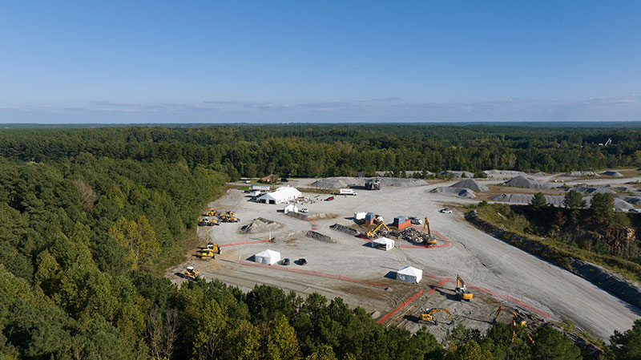
Liebherr_earthmoving-sales-seminar-2023-aerial-quarry.jpg
Each station was equipped with multiple Liebherr machines, a digital display set up, and tents for onlookers. Liebherr product managers as well as support staff manned each product station, served as operators, and assisted participants as they took turns in the operator’s cab.

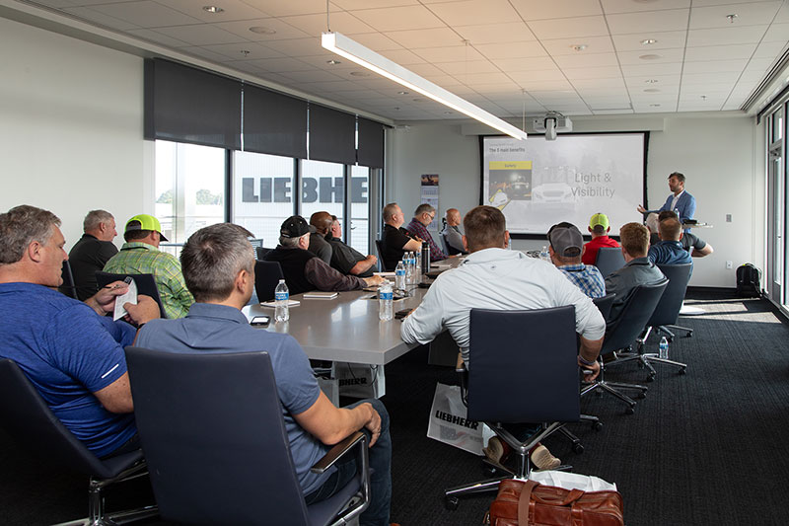
Liebherr_earthmoving-sales-seminar-2023-classroom-training.jpg
Participants received theoretical knowledge in the classroom for each machine presented.

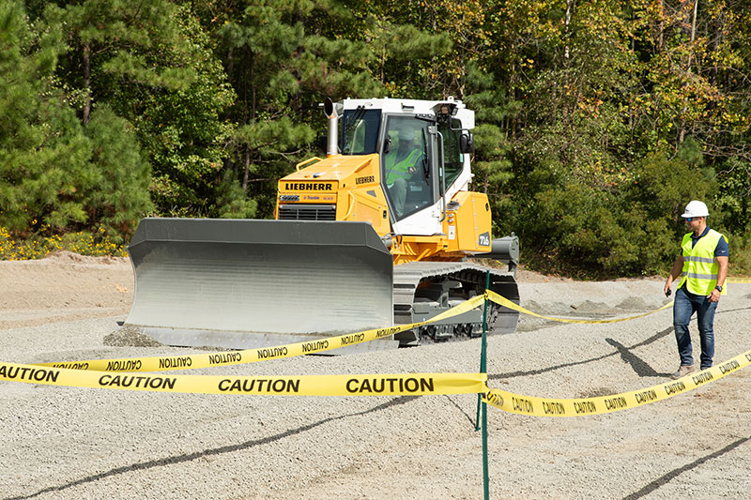
Liebherr_earthmoving-sales-seminar-2023-dozer-training.jpg
Each participant completed a full walk around, participated in hands-on training, and received individual seat time in the Liebherr dozers.

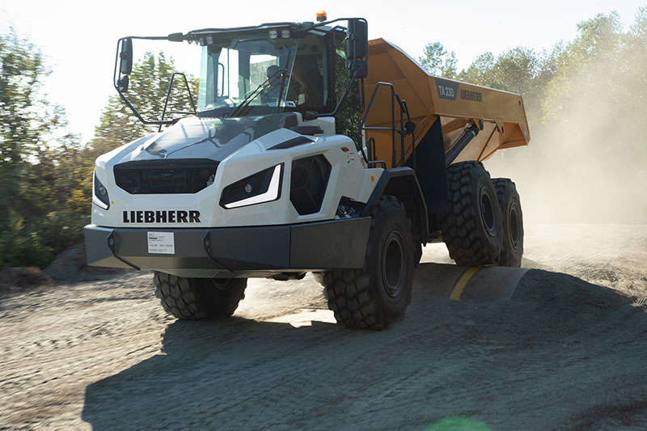
Liebherr_earthmoving-sales-seminar-2023-ta230-training.jpg
Each participant completed a full walk around, participated in hands-on training, and received individual seat time in the Liebherr TA 230 articulated trucks.

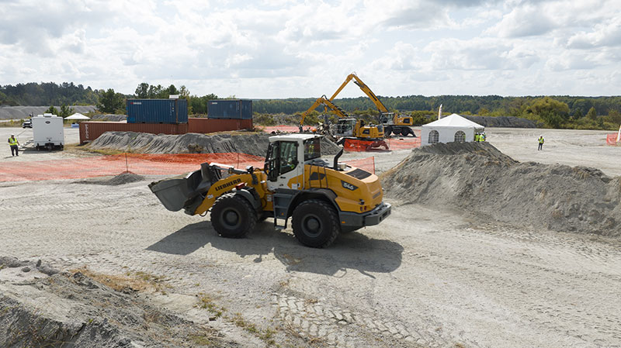
Liebherr_earthmoving-sales-seminar-2023-wheel-loader-training.jpg
Each participant completed a full walk around, participated in hands-on training, and received individual seat time in the Liebherr wheel loaders.

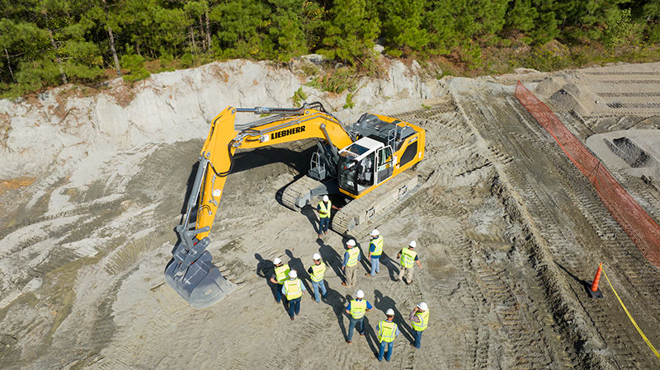
liebherr-earthmoving-sales-seminar-2023-crawler-excavator-training.jpg
Each participant completed a full walk around, participated in hands-on training, and received individual seat time in the Liebherr crawler excavators.

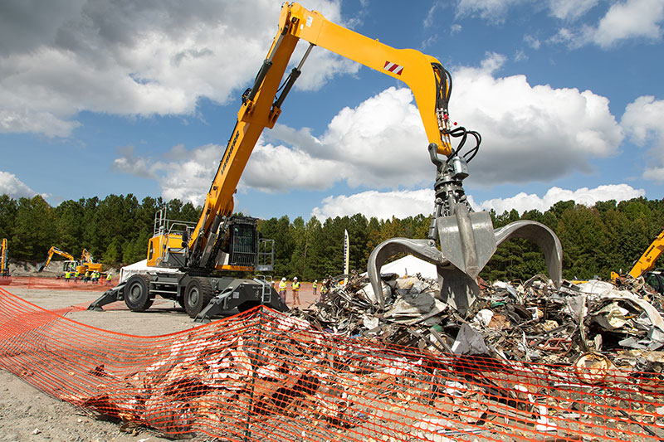
liebherr-earthmoving-sales-seminar-2023-material-handler-training.jpg
Each participant completed a full walk around, participated in hands-on training, and received individual seat time in the Liebherr material handlers.
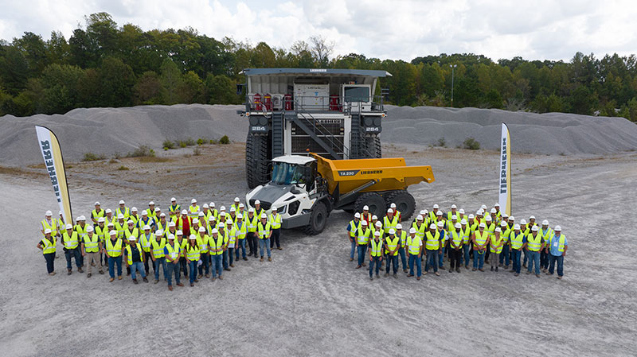
liebherr-earthmoving-sales-seminar-2023-group-photo.jpg
Over 70 participants joined Liebherr USA, Co. Earthmoving and Material Handling team at a local quarry to receive hands-on training.

Contact
Ana Cabiedes Uranga
Head of Marketing
Liebherr USA, Co. Phone: +1 757 240 4250
E-mail: ana.cabiedes@liebherr.com
Published by
Liebherr USA, Co.
Newport News / USA
www.liebherr.com

