Press release

ISO Limited and Liebherr advance New Zealand timber

⸺

Four mobile harbour cranes of type LHM 550 were supplied with specialised motorised timber grabs and have been operating in Tauranga, New Zealand since 2020

In 2021, ISO introduced two more MHCs, three of which are based in Gisborne and three that remain in Tauranga

The MHCs support one of New Zealand’s leading industries, and in combination with the grabs offer improved operating safety and increased turnover of up to 35%

ISO’s mission was to enhance safety, improve efficiency and productivity, and to radically improve the supply chain for its customers

Liebherr and ISO Limited have been building on a long partnership to drive innovation in New Zealand’s forestry industry. The outreach began in 2018, and after careful planning and due diligence, the delivery of MHCs and SMAG grabs have been operating since 2020. The delivery is considered a “lighthouse project” that other locations are analysing to expand and improve their own operations. The LHM 550 has a 51-metre lifting height and an outreach of 54 metres. The electric-hydraulic grapples feature a world-first in terms of size and capacity at 35 tonnes and 9.0 m², respectively.

Rostock (Germany), May 2023 – Innovation never rests. To support the sizeable lumber industry in New Zealand, Liebherr Maritime Cranes has worked with ISO Limited, a Qube company, and SMAG to develop a state-of-the-art timber handling solution for the ports of Tauranga and Gisborne. This project marks a significant milestone for the forestry industry in New Zealand and demonstrates Liebherr’s commitment to delivering innovative solutions that drive efficiency and safety in maritime operations. The project began in mid-2018. Following customer meetings in Tauranga and Gisborne, Liebherr had a clearer picture of the project’s requirements.

In September 2019, a customer meeting was held at the Liebherr Rostock manufacturing plant, with the first test of the SMAG electric-hydraulic grapples, and a contract was signed for four LHM 550 and six SMAG timber grabs. A crane simulator to assist with training of crane operators was also part of the purchase for Tauranga. In January 2020, a successful second grab test was completed with a new bucket design, and production of the six grabs was released. By Q1 2020, the crane simulator had been delivered and installed at the customer’s site. In mid-July 2020, the four fully assembled LHM 550 mobile harbour cranes and six timber grabs were loaded onto the ship “Rolldock Sun” and arrived in Tauranga in early September 2020. In addition, a further contract was signed for two more LHM 550 and three more SMAG timber grabs. They arrived at Eastland Port - Gisborne November 2021. All units have been handed over to the customer and are in operation. Turnover has been increased by as much as 35%.

**A “lighthouse project” for one of New Zealand’s leading industries**

“The new MHCs have significantly changed the way logs are loaded in New Zealand and most importantly are a significant step-change to our current practices, improving both safety and productivity,” states Paul Cameron, Director and CEO at ISO Limited.

Not only has this project opened up great potential for further shipments with ISO, but other companies have also expressed interest. The concept of more efficient and safer ways of handling timber is proving to be an attractive option for many. Forestry is a significant industry in New Zealand, contributing to an annual export revenue of around $6.8 billion, 1.6% of New Zealand’s GDP, and to the employment of around 35,000 people in production, processing, and commercialisation. Innovations in this field are therefore of great relevance to many people, and Liebherr and its partners will continue to collaborate closely on forward-looking options to support safe and efficient ways of operating in the timber industry.

About Liebherr-MCCtec Rostock GmbH

Liebherr-MCCtec Rostock GmbH is one of the leading European manufacturers of maritime handling solutions. The product range includes ship, mobile harbour and offshore cranes. Reach stackers and components for container cranes are also included in the product portfolio.

About the Liebherr Group

The Liebherr Group is a family-run technology company with a highly diversified product portfolio. The company is one of the largest construction equipment manufacturers in the world. It also provides high-quality and user-oriented products and services in a wide range of other areas. The Liebherr Group includes over 140 companies across all continents. In 2022, it employed more than 50,000 staff and achieved combined revenues of over 12.5 billion euros. Liebherr was founded in Kirchdorf an der Iller in Southern Germany in 1949. Since then, the employees have been pursuing the goal of achieving continuous technological innovation, and bringing industry-leading solutions to its customers.

Images

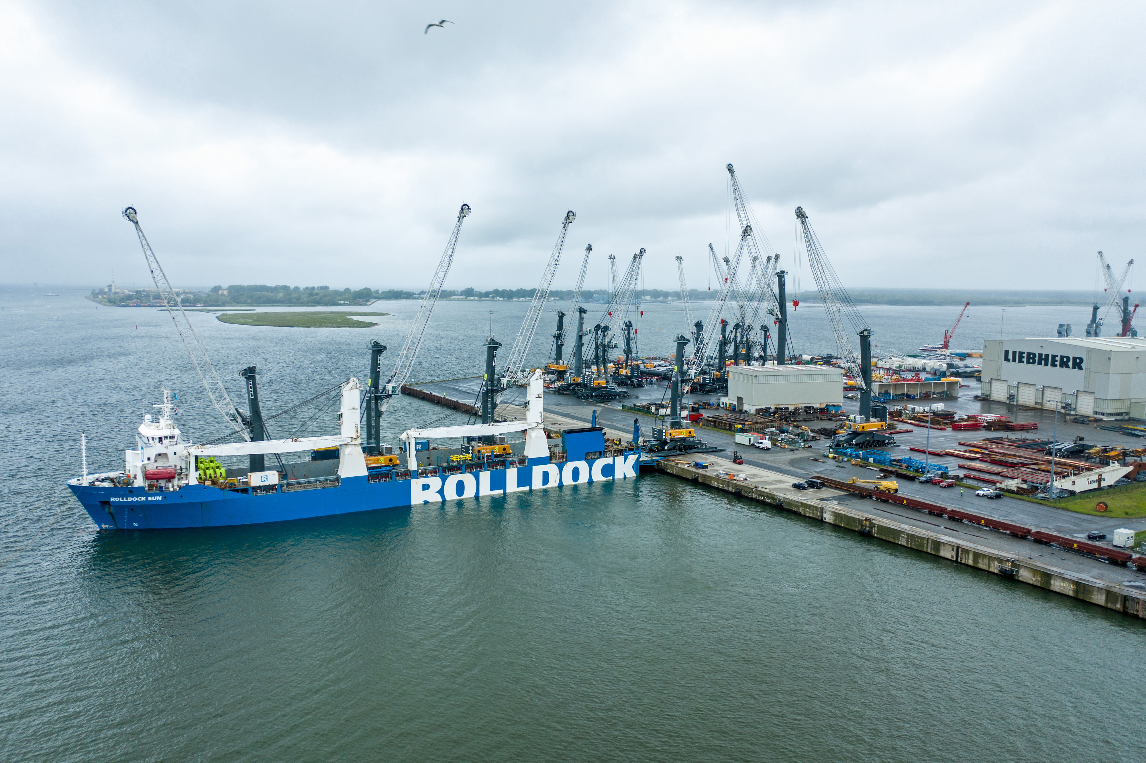

liebherr-lhm550-iso-limited-1.jpg  
Six timber grabs and four fully assembled LHM 550 mobile harbour cranes were loaded onto the ship “Rolldock Sun” in mid-July 2020, and the vessel docked in Tauranga in early September.

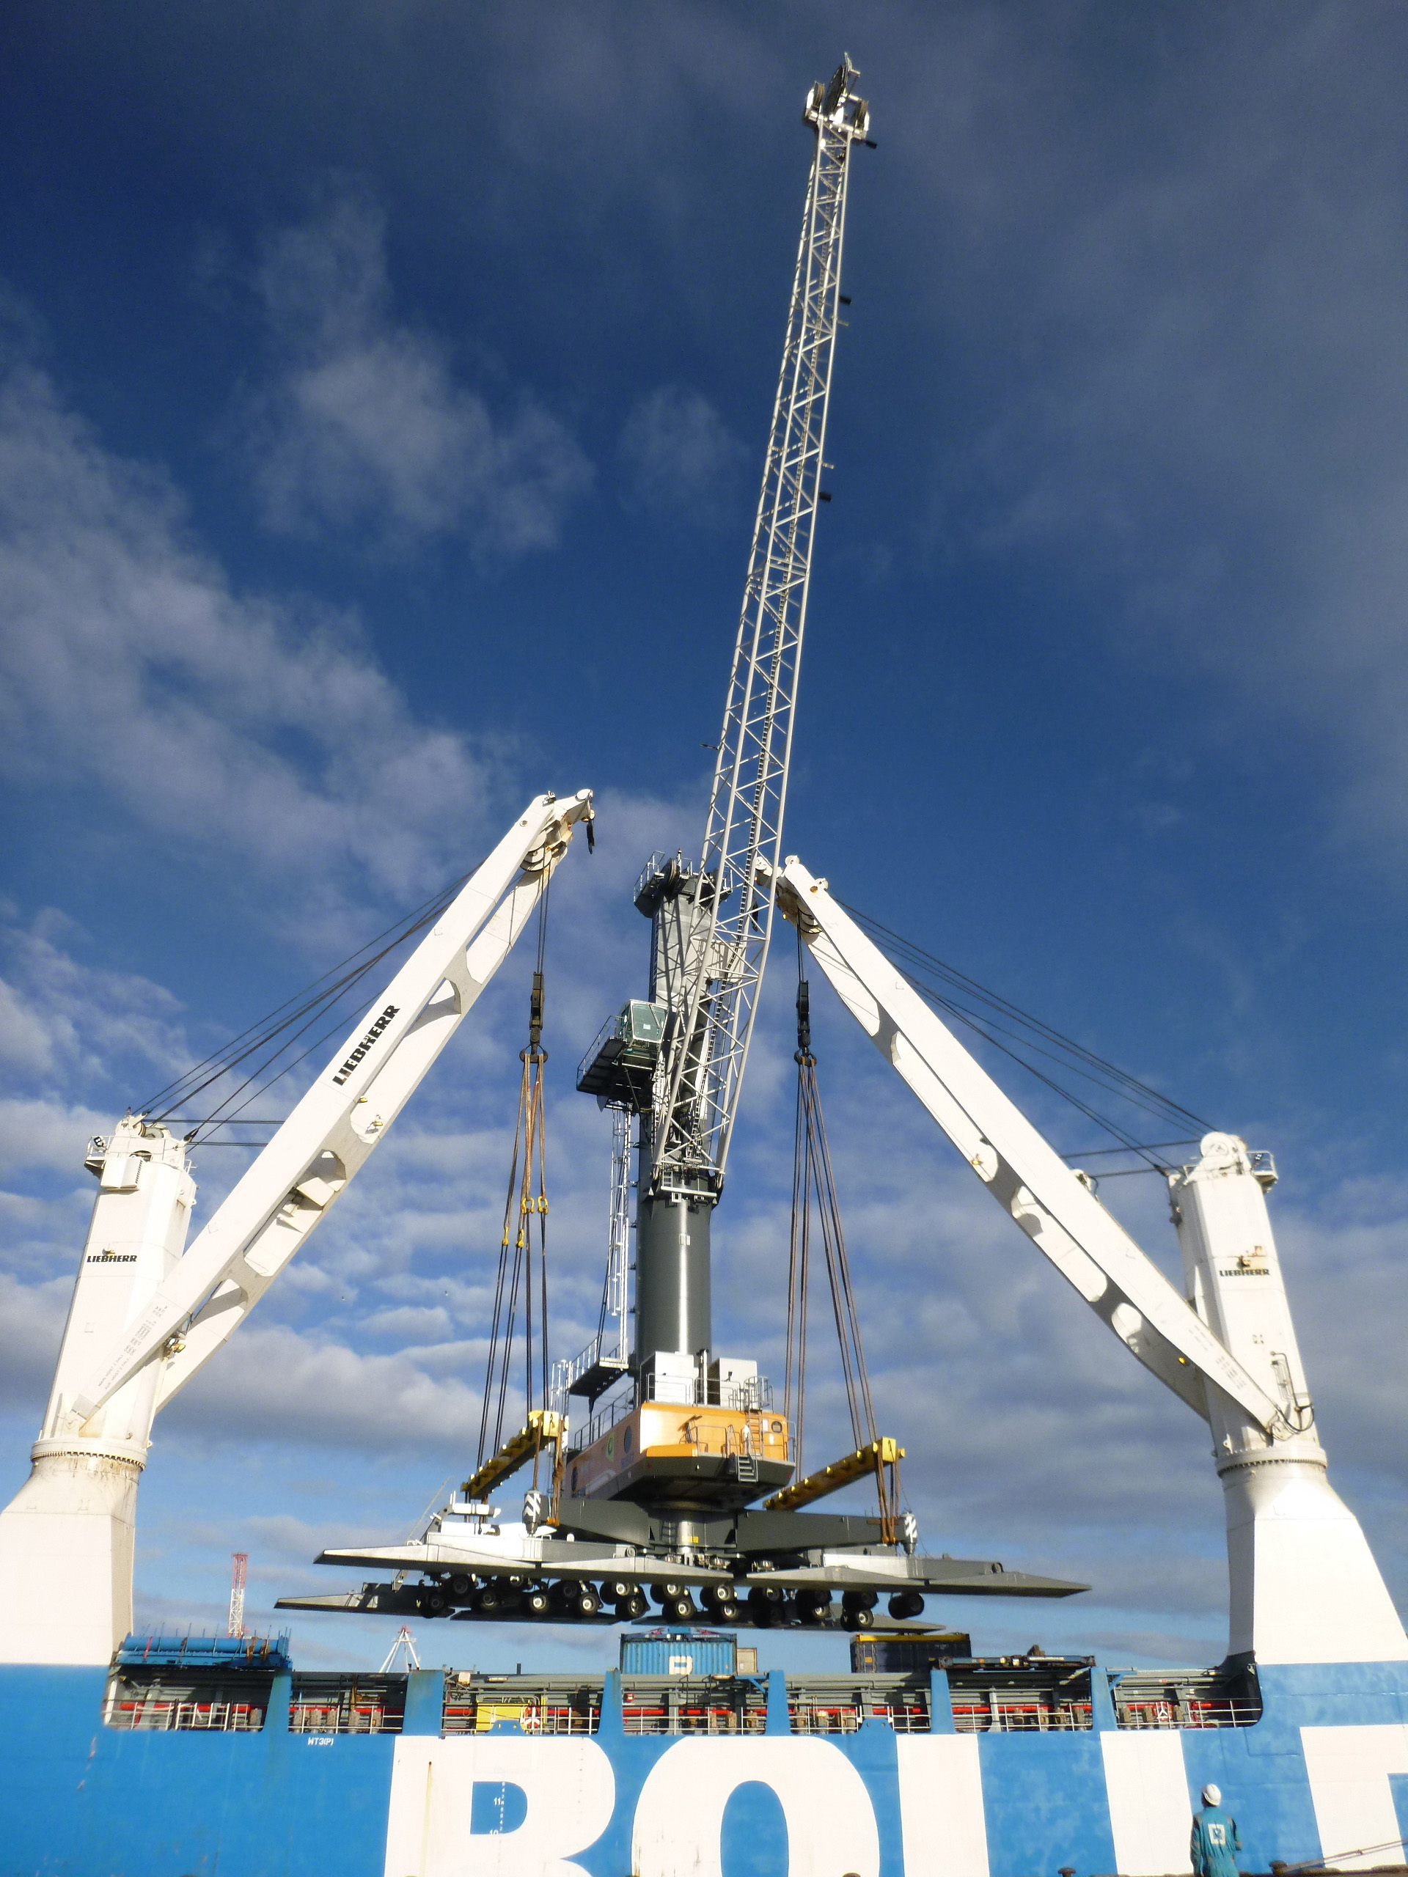

liebherr-lhm550-iso-limited-2.jpg  
A Liebherr ship crane tandem lift was used to unload the LHM 550 cranes at their destination in Tauranga. The ship cranes of type CBB 4200-350 can lift 350 tonnes individually, and 700 tonnes via tandem lift.

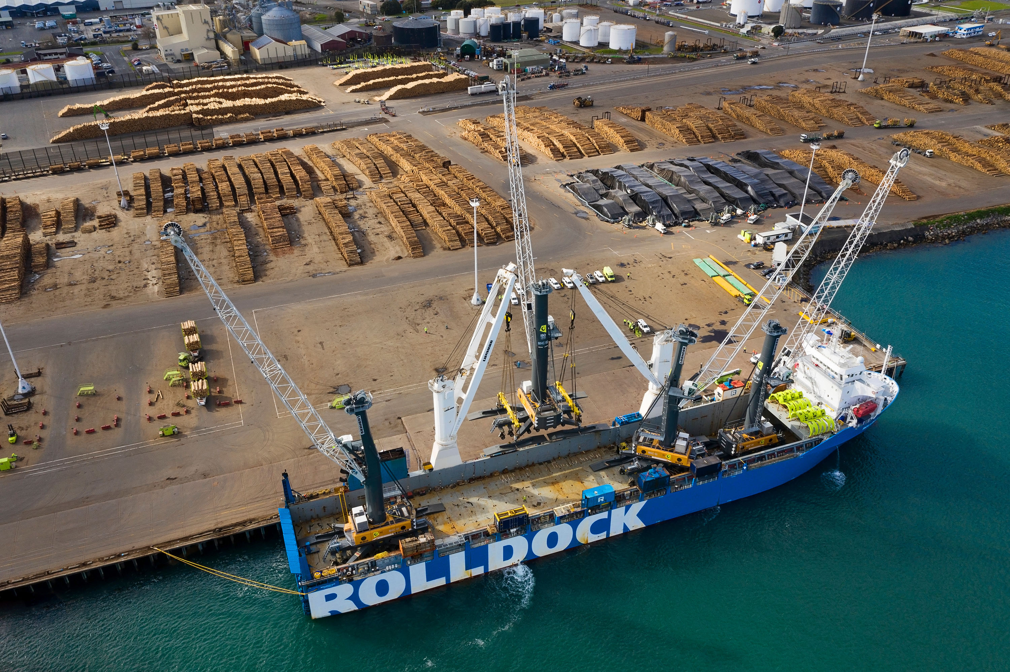

liebherr-lhm550-iso-limited-3.jpg  
A significant industry in New Zealand, forestry generates $6.8 billion in export revenue annually, or 1.6% of the country’s GDP, and employs about 35,000 people in production, processing, and commercialization.

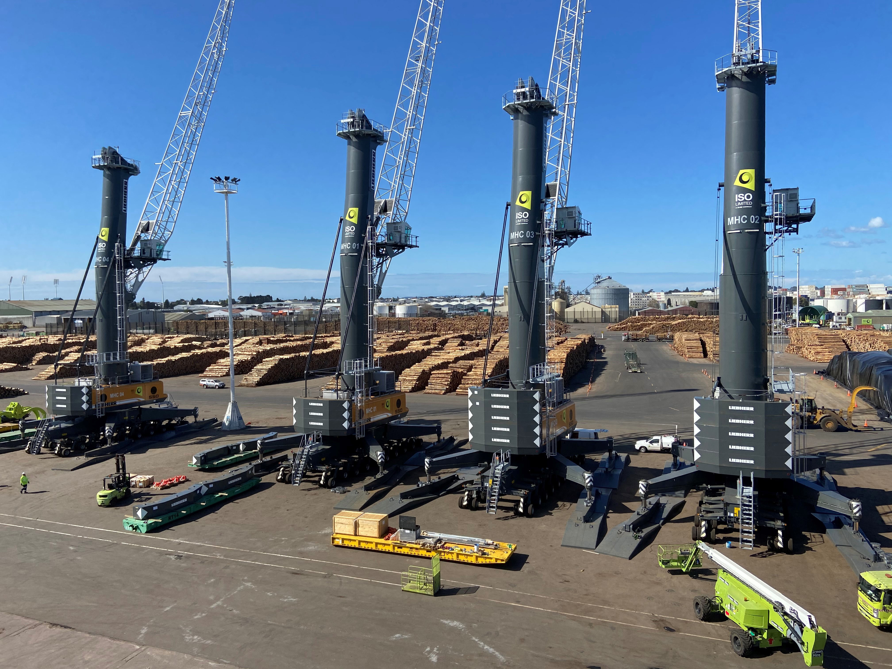

liebherr-lhm550-iso-limited-4.jpg  
Safety has been greatly improved with the new cranes and SMAG grabs, and turnover has increased by as much as 35%.

Contact

Mathias Haugner

Marketing Manager – Maritime Cranes

Phone: +49 38160 / 0650 - 36

E-Mail: mathias.haugner@liebherr.com

Published by

Liebherr-MCCtec Rostock GmbH

Rostock / Germany

www.liebherr.com