Press release

Excellent brand presence: Liebherr Brand Design wins iF Design Award 2023

⸺

**Liebherr has received the renowned iF Design Award 2023 for its new brand design. The award is the second design prize for the renewed brand presence. In October 2022, it already won the Red Dot Design Award.**

Bulle (Switzerland), 17.05.2023 – Winning the iF Award 2023 confirms the radiance of Liebherr’s new brand presence for the second time. Last year, it already received the Red Dot Award for it. The revised design offers a high recognition value, a distinctive brand experience and at the same time can be adapted more flexibly to different media and formats. “The fact that all staff could hardly wait to work with the new design system was the greatest praise of all for us,” says Holger Spreda, Head of Corporate Design, Media & Print at Liebherr-International Deutschland GmbH.

**Guiding star and source of inspiration**

A good design makes a brand unmistakable. It provides orientation, inspires and ensures that target groups quickly recognise the brand across all touchpoints and remember it in the long term. With 13 product segments, 140 companies worldwide, around 200 exhibition appearances per year and almost innumerable means of communication, these qualities are particularly important for Liebherr. The new concise branding of the umbrella brand connects the numerous individual elements and, as a guiding star, ensures that customers, partners and all other interest groups can quickly and easily find their way around the Liebherr universe.

**Strong brand, subtly modernised**

New media, formats and viewing habits required more flexible design options. In 2017, the creative experts of the Group got to work together with the MetaDesign agency and other service providers. Four years later, the new brand presence was given the green light. Since then, the subtly revised design has been a common thread running through the product segments and media of the Group – from construction machinery, refrigeration units, brochures and advertisements, to online portals, company videos and social media channels, the brand certainly has a fresh look.

**More flexible to use**

The design guidelines underlying the new look have been relaxed compared to the previous version. They now allow more flexible design options. Digital formats in particular can be better integrated. “Since the flexible design system was thought of digitally from the very beginning, we have created an important basis for the digital platforms of the Group,” says Alexandra Federle, Head of Digital Design at Liebherr-International Deutschland GmbH. At the same time, the high recognition value of the traditional brand is preserved.

The iF Design Award is considered one of the most prestigious design prizes in the world. The jury, made up of international design experts, awards the prize once a year.

About the Liebherr Group

The Liebherr Group is a family-run technology company with a highly diversified product portfolio. The company is one of the largest construction equipment manufacturers in the world. It also provides high-quality and user-oriented products and services in a wide range of other areas. The Liebherr Group includes over 140 companies across all continents. In 2022, it employed more than 50,000 staff and achieved combined revenues of over 12.5 billion euros. Liebherr was founded in Kirchdorf an der Iller in Southern Germany in 1949. Since then, the employees have been pursuing the goal of achieving continuous technological innovation, and bringing industry-leading solutions to its customers.

Images

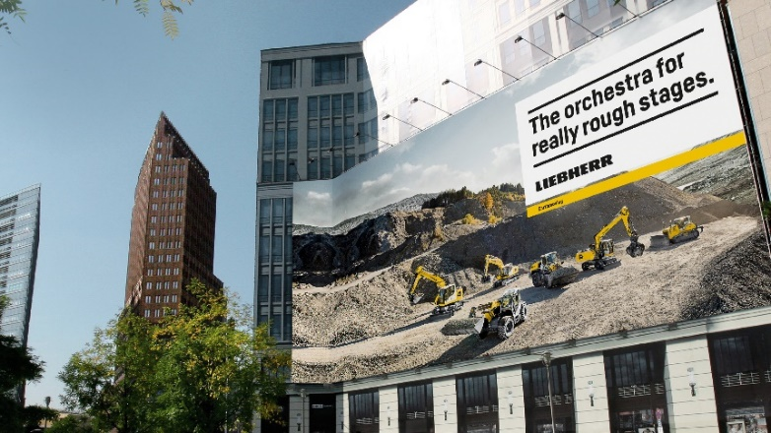

liebherr-brand-design-billboard.jpg

Liebherr’s brand design was awarded the iF Design Award 2023. It already received the Red Dot Design Award last year.

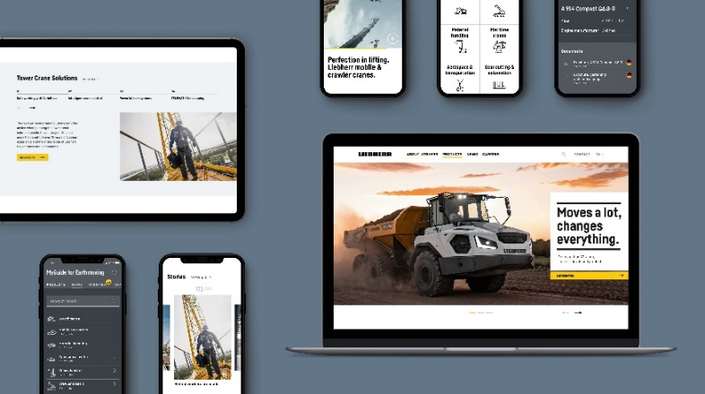

liebherr-brand-design-digital.jpg

Liebherr’s revised brand design also works in digital communication with its innumerable media and formats.

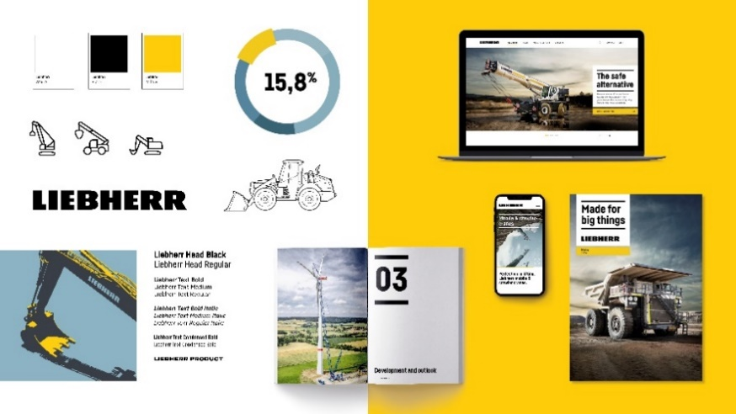

liebherr-brand-design-colours.jpg

Liebherr has optimised its logo, revised the colour concept and developed its own font. The icons are also new.

Contact

Philipp Hirth  
Department Head Corporate Communications  
Phone: +41 56 296 40 70  
E-mail: philipp.hirth@liebherr.com

Published by

Liebherr-International AG  
Bulle / Switzerland  
www.liebherr.com