Press release

Distribution and services close to the customer: A new Liebherr branch in the Paris region

⸺

The new Liebherr branch in the west of Paris is the 10th site in France for Liebherr Distribution et Services France SAS

Specialized in sales, rental and maintenance, the new branch now serves the Paris region

In total, five product segments of the Group are represented in Taverny: earthmoving, material handling machines, aerospace and transportation, components, gear technology and automation systems

A further step forward in one of the Group's most important markets

A new Liebherr branch in the west of Paris is inaugurated in Taverny on 26 May 2023, in the presence of customers and partners, representatives of local politics and the Liebherr family, among others. The expanded structure in Taverny - in addition to the branch in Fontenay-Trésigny - will serve the sales, customer service and maintenance of earthmoving and material handling machines as well as other products from various product segments of the Group in the Paris area.

Paris / Taverny (France), 26 May 2023 – The new Liebherr branch in Taverny, in the west of Paris, has opened its doors. This expanded sales and service structure complements the offer of the Paris branch in Fontenay-Trésigny (77), on the other side of town, south-east of Paris.

**A new site in the Paris region to better satisfy French customer demand**

The new Taverny branch is the tenth site of Liebherr Distribution et Services France SAS. This company, which is based in Niederhergheim in Alsace, groups together the sales and service activities of all product segments of the Group in France. In the Paris region, where customer demand is particularly high, the Taverny branch is intended to bring the sales and service of the product segments earthmoving and materials handling machines, aerospace and transportation, components as well as gear technology and automation systems closer together and to optimally meet the individual needs of the Ile-de-France region.

In concrete terms, this means sales and service as well as rental and maintenance of products such as mobile and crawler excavators, wheel loaders and dump trucks from the earthmoving and material handling machines segments, as well as for example HVAC systems from the field of transportation. On the opening day, the components segment presents a highlight: a hydrogen combustion engine developed and produced internally, the H966

"Around 30 people are currently working at the Taverny site and are once again demonstrating here in France the international presence of the Liebherr Group with its excellent sales and service. In addition, we handle different product segments, which once again underlines the diversity of the Group's product range, also here in France", explains Cédric Schaff, Director of the Paris branch.

The Liebherr Group in France - and in the Paris region

The Liebherr Group has been active in France for over 60 years. Since 1961, just about ten years after the group was founded, the French market has been one of the company's most important markets. The first Liebherr branch in Paris was opened in 1974 and then moved to Fontenay-Trésigny in 2007.

Last year, this branch in Fontenay-Trésigny and the three other Liebherr sales and service branches in France were integrated into the newly founded Liebherr Distribution et Services France SAS. This means that the sales and service activities for France, which until then had belonged to Liebherr-France SAS, the production site for crawler excavators in Colmar, have been completely bundled in a separate unit. With the new Paris branch, 2023 represents a further step towards individual local sales and service, bringing the business even closer to the customer.

The Liebherr Distribution et Services France SAS thus consists of four branches throughout France (Paris, Marseille, Bordeaux, Colmar) and five sub-branches with various locations as well as a warehouse area in St-Priest.

The Liebherr branch in Taverny in a few figures

9 million € of investment

11,000 m² total surface

900 m² office space

1,200 m² workshop area

About Liebherr Distribution et Services France SAS

With the foundation of Liebherr Distribution et Services France SAS, Liebherr has combined all existing distribution and service activities in France. From its headquarters in Niederhergheim (Grand-Est region), the new company will provide distribution and service across the country for the following product segments: mobile and crawler cranes, deep foundation machines, marine cranes, tower cranes and concrete technology. The product segments earthmoving and material handling machines are distributed in France by a mixed network of branches and dealers. Liebherr Distribution et Services France SAS distributes its products through its branches in Paris, Marseille, Colmar and the south-west.

**About the Liebherr Group**

The Liebherr Group is a family-run technology company with a highly diversified product portfolio. The company is one of the largest construction equipment manufacturers in the world. It also provides high-quality and user-oriented products and services in a wide range of other areas. The Liebherr Group includes over 140 companies across all continents. In 2022, it employed more than 50,000 staff and achieved combined revenues of over 12.5 billion euros. Liebherr was founded in Kirchdorf an der Iller in Southern Germany in 1949. Since then, the employees have been pursuing the goal of achieving continuous technological innovation, and bringing industry-leading solutions to its customers.

Images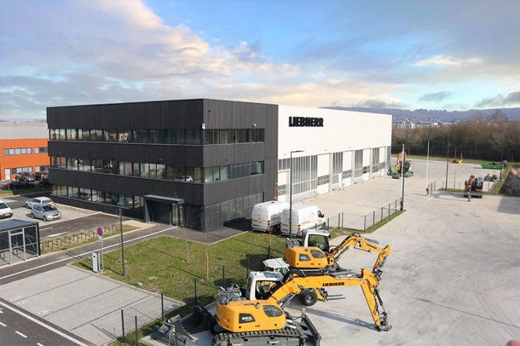

liebherr-antenne-de-taverny.jpg

The new Liebherr branch in Taverny.

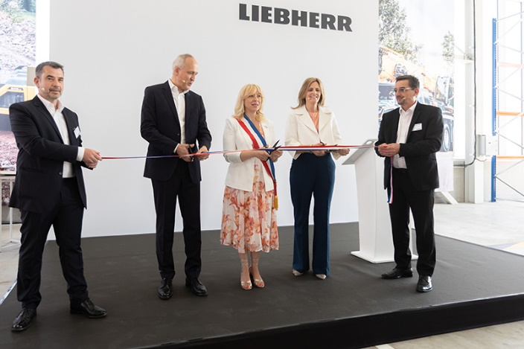

liebherr-inauguration-taverny.jpg

Cutting of the ribbon by two of the family shareholders, Jan Liebherr (left) and Patricia Rüf (right) as well as and Florence Portelli (centre), the mayor of Taverny, at the opening ceremony. The ribbon was held by Cedric Schaff (left), branch manager of Taverny, and Jean-Christophe Savoyet (right), managing director of Liebherr Distribution et Services France SAS.

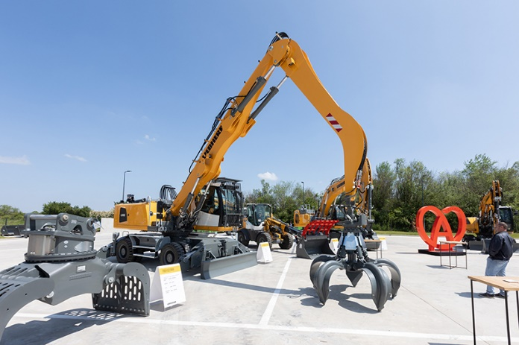

liebherr-machines-exposees-taverny.jpg

The machines exhibited on the inauguration of the Liebherr branch in the west of Paris.

Contact

Alban Villaumé  
Responsable Communication Marketing  
Téléphone : +33 3 89 21 36 09  
E-mail : alban.villaume@liebherr.com

Published by

Liebherr-France SAS  
Colmar / France  
www.liebherr.com