Press release

New Liebherr Ship-To-Shore (STS) container crane for PSA Penn Terminals

⸺

Liebherr has a strong track record of supplying STS cranes to the USA and remains committed to this important market

Liebherr's high-quality and secure cranes with local support and data backup systems meet the high standards required by PSA Penn Terminals

Liebherr Container Cranes Ltd. is pleased to announce the sale of one Ship-To-Shore (STS) container crane to PSA Penn Terminals in Philadelphia, USA. This crane is a repeat of a previous order for two STS cranes commissioned in 2018. The crane has an outreach of 48 m, a span of 18.288 m, a backreach of 15 m, and a safe working load (SWL) of 66 tonnes. The lift height over rail is 35 m. It is a high-performance crane ideally suited for the demands of modern container terminals.

Killarney (Ireland), May 2023 – The STS crane is being sold by Liebherr USA Co., a mixed sales and service company for Liebherr Maritime Cranes, which offers local support and proximity to Liebherr customers. Liebherr has a strong track record for the supply of STS cranes to the USA, with over 20 cranes in recent years, demonstrating its commitment to this important market. As a European manufacturer, Liebherr offers high-quality cranes, with multiple security layers and data backup systems that meet the needs of its customers.

Winston Ziegler, Liebherr’s Head of Sales – Maritime Cranes at Liebherr USA Co. said “Liebherr’s expertise in designing and manufacturing STS cranes is unmatched. With this in mind, we are proud to be a trusted supplier to PSA Penn Terminals. Our team in the US provides support through our local Liebherr USA service program, and we are confident that this new crane when it is delivered next year, will help PSA Penn Terminals to continue to meet the needs of its customers with security, efficiency, and reliability. Liebherr have been designing and manufacturing container cranes from our base in Ireland for over fifty years. We leverage the strength of our sister Liebherr companies to manufacture the drive control systems, electronics, and many of the mechanical components.”

Speaking about security of operations, Declan O’Sullivan, General Manager Sales with Liebherr Container Cranes Ltd added, “We understand that security is a top concern for PSA Penn Terminals, and we take this responsibility very seriously. Our engineers work tirelessly to ensure that our cranes are productive, safe, reliable, and secure and we are confident that this new crane will meet the high standards required.”

PSA Penn Terminals is one of the best-equipped, privately owned multipurpose marine terminals on the US East Coast.

"Having built a reputation as a reliable supplier of container cranes, Liebherr has proven their performance and reliability through the STS cranes we have previously procured from them. As such, we are confident that this new crane will be adequate in meeting our requirements and will help us continue providing exceptional service to our clients." said John Brennan, President, and CEO of PSA Penn Terminals. Mr Brennan continued, "We are pleased to collaborate once more with Liebherr Container Cranes and to have procured another one of their STS cranes for our terminal. This repeat order stands as proof of their product's quality and the robustness of our partnership.

Liebherr Container Cranes Ltd, Liebherr US Co. and Liebherr Maritime Cranes are part of the family owned Liebherr group of companies.

About Liebherr Container Cranes

Liebherr Container Cranes Ltd. Is one of the world’s leading manufacturers of ship to shore container cranes, rail mounted gantry cranes and rubber tyre gantry cranes. From a base in Killarney, Ireland, Liebherr Container Cranes Ltd designs, builds and exports container cranes worldwide. Founded in 1958 as the first Liebherr factory outside of Germany, today, container cranes manufactured by Liebherr in Ireland are renowned for their quality, longevity, and productivity.

About Liebherr USA Co.

Liebherr USA, Co. based in Newport News, VA provides sales and service on behalf of nine different Liebherr product segments: earthmoving, mining, mobile and crawler cranes, tower cranes, concrete technology, deep foundation machines, maritime cranes; components, and refrigeration and freezing.

About the Liebherr Group

The Liebherr Group is a family-run technology company with a highly diversified product portfolio. The company is one of the largest construction equipment manufacturers in the world. It also provides high-quality and user-oriented products and services in a wide range of other areas. The Liebherr Group includes over 140 companies across all continents. In 2022, it employed over 51,000 staff and achieved combined revenues of over 12.6 billion euros. Liebherr was founded in Kirchdorf an der Iller in Southern Germany in 1949. Since then, the employees have been pursuing the goal of achieving continuous technological innovation, and bringing industry-leading solutions to its customers.

Images

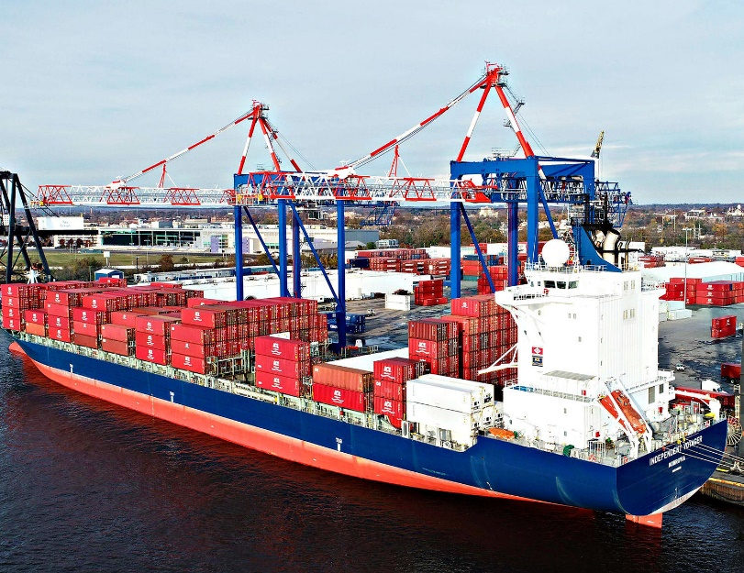

Liebherr_psa_penn.jpg  
Two Liebherr STS at PSA Penn Terminals

Contact

Trevor O’Donoghue  
Marketing Manager  
Telefon: +353 64 66 80459  
E-Mail: [trevor.odonoghue@liebherr.com](mailto:trevor.odonoghue@liebherr.com)

Published by

Liebherr Container Cranes Ltd.   
Killarney / Ireland  
www.liebherr.com

Liebherr USA Co.   
Newport News / USA  
www.liebherr.com