Press release

Liebherr at Intermat 2024: Alternative drives and intelligent assistance systems

⸺

The portfolio of international customer applications for telescopic handlers and crawler dozers is diverse. In line with its open-technology approach, Liebherr will be presenting at Intermat Liebherr a range of alternative engines for telescopic forklift trucks, including a battery-electric machine in the 7-metre class. Liebherr telescopic handlers excel with application- and market-optimized drive concepts: Hydrogenated vegetable oil (HVO) as a low-emission counterpart or additive to fossil fuels, battery-electric drives and a hybrid drive consisting of a combustion engine and electric motor.

Existing hydrostatic drive, new environmentally friendly fuel - made from hydrogenated vegetable oil (HVO)

HVO is a synthetic, but sustainable fuel that is growing in importance at Liebherr. It is the first fuel available commercially that can be used with conventional combustion engines in an almost climate neutral manner. Its production is climate-neutral if electricity from renewable energy sources is used exclusively during production. In addition, it produces lower emissions in actual use than a machine running on fossil diesel fuel.

Due to the excellent compatibility with all engine components and the miscibility with fossil diesel, the barrier to entry or conversion is low for customers. It even is possible to switch back to fossil diesel during operation, for example, in the event of procurement bottlenecks. Basic processes at the end customer do not have to change either: The drive concept remains in place without loss of performance, there are no other maintenance steps and no additional technical training is required.

Local zero emissions based on electric battery drive telescopic handler

The local emission-free solution for the Liebherr telescopic handler is a modular high-voltage battery design paired with an electric drive, which can be scaled according to customer requirements and application, and is equipped with on-board charging electronics. 3/5 This drive is particularly suitable for indoor applications, such as recycling, and offers an impressive increase in driver comfort, low noise emissions and optimised vibration behaviour.

Due to the charging times, switch over to an electric machine requires certain organisational changes for the customer. But equally, this drive uses electricity, the most widely available source for self-generated primary energy and offers control and regulation advantages in use. This advantage also applies to the hybrid drive concept described below.

**20 percent and above: Fuel savings with the Liebherr hybrid concept**

The third potential telescopic handler drive concept - a serial hybrid with "plug-in" - guarantees customers are not restricted by range and allows operation without a battery. Of the three systems presented, it has the highest overall efficiency and the ability to recuperate energy when braking and lowering the boom. This means fuel savings of more than 20 percent are achievable.

**Liebherr driver assistance systems - increased performance through efficient crawler dozer blade control**

In the face of the constantly increasing pressures on time and costs, construction machines have to meet the highest demands, both in terms of speed and precision in operation, in order to win through. For this very reason, automatic machine control and operator assistance systems are being used ever more extensively to increase the productivity of operator and machine.

The intelligent assistance systems in generation 8 crawler dozers include three levels of driver support: Free Grade for active blade stabilisation during fine grading; Definition Grade for automatic blade positioning when creating simple 2D surfaces, 3D Grade for modelling complex terrain forms. These "3D grade" solutions use digital planning data to automatically control the machine equipment when removing or applying material. Using the latest technology, complex surfaces and exact planes can be produced swiftly and precisely.

About the Lieberr-Werk Telfs GmbH

The Liebherr-Werk Telfs GmbH has been producing and developing an ever-growing range of construction machines with hydrostatic drives since 1976. The company is able to draw on the many years of experience of the Liebherr Group with this type of drive. Whether it’s Crawler Dozers or Loaders, Telescopic Handlers or Pipe Layers – construction machinery from Telfs is consistently designed to keep you on the move with the highest efficiency and cost effectiveness. Increasing efficiency and reducing fuel consumption and CO2 emissions are a central focus. The latest computer-aided technologies are used both in development and production: from design engineering to welding robot processes, right through to computerised quality management.

About the Liebherr Group

The Liebherr Group is a family-run technology company with a highly diversified product portfolio. The company is one of the largest construction equipment manufacturers in the world. It also provides high-quality and user-oriented products and services in a wide range of other areas. The Liebherr Group includes over 140 companies across all continents. In 2022, it employed more than 50,000 staff and achieved combined revenues of over 12.5 billion euros. Liebherr was founded in Kirchdorf an der Iller in Southern Germany in 1949. Since then, the employees have been pursuing the goal of achieving continuous technological innovation, and bringing industry-leading solutions to its customers.

Images

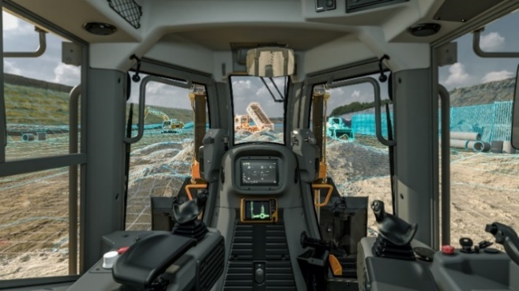

liebherr-kabinenansicht-G8-BIM.jpg  
Liebherr crawler dozer of the generation 8 are equipped with advanced assistance systems.

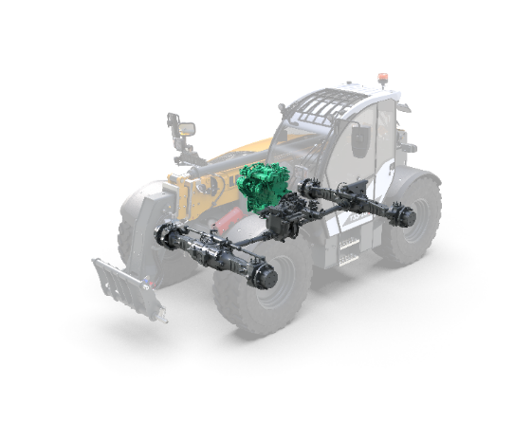

liebherr-teleskoplader-HVO.jpg   
The proven low-emission Liebherr telehandler drive can be operated alternatively with hydrogenated vegetable oil (HVO).

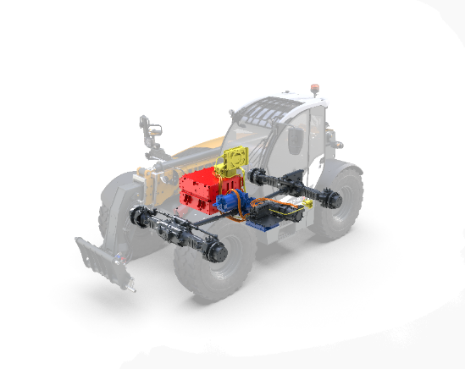

liebherr-teleskoplader-BEV.jpg   
Electric battery zero emission drive design with main components from a modular system.

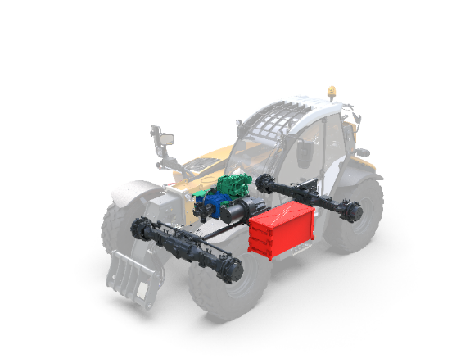

liebherr-teleskoplader-HEV.jpg   
The hybrid concept – consisting of a conventional diesel engine, electric drive and electric intermediate storage.

Contact

Lisa Kahlig  
Marketing Manager PR and Press  
Phone: +43 690 500 644 96  
E-mail: lisa.kahlig@liebherr.com

Published by

Liebherr-Werk Telfs GmbH   
Telfs/Österreich   
www.liebherr.com