Press release

Liebherr-Werk Bischofshofen

invests in new assembly hall for battery-electric wheel loaders

⸺

Separate hall for the assembly of the L 507 E battery-electric wheel loader in Bischofshofen

Modern, energy-efficient building with a digitally designed assembly line

L 507 E battery-electric wheel loader with the same great performance as a conventional wheel loader

After roughly ten months of construction, Liebherr has commissioned a new assembly hall especially for the manufacture of battery-electric wheel loaders at their plant in Bischofshofen. The group’s first electric wheel loader, the L 507 E, has been rolling off the assembly line here since March 2024. In total, Liebherr has invested over €2.2 million in the new manufacturing facilities. The nearly 1000 m² production area is designed for a maximum yearly output of up to 500 battery-electric wheel loaders.

Bischofshofen (Austria) 12 March 2024 – In order to uphold the most stringent safety standards, the new production area is located in a separate hall, away from the conventional wheel loader assembly. “This separate space is something we opted for because we wanted to fully adapt the new assembly hall to meet the work-safety measures required by the new high-voltage battery system. All employees involved in constructing the L 507 E receive specialised training, which means we are particularly well prepared to meet the demands of electrical technology,” explains Peter Schachinger, Director of Production and Operations at Liebherr-Werk Bischofshofen.

Designed using virtual reality: a modern wheel loader assembly line that uses space intelligently

The new wheel loader assembly line is located in one of the plant’s former workshop halls, which Liebherr has gutted and restored for the production of the L 507 E. The building is now characterised by its expansive windows, which create a friendly working environment. Liebherr has also invested in new break rooms for its employees. “We’ve also brought the building up to the latest energy standards, with concrete core activation, a district heating connection and heat pumps. We’re increasingly generating the electricity required for the hall ourselves, as we now operate several solar panels at our plant – which cover over 3400 square metres in total,” Schachinger explains.

The wheel loader experts designed the interior of the assembly hall almost entirely digitally using virtual reality applications. “This allowed us to test various layouts and therefore perfectly coordinate the pre-assembly stations and the main assembly line. We were therefore able to efficiently use the available space and create short transport paths,” says Jonas Schwob, Project Manager for the Production of Electric Wheel Loaders. A digital display at the centre of the assembly hall gives an overview of the current key production figures in real time. Liebherr has given special consideration to ergonomics at the individual work stations: Special lifting devices and transport systems as well as wireless bolting tools make it easier for workers to assemble the new L 507 E wheel loader.

Liebherr L 507 E wheel loaders: maximum performance with a high-voltage battery system

The new L 507 E has been available from Liebherr sales partners in several European countries since late 2023. It is based on the conventionally driven L 507 Stereo wheel loader and combines the tried-and-tested advantages of a stereoloader with a battery-electric drive developed by Liebherr. This drive relies on a high-voltage battery system, specially designed by Liebherr for wheel loader operations, ensuring powerful performance and efficient charging.

While the L 507 E’s performance is identical to conventionally driven Liebherr wheel loaders of the same size class, it emits no local CO2, and noise emissions are minimal. This makes the new wheel loader particularly suitable for any operation where you have to consider noise or exhaust fumes, such as in inner-city areas or in halls.

Depending on the operating conditions, the L 507 E has a run time of up to eight hours. Liebherr’s modular battery design also makes it possible to install a second lithium-ion battery ex works at the customer’s request, which further extends the run time. A full battery charge can take between ninety minutes and three hours, depending on the on-board charging technology and power rating.

About Liebherr-Werk Bischofshofen GmbH

Liebherr-Werk Bischofshofen GmbH develops, produces and sells wheel loaders from the Liebherr Group. The plant in Salzburger Land (Austria) has grown steadily over the decades thanks to sustainable innovations, creative solutions and high quality standards. The wheel loader range is constantly being expanded and includes models in different product groups: compact loaders, stereoloaders, and mid-sized and large wheel loaders with impressive and innovative drive designs.

About the Liebherr Group

The Liebherr Group is a family-run technology company with a highly diverse product portfolio. Not only is the company one of the largest construction equipment manufacturers in the world, it also provides high-quality and user-oriented products and services in many other areas. The Liebherr Group now includes over 140 companies across all continents. In 2022, the group employed more than 50,000 staff and achieved combined revenues of over €12.5 billion. Liebherr was founded in 1949 in Kirchdorf an der Iller, in Southern Germany. Since then, its staff have worked tirelessly to impress their customers with sophisticated solutions and actively advance technology.

Images

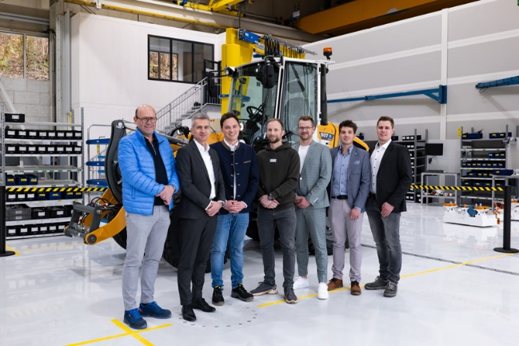

liebherr-new-assembly-hall-project-team.jpg  
Peter Schachinger (2nd from left, Director of Production and Operations) and Jonas Schwob (3rd from left, Project Manager for the Production of Electric Wheel Loaders) celebrate the commissioning of the new assembly hall at Liebherr-Werk Bischofshofen together with members of the project team.

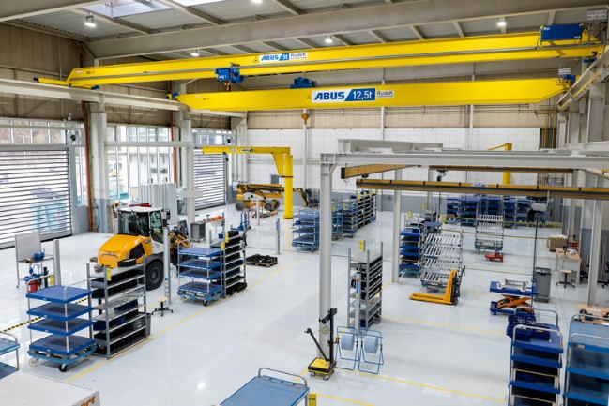

liebherr-new-assembly-hall-for-electric-wheel-loaders.jpg  
Just before production start-up: The new assembly hall for Liebherr’s L 507 E battery-electric wheel loader.

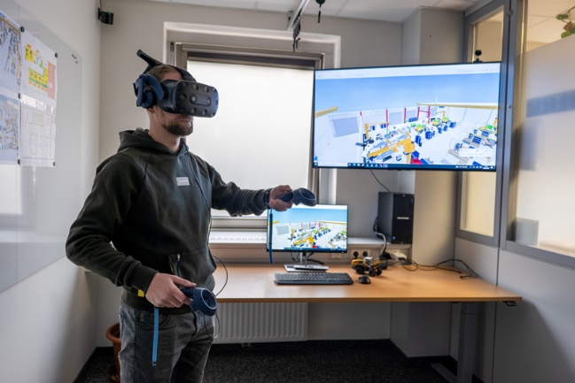

liebherr-new-assembly-hall-for-electric-wheel-loaders.jpg  
The wheel loader experts in Bischofshofen designed the new assembly line almost entirely digitally using virtual reality applications.

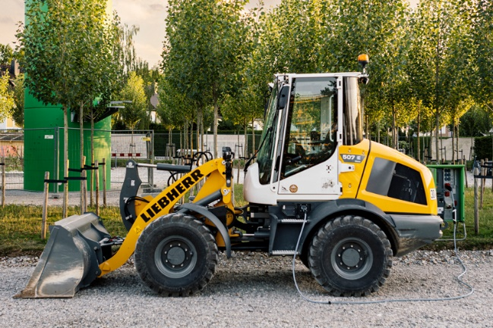

liebherr-l507e-battery-electric-wheel-loader.jpg  
Liebherr wheel loader L 507 E: Full power, long run times and efficient charging thanks to the high-voltage battery system.

Contact

Anna Zögernitz  
Marketing and Public Relations  
Phone: +43 50809 12195  
E-mail: [anna.zoegernitz@liebherr.com](mailto:anna.zoegernitz@liebherr.com)

Published by

Liebherr-Werk Bischofshofen GmbH  
Bischofshofen/Austria  
[www.liebherr.com](http://www.liebherr.com)