Press release

Simply the best: LTM 1300-6.3 for crane rental company
Xin-Hong in Taiwan

⸺
Third Liebherr crane for Xin-Hong Crane Engineering Co., Ltd. becomes flagship of its fleet
Customer appreciates Liebherr’s high-quality products and reliable support
LTM 1300-6.3 offers a 90-metre boom and compact ballasting options

Xin-Hong Crane Engineering Co., Ltd. has taken delivery of its third Liebherr crane. The new LTM 1300-6.3 is the first 300-tonne crane in the Taiwanese crane rental company’s fleet. Thanks to its 90-metre-long boom and high lifting capacities, the mobile crane is ideal for applications that require increasingly high hook heights.
Ehingen (Donau), (Germany), 4 April 2024 – “Liebherr is simply the best. Not only their cranes, but also their after-sales service,” says Chien-Min Wu, owner and CEO of Xin-Hong, about his working relationship with Liebherr in Ehingen. The Taiwanese crane rental company recently took delivery of an LTM 1300-6.3. This mobile crane can carry its 90-metre telescopic boom with a 12-tonne axle load on public roads. In addition to the long telescopic boom, key factors for choosing this economical, fast-erecting crane were its compact ballast options thanks to VarioBallast® and its flexible VarioBase® support technology.
Flying high in Taiwan’s science parks
Whether for semiconductors or high-tech microchips – the production facilities of the Taiwanese IT industry are becoming increasingly taller. “The LTM 1300-6.3 is therefore particularly suitable for our planned operations in science parks, but also on construction sites, in refineries and power stations. It’s a versatile 6-axle crane with an excellent telescopic boom and outstanding capacities,” says Wu. “With the new mobile crane, we now also have a new flagship for our fleet, which has a considerable resale value.”
Transport services and crane jobs
The story of Xin-Hong began with just one forklift truck in 2003. Step by step, the company grew, branched out into traditional transport work and now has 120 employees in both Taiwan and China. The crane hire company’s fleet is used for traditional lifting jobs as well as challenging crane jobs. The company added its first Liebherr crane, an LTM 1230-5.1, to its portfolio in 2023.

About Liebherr-Werk Ehingen GmbH
Liebherr-Werk Ehingen GmbH is a leading manufacturer of mobile and crawler cranes. Its range of mobile cranes extends from 2-axle 35 tonne cranes to heavy duty cranes with a lifting capacity of 1200 tonnes and a 9-axle chassis. Its lattice boom cranes on mobile or crawler travel gear deliver lifting capacities of up to 3000 tonnes. With universal boom systems and extensive additional equipment, they can be seen in action on construction sites throughout the world. The Ehingen site has a workforce of 5,000. An extensive, global service network guarantees the high availability of Liebherr mobile and crawler cranes. In 2023, the Liebherr plant in Ehingen recorded a turnover of 2.81 billion euros.
About the Liebherr Group – 75 years of moving forward
The Liebherr Group is a family-run technology company with a highly diversified product programme. The company is one of the largest construction equipment manufacturers in the world. It also provides high-quality, user-oriented products and services in a wide range of other areas. The Liebherr Group includes over 150 companies across all continents. In 2023, it employed more than 50,000 staff and achieved combined revenues of over 14 billion euros. Liebherr was founded by Hans Liebherr in 1949 in the southern German town of Kirchdorf an der Iller. Since then, the employees have been pursuing the goal of achieving continuous technological innovation, and bringing industry-leading solutions to its customers. Under the slogan ‘75 years of moving forward’, the Group celebrates its 75th anniversary in 2024.

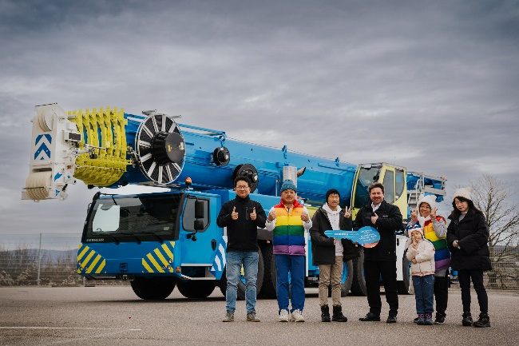
Images

liebherr-ltm-1300-6-3-xin-hong.jpg
Handover of the LTM 1300-6.3 to the crane rental company Xin-Hong Crane Engineering Co, Ltd: JR Wang (Hector Machinery), owner Chien-Min Wu, Ping-Jui Wu, Liebherr sales representative Marcel Beck, Man-Hsuan Lu, Hsiu-Chuan Lu and Man-Wie Wu (from left to right).

Contact
Berenike Nordmann
Marketing and Communication
Phone: +49 7391 / 502-0
Email: berenike.nordmann@liebherr.com
Published by
Liebherr-Werk Ehingen GmbH
Ehingen (Donau) / Germany
www.liebherr.com

