Press release

At Intermat, Liebherr shows how customers enjoy first-class service at any time on site or digitally

⸺

Understanding customer needs as a basis for customer satisfaction

Customised solutions owing to a global service network

MyLiebherr: access to comprehensive online services of the Group

Troubleshooting via remote products and services guarantees high machine availability

In the ‘Service’ pavilion at Intermat, trade show visitors find out how Liebherr offers its customers and partners unique services throughout the entire life cycle of the machines. The global service network is available on site in more than 50 countries on all continents and is supplemented with remote services. In France, the full-service provider has a dense dealer and technician network with a wide range of sales and service activities. In this way, the Group manages to provide fast and reliable support in every market in which it operates. Furthermore, customers enjoy a comprehensive service via digital platforms such as MyLiebherr. An EMT simulator is also available to trade show visitors. This allows the visitors to operate a construction machine virtually.

Paris (France), 24 April 2024 – At the Intermat trade show, Liebherr showcases itself under the motto ‘On your site’. The motto indicates that, within the Group, the focus is always on the customer – at all times and all over the world. Whether it is on the construction site with the products or through individual advice, services and comprehensive solutions, Liebherr offers customised solutions for every challenge and requirement. To meet this requirement, Liebherr works closely with customers and partners and offers first-class services anywhere and at any time – directly on site or remotely.

In the ‘Service’ theme pavilion, Liebherr, as a provider of comprehensive end-to-end solutions, shows how customers and partners enjoy a comprehensive service package throughout the entire life cycle of the machines and are also guided with efficient and customised services. The global service network covers more than 50 countries on all continents and is supplemented with remote services. In every market where the Group is active, it aims to be as close as possible to its customers in order to provide fast and reliable support on site, which best meets the customer requirements in the respective situation. One of these markets is France, which has been one of the Group’s key sales markets and production sites for over 60 years. Liebherr is constantly investing in the expansion of the nationwide service network there – most recently with the opening of another subsidiary of Liebherr Distribution et Services France SAS (LDF), which has been pooling all sales and service activities in France since 2022.

**Wide range of sales and service activities through extensive dealer network in France**

Liebherr has been present in France since the early 1960s and has continually developed its distribution network through dedicated agencies and dealerships. The creation of its own company, Liebherr-Distribution et Services France SAS, in 2023 further underlines the importance the Group attaches to Service. The segment-specific, shared sales expertise also makes it easier for staff to develop and implement solutions that are tailored to customers. The Liebherr network in France comprises 60 service stations with over 500 mobile technicians, who look after the different customer concerns for all products with 500 service vehicles. With a service vehicle at its booth, Liebherr provides insights into the expertise the technicians should have and how they can acquire this knowledge.

Liebherr’s sales and service network is characterised by its density, the proximity of its infrastructure, the consistency of its approach in all areas and the quality of its employees, who receive regular training at the production sites in Europe. The ‘Service’ theme also covers rental offers, used machines and a variety of digital solutions, which facilitate the work and communication with customers and business partners.

**MyLiebherr provides access to information and services relating to purchased products**

The Liebherr motto is: we are only satisfied when our customers and business partners are also satisfied. This is also how solutions for the construction site of the future are created – solutions with which Liebherr contributes to technological progress. Liebherr’s digital solutions make innovative information technology easy and convenient to use throughout the entire customer journey. Via the digital customer service platform MyLiebherr, customers and service partners have access to comprehensive online services of the Group: from planning and operation, performance and maintenance through to safety-relevant solutions. Comprehensive functions and simple operation are always to the fore.

**Maintenance of the Liebherr machine: from the spare parts shop to the replacement of the diesel particulate filter**

All features of the customer service platform can be used once registration is completed and the business relationship with a Liebherr service partner is confirmed. MyLiebherr enables access at any time to information and services relating to purchased products from the areas of construction machines, mining, cranes and material handling technology. A wide range of online functions is opened up to the user, including an extensive spare parts catalogue as well as uncomplicated contact with the respective Liebherr service partner. Customers can thus coordinate the maintenance and extension of their fleet at any time and completely independently of the site. In addition, the system displays if the function is supported by the respective service partner, whether the desired products are available or the expected delivery time.

Via MyLiebherr, the diesel particulate filter (DPF), for example, can be replaced independently in a crane from LICCON2 control and exhaust emissions stage 5. The LICCON screen displays the message that the diesel particulate filter (DPF) has reached its cleaning interval and the filter element of the DPF must be replaced. The customer is guided step-by-step via MyLiebherr. A digital solution that saves costs and increases flexibility in work planning.

**Remote offer: services configured to meet customer requirements**

In order to perform targeted troubleshooting simply and quickly all over the world, Liebherr customers benefit from remote features. Via audio and video calls, a chat function, screen sharing, exchange of images and documents, as well as whiteboard functions, customers can request support from the Liebherr experts in real time. A laptop, tablet or smartphone as well as an Internet connection is all that is required to solve problems with a crawler crane, duty cycle crawler crane, deep foundation machines or maritime cranes.

The remote product XpertAssist is presented to trade show visitors in the Liebherr ‘Service’ pavilion. It is based on an annual subscription and combines several service tools in order to offer additional benefits such as a reduction of the average time until repair and thus a reduction of costs. Liebherr experts provide fast and effective real-time support as well as second-level backup support worldwide. XpertAssist contains forward-looking maintenance recommendations and reports on individual machines or entire fleets, such as reports on safety or machine utilisation and engine load. The interactive performance review and advice on preventive maintenance ensure a high level of machine availability and early budget planning.

Trade show visitors can perform machine maintenance using the EMT simulator with VR glasses. In the virtual world, they are asked to perform various control mechanisms. This way, they find out where the parts are located in the machine and how they are repaired. In addition, visitors can drive excavators, wheel loaders and telescopic handlers in simulation mode.

About the Liebherr Group – 75 years of moving forward

The Liebherr Group is a family-run technology company with a highly diversified product programme. The company is one of the largest construction equipment manufacturers in the world. It also provides high-quality, user-oriented products and services in a wide range of other areas. The Liebherr Group includes over 150 companies across all continents. In 2023, it employed more than 50,000 staff and achieved combined revenues of over 14 billion euros. Liebherr was founded by Hans Liebherr in 1949 in the southern German town of Kirchdorf an der Iller. Since then, the employees have been pursuing the goal of achieving continuous technological innovation, and bringing industry-leading solutions to its customers. Under the slogan ‘75 years of moving forward’, the Group celebrates its 75th anniversary in 2024.

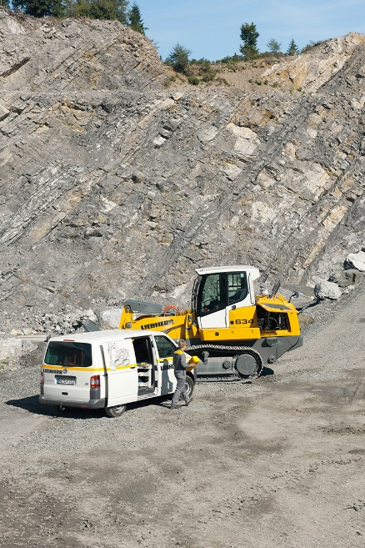Images

liebherr-servicepartner.jpg  
Service partners are available everywhere and at any time for Liebherr customers – there are over 500 in France.

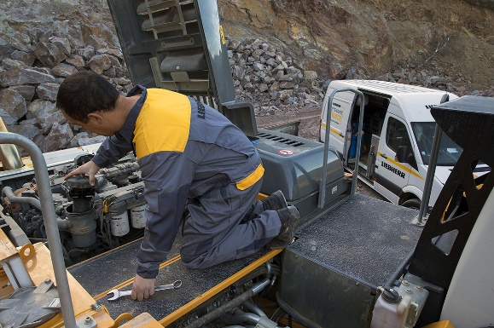

liebherr-kundenberater-inspektion.jpg  
As close as possible to its customers: Liebherr is present on site in over 50 countries on all continents in order to meet the customer requirements in the respective situation.

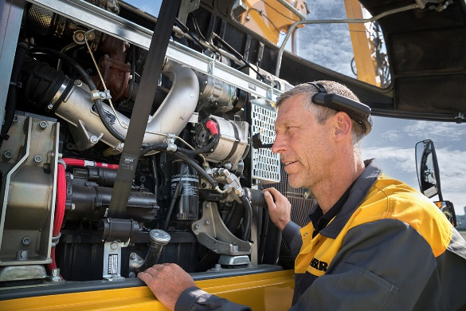

liebherr-remote-services.jpg  
Irrespective of where the machine is located in the world, Liebherr customers receive real-time support with the Remote Services offering.

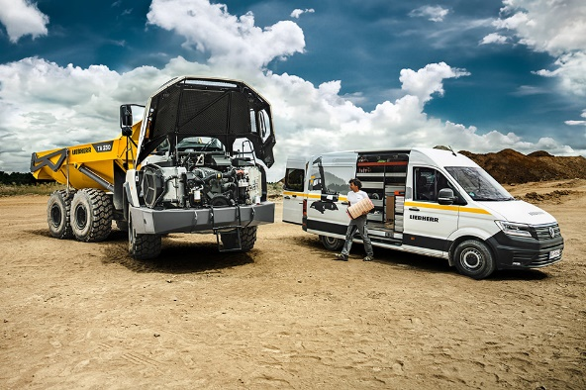

liebherr-serviceberater-kunde.jpg  
Customers benefit from fast and reliable support ‘on the site’ thanks to the global service network.

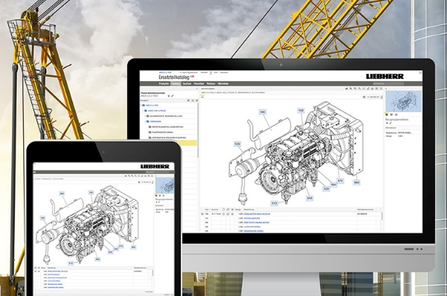

liebherr-myliebherr-shop.jpg  
MyLiebherr enables access at any time to information, services relating to purchased products and online functions such as the spare parts catalogue.

Contact

Larissa Lunitz  
Head of Public Relations

Phone: + 41 79 645 70 67

Email: larissa.lunitz@liebherr.com

Published by

Liebherr-International AG

General-Guisan-Strasse 6

5415 Nussbaumen, Switzerland

www.liebherr.com