Press release

Liebherr enters air cargo market

⸺
Liebherr-Aerospace Saline and LHColus announce the signature of a Sole Distribution Agreement for LHColus’ quick conversion passenger to freighter cargo solution. With this agreement, Liebherr- Aerospace Saline, Inc., Liebherr’s dedicated aftermarket aerospace center for the Americas, becomes the exclusive international distributor of the cargo conversion kit developed by the Brazilian company LHColus, provider of aeronautical engineering consulting services.

Saline, Michigan (USA), April 2024 – Liebherr Aerospace Saline Inc., Michigan (USA) and LHColus Tecnologia Ltda., based in São José dos Campos (Brazil), have recently signed an agreement that declares Liebherr-Aerospace Saline as the exclusive international distributor of the quick conversion passenger to freighter cargo aircraft solution – also known as Class F Quick Change - developed and certified by LHColus. Liebherr will be responsible for the global distribution (excluding Brazil) through its worldwide customer services network, that shall provide sales and technical support.
“We are excited about our entry into the booming air cargo market and the possibility to bring to our customers such an easy, fully reversible and cost-effective solution”, commented Mr. Alex Vlielander, Chief Customer Officer of Liebherr-Aerospace & Transportation SAS
“We are very happy about this agreement with Liebherr, a leading global OEM that has shown keen interest in our cargo conversion kit, contemplating its distribution worldwide as well as looking forward to developing this project for other aircraft models like the Airbus A320 and Boeing’s 737. This partnership will surely enhance our market reach and enable us to offer cost-effective cargo conversion solutions on a global scale.”, explained Mr. Luís Henrique Colus, LHColus Executive Director.
Mr. Flávio Costa, Technical Vice-President of Azul added: “We are the first company in the world to have installed this system. In our fleet, we have converted five Embraer E-Jets E1 with the Class F Quick Change Solution, and we are very excited about the agility and versatility that this change has given us. It is a constant improvement that allows us to serve our customers better.”
The Class F Quick Change Solution
The Class F Quick Change is implemented by the means of a simple, fast, and fully reversible modification on the aircraft. Its efficiency and reliability have been field proven with a sizeable fleet operating for over 2 years in Latin America that has already accumulated more than 18 thousand flight hours and transported over 15.3 million (e-commerce) packages equivalent to 33.3 thousand tons of payload. The solution is currently certified for Embraer E190 aircraft but can be extended to other single aisle aircraft types.
In a simplified approach, the conversion requires the removal of all main cabin seats to make room for aluminum frames and independent fire-proof and smoke-contained cargo nets. The cargo is monitored by 2 fully independent IR cameras, which are designed to detect any heat sources, alerting the pilots in the cockpit. The system also features a smoke barrier to isolate the main cabin from the front galley/cockpit area (a mandatory requirement) and cargo placards, which are used to indicate the maximum load height.
About Liebherr-Aerospace & Transportation
Liebherr-Aerospace & Transportation SAS, headquartered in Toulouse (France), is one of 13 product segments of the Liebherr Group and a first-tier provider of on-board solutions in the aerospace and transportation industry, contributing to a more sustainable transport through innovative products, best in class services and performance excellence.
The aerospace product portfolio offered to civil and defense customers includes environmental control and thermal management systems, flight control and actuation systems, landing gears as well as on-board electronics. For rail vehicles of all kinds Liebherr offers heating, ventilation and air conditioning systems, passive and active hydraulic systems for braking, damping, axle steering and levelling. Furthermore, Liebherr serves the commercial vehicle market with trailer cooling systems.
About the Liebherr Group
The Liebherr Group is a family-run technology company with a highly diversified product portfolio. The company is one of the largest construction equipment manufacturers in the world. It also provides high-quality and user-oriented products and services in a wide range of other areas. The Liebherr Group includes over 150 companies across all continents. In 2023, it employed more than 50,000 staff and achieved combined revenues of over 14 billion euros. Liebherr was founded in Kirchdorf an der Iller in Southern Germany in 1949. Since then, the employees have been pursuing the goal of achieving continuous technological innovation and bringing industry-leading solutions to its customers.
About LHColus
LHColus Tecnologia Ltda. was founded in 2008 by engineer Luís H. Colus to provide aeronautical engineering consulting services. For over 38 years Mr. Colus has worked with aeronautical authorities and the industry (Embraer) as a partner in the development of the fuselage for the ERJ170/190 aircraft. Based on strong demand for services in this area, the team has grown with new participants increasing its capacity to manage a wider range of larger and more complex projects. The company is 100% Brazilian owned, located in São José dos Campos, and features exclusive members in the aeronautics field.
About Azul
Azul S.A. (B3: AZUL4, NYSE: AZUL), the largest airline in Brazil by departures and cities served, offers around 1,000 daily flights to over 160 destinations. With an operating fleet of over 180 aircraft and more than 16,000 Crewmembers, the Company has a network of 300 non-stop routes as of December 2023. Azul was named by Cirium (leading aviation data analysis company) as one of the two most on-time airlines in the world in 2023. In 2020 Azul was awarded best airline in the world by TripAdvisor, the first time a Brazilian flag carrier earned the number one ranking in the Traveler’s Choice Awards.

Images
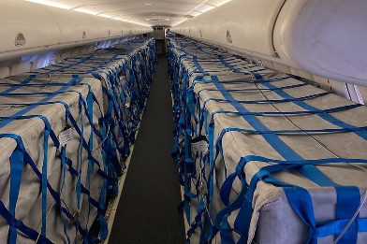
liebherr-lhcolus-cargo-version1.png
Cabin interior view of a passenger aircraft converted into a cargo aircraft by LHColus’ Class F Quick Change Solution – © LHColus
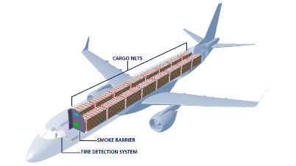

liebherr-lhcolus-cargo-version 2.png
The solution is currently certified for Embraer E190 aircraft but can be extended to other single aisle aircraft types. – © LHColus

Contact person
Ute Braam
Head of Corporate Communication
Phone: +49 8381 / 46 - 4403
E-Mail: ute.braam@liebherr.com
Published by
Liebherr-Aerospace & Transportation SAS
Toulouse / France
www.liebherr.com

