Press release

Liebherr at IFAT 2024 in Munich

⸺

Trade fair premiere of the new LH 40 M Port Elektro in Germany

Liebherr presents two wheel loaders: L 507 E and L 556 XPower®

Liebherr telescopic handlers: HVO and smart assistance systems

LiXplore® digital camera monitor system for convenient 360° all-round visibility

Liebherr stand 151/250 in hall C5

**Liebherr will be present at IFAT 2024, the world's leading trade fair for water, sewage, waste and raw materials management, which will take place in Munich from 13 to 17 May 2024, with a stand measuring around 280 m². In Hall C5, Stand 151/250, Liebherr will be exhibiting machines specially designed for use in waste management and recycling. The new LH 40 M Port Elektro electric material handling machine will be celebrating its trade fair premiere in Germany, as well as the new GMM 35-5 multi-tine grapple. With the L 507 E and the L 566 XPower, Liebherr will be showing two representatives from its wheel loader portfolio. The Liebherr T 60-9s, T 41-7s and T 33-10s telescopic handlers will also be part of the exhibition appearance. In the area of digitalisation, Liebherr will be showing the LiXplore® camera monitor system.**

Munich (Germany), May 13, 2024 – The recycling industry is growing rapidly, and it is changing. In recent years, many waste disposal companies have developed from being generalists to being highly specialised recycling operations. This has brought about changes in requirements, and these have to be satisfied by the machines used in the recycling industry.

Liebherr is meeting this challenge by developing machines and equipment options especially for the different operations in the field of recycling and waste management. Liebherr will be presenting a selection of these high-performance, economical and yet reliable machines to the trade audience at the IFAT in Munich.

**New LH 40 M Port Litronic electric material handling machine makes its trade fair debut in Germany**

At IFAT, Liebherr will present the LH 40 M Port Elektro for the first time at an exhibition in Germany. The new material handling machine with an operating mass of around 45 tonnes is specially designed for handling bulk and general cargo in port operations and is characterised by very high loads combined with a long reach. Thanks to its electric drive concept and powerful electric motor, the machine combines emission-free, extremely low-noise operation with low operating and maintenance costs. The centrepiece of the material handling machine is a 145 kW Liebherr electric motor, which ensures powerful and dynamic working movements. Furthermore, the innovative drive concept includes an additional electric motor for auxiliary consumers, which ensures targeted energy distribution as well as maximum energy efficiency.

The new weight-optimised equipment guarantees powerful loading cycles and therefore maximum performance at a minimum cost per tonne of material handled. In addition, the modular design enables customised solutions for a wide range of requirements. Thanks to the weight-optimised equipment, the powerful machine can also be used in other scopes of application in addition to port handling.

At IFAT, the LH 40 M Port E will be on display with a trailing cable; alternatively, equipment with a winding system is also possible. In addition, the exhibit at the exhibition has a port boom with a length of 10.6 metres and a 7.7 metre stick. Liebherr will also be showing the GMZ 40 and the GMM 35-5, two attachments with which material handling machines can be used flexibly in different areas.

For efficient and economical goods handling: Liebherr multi-tine grapple GMM 35-5

Liebherr will also present the new GMM 35-5 multi-tine grapple at its IFAT hall stand. This intelligently designed five-tine grapple was not merely developed for customers, but also with input from customers. It is available for material handling machines with an operating mass of 22 to 35 tonnes. The GMM 35-5 is specially designed to ensure the best possible grappling on mixed and shredded scrap as well as chips with dimensions of up to 0.6 m³. Thanks to an extensive portfolio of shell shapes and a broad range of options, a wide variety of materials can be handled efficiently and economically in the area of recycling and scrap utilisation. The arrangement and shape of the shells has been improved to ensure perfect penetration and a secure grip on bulky yet loose material. A total of three shell shapes are available for handling a wide variety of materials: open shells for large and bulky pieces of scrap, semi-closed shells for medium-sized pieces, mixed materials and shear scrap, and closed, heart-shaped shells for small, fine-grained materials and chips.

**No CO2 emissions onsite and low noise emissions: the first battery-electric Liebherr wheel loader L 507 E**

Liebherr presents the L 507 E, the first battery-electric wheel loader in the group, at IFAT. It combines the demonstrable advantages of a Liebherr Stereoloader with a battery-electric drive design developed by Liebherr. The performance of the L 507 E is equal to that of a conventionally powered Liebherr wheel loader in the same size class, but it emits no CO2 onsite. In addition, noise emissions are kept to a minimum, which makes the new wheel loader particularly suitable for any application where you have to consider noise or exhaust fumes, such as in inner-city areas or in halls. Liebherr relies on a high voltage battery system – specially developed for L 507 E wheel loader applications – which ensures powerful performance and efficient charging.

**Liebherr telescopic handlers with HVO drive and smart assistance systems**

In view of the increasing demand for efficient and sustainable solutions, Liebherr is continuing its commitment in this area and will present a T 60-9s, T 41-7s and T 33-10s telescopic handlers at IFAT 2024. Liebherr telescopic handlers are characterised above all by their versatility and high mobility, setting new standards in industrial use. The infinitely variable hydrostatic travel drive, robust overall structure and excellent visibility ensure safe and comfortable operation.

Thanks to the use of hydrotreated vegetable oil (HVO), fewer emissions are released during use compared to a machine powered by fossil diesel fuel. Due to the good compatibility with all engine components and the miscibility with fossil diesel, the entry or changeover barrier for customers is low. It is even possible to switch fuels during operation; for example, in the event of procurement bottlenecks. The drive concept remains unchanged without any loss of performance, there are no additional maintenance steps and no extra technical training is required. There is also no change in terms of the maximum lifting power, precise control and smooth machine operation.

In addition, Liebherr has removed its telescopic handler expertise with the EVO stage that is now available. A special highlight is the new "EcoMotion" and "MultiMotion" assistance functions, which act as efficiency boosters. The “EcoMotion” assistance function enables load-free lowering of the telescopic arm without having to increase the speed of the diesel engine. At the same time, this function offers increased convenience and also enables more efficient working movements, as the telescopic arm can be lowered faster and more smoothly. With the "MultiMotion" function, the telescopic arm is retracted fully automatically in proportion to the working movement during lowering, with no need to manually adjust this function. At the same time, direct, load-independent control of all functions using the multifunction joystick is still possible.

For demanding waste disposal applications: the L 556 XPower®

Liebherr will present the L 556 XPower® model from its XPower large wheel loader series at this year's IFAT exhibition. Like all Liebherr wheel loaders in the XPower series, it features a power-split travel drive as standard. This unit combines the hydrostatic drive unit, which is perfect for short loading cycles, with the mechanical drive unit, whose benefits come to the fore when longer distances are involved. The power-split transmission of the XPower wheel loaders is responsible for combining the two drive types. It works variably and adapts the blending ratio of the two drive paths infinity variable and automatically to suit the task at hand. Low fuel consumption and maximum power delivery are the result, even if (for example) steep climbs or long paths of the machine need to be mastered in a quarry in combination with short loading cycles.

The Liebherr L 550 XPower® and L 556 XPower® wheel loaders are ideal for demanding industrial applications; for example, in the field of waste disposal (e.g. handling paper, bulky scrap metal or refuse slag). They have reinforced kinematics, which provides a higher tipping capacity. Powerful working hydraulics enable dynamic lifting and tilting functions, regardless of the size or weight of the attachment. The machine operator can efficiently handle challenging materials such as scrap metal, paper, compost or logs, especially in the upper lifting range.

**360° for 100 percent comfort: digital surround view systems from Liebherr**

With its exhibition appearance at IFAT, the group of companies is not only demonstrating its expertise in high-performance machines, but also the great diversity of its product portfolio. Liebherr has been developing and producing digital cameras for mobile machinery at its Lindau site for more than a decade. The digital camera systems are not only used in the company's own machines. They are ideal for vehicles and machines in the waste management, winter service, sewer and street cleaning sectors, as they are perfectly adapted to their demanding working conditions. Drivers can rely on the consistently high image quality of Liebherr digital cameras, even in very dark environments and changing light conditions, making their daily work easier and contributing to greater efficiency and accident prevention.

Depending on the requirements of the work process, different product variants are available. The 360° version combines front, rear and side area monitoring, giving the operators a comfortable surround view of their working environment. They don’t only monitor driveways and operations from a bird's eye view perspective but ensure timely recognition of obstacles and people. If you need to monitor a specific area in detail, a camera monitor system is the ideal choice. The multicast function offers additional efficiency and convenience. Liebherr cameras can simultaneously transmit identical video streams to multiple remote workstations. This option is ideal for observing and monitoring operations from multiple locations.

About the Liebherr Group – 75 years of moving forward

The Liebherr Group is a family-run technology company with a highly diversified product portfolio. The company is one of the largest manufacturers of construction equipment in the world. It also provides high-quality, user-oriented products and services in a wide range of other areas. The Liebherr Group includes over 150 companies across all continents. In 2023, it employed more than 50,000 staff and achieved combined revenues of over 14 billion euros. Liebherr was founded by Hans Liebherr in 1949 in the southern German town of Kirchdorf an der Iller. Since then, the staff have been pursuing the goal of achieving continuous technological innovation, and bringing industry-leading solutions to its customers. Under the slogan ‘75 years of moving forward’, the Group celebrates its 75th anniversary in 2024.

Images

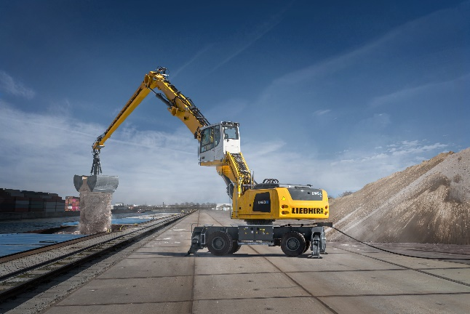

liebherr-lh40-m-port-elektro.jpg  
The LH 40 M Port E electric material handling machines are predestined for handling bulk and general cargo in harbour handling.

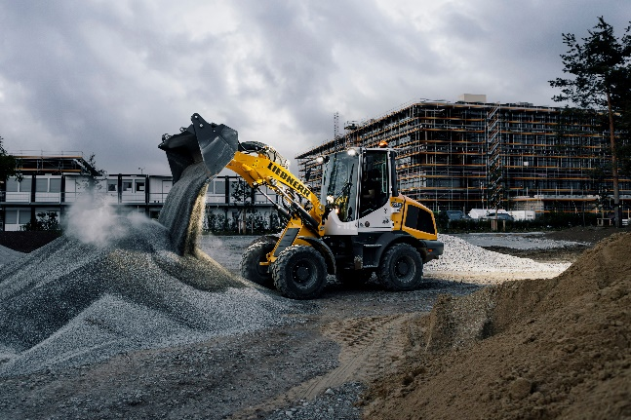

liebherr-l507e-battery-electric-wheel-loader.jpg  
In noise-sensitive environments, operating companies benefit from the low noise emissions of the L 507 E.

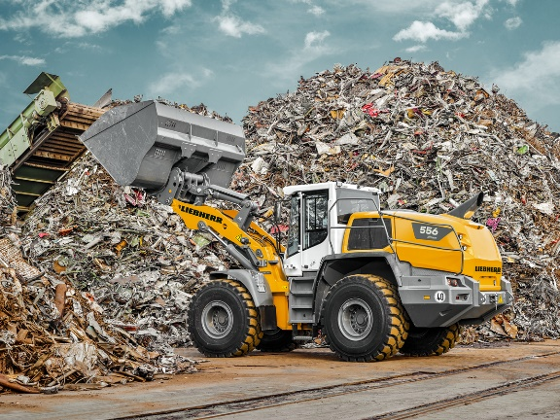

liebherr-l556_XPower-wheel-loader-96dpi.jpg  
The L 556 XPower® wheel loader with industrial kinematics is particularly suitable for demanding waste disposal applications.

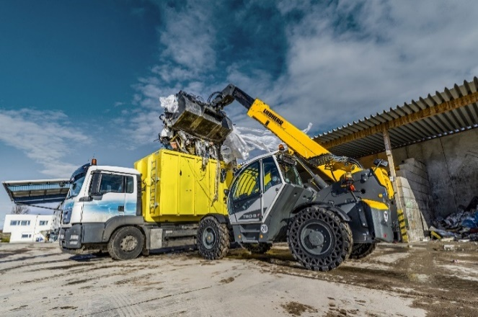

liebherr-teleskoplader-T60-9s.jpg  
Versatile use: Liebherr T 60-9s telescopic handlers optimise work processes.

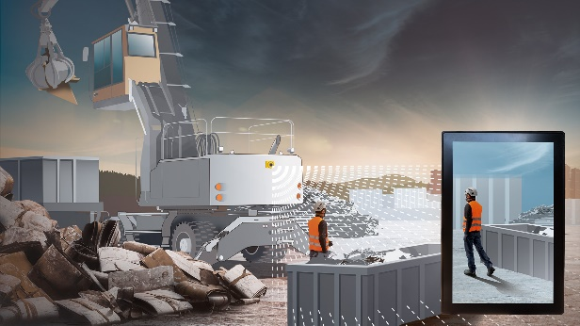

liebherr-kamera-monitor-system-liXplore.jpg  
The LiXplore® digital camera-monitor system provides detailed work area monitoring and comfortable 360° surround view.

Contact

Marc Wiedenmann  
Marketing  
Phone: +49 7354 / 80 - 8494  
Email: marc.wiedenmann@liebherr.com

Published by

Liebherr-Hydraulikbagger GmbH   
Kirchdorf an der Iller / Germany  
[www.liebherr.com](http://www.liebherr.com)