Press release

In the middle of Canada’s icy winter: LB 30 unplugged

⸺

Calgary has a clear goal: to reduce greenhouse gases. Part of the climate strategy is the use of emission-free technological innovations. With the first battery-powered unplugged model on Canadian soil, this strategy is also being consistently pursued in construction projects. During the construction of a new pedestrian overpass, contractor Graham and deep foundation subcontractor Ki International Ltd. put the LB 30 unplugged drilling rig purposely to the test with difficult drilling work and temperatures as low as minus 36 degrees.

Nenzing (Austria), 14 May 2024 − "We saw the LB 30 unplugged as an opportunity to do something good for our society," explains Gordon Williamson, owner of Ki International Ltd. “It is imperative that construction machines with electric drives have a future in Canada in order to steer our economy towards sustainability."

The construction site where the machine is being used is located in a busy area in north-west Calgary, Alberta. There are important centres here, including the Foothills Medical Centre, the Calgary Cancer Centre and the UXBorough project. The new pedestrian overpass facilitates access for the population and promotes growth in the area.

Ki International Ltd. is using the Kelly method with the Liebherr drilling rig to construct 22 cast-in-place piles for the overpass. The largest of these have a diameter of 1,000 mm and are 18 m deep. Mud, water and sand make the ground very soft, which is why the entire drilling depth has to be cased.

"We wanted a difficult task"

The biggest challenge for the work was the cold Canadian winter. Temperatures dropped to minus 36 degrees. It felt even icier in the wind. Nevertheless, the work had to be started in January. "However, there were no delays with regard to the performance of the drilling rig," says Janelle Bekkering, Project Manager at contractor Graham.

The direct location of the construction site next to a large hospital makes one advantage of the LB 30 unplugged particularly significant: the low noise emissions. The passage of emergency vehicles must be ensured at all times, even during ongoing construction site operations. The quiet operation of the machine means that emergency vehicles can be heard more clearly, which considerably improves safety for medical staff and patients as well as for construction site staff. The low noise level is particularly appreciated in urban and densely built-up areas.

Jason Lin, Project Manager for the City of Calgary, is also enthusiastic about the alternative drive system of the LB 30 unplugged: "We are proud that this emission-free technology is being used in Canada for the first time. Zero emission aligns with our policies and our climate strategy. The use of such machines will help us to reduce greenhouse gases. That is very important for us."

Gordon Williamson summarises the first use of the drilling rig on Canadian soil with satisfaction: "We wanted a difficult task. One that would really put the machine to the test. We got what we wanted. On this construction site, we have proven that the LB 30 unplugged is able to deal with difficult drilling work and extreme weather conditions."

Film: <https://youtu.be/nG64UQ7A9u4?si=3pvmiMDCcRreDYAt>

About the Liebherr Group – 75 years of moving forward

The Liebherr Group is a family-run technology company with a highly diversified product programme. The company is one of the largest construction equipment manufacturers in the world. It also provides high-quality, user-oriented products and services in a wide range of other areas. The Liebherr Group includes over 150 companies across all continents. In 2023, it employed more than 50,000 staff and achieved combined revenues of over 14 billion euros. Liebherr was founded by Hans Liebherr in 1949 in the southern German town of Kirchdorf an der Iller. Since then, the employees have been pursuing the goal of achieving continuous technological innovation, and bringing industry-leading solutions to its customers. Under the slogan ‘75 years of moving forward’, the Group celebrates its 75th anniversary in 2024.

About Ki International

Ki International is an Alberta-based, family owned, piling contractor and has been operating since 2006 in Western Canada. Ki's expertise in civil infrastructure, light industrial, power, commercial construction, residential and oilfield construction has been proven with its excellent reputation for completing projects safely, on-time, on-budget and with a high-quality finished product. As part of its ongoing business practices, culture, and commitment to continual improvement, Ki International Ltd. is advancing innovative and sustainable construction technologies in Alberta.

Images



liebherr-lb 30 unplugged_1.jpg   
The first unplugged machine in Canada successfully completed its icy premiere.

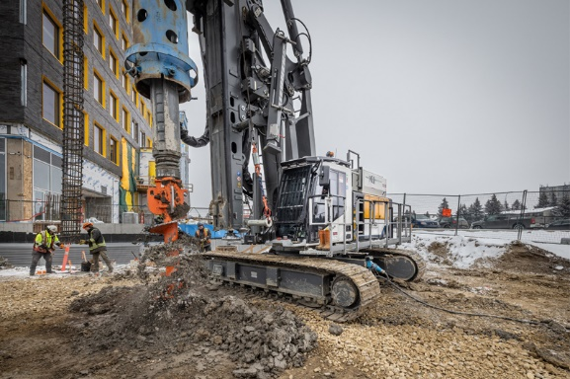

liebherr-lb 30 unplugged_2.jpg  
The LB 30 unplugged installed 22 piles using the Kelly method.

Contact Liebherr

Gregor Griesser  
Strategic Marketing and Communications  
Email: [gregor.griesser@liebherr.com](mailto:gregor.griesser@liebherr.com)

Wolfgang Pfister  
Head of Strategic Marketing and Communications  
Tel.: +43 50809 41-444  
Email: [wolfgang.pfister@liebherr.com](mailto:wolfgang.pfister@liebherr.com)

Contact Ki International Ltd.

Alex Williamson  
Business Manager  
403-912-6008   
Email: [alex.w@kiinternational.ca](mailto:alex.w@kiinternational.ca)

Published by

Liebherr-Werk Nenzing GmbH  
Nenzing/Austria  
[www.liebherr.com](http://www.liebherr.com)