Press release

Efficiency in the mining industry: Eti Maden opts for Liebherr Crawler Dozers

⸺

Industry leader Eti Maden confirms lower fuel consumption thanks to the hydrostatic drive

Liebherr PR 766 Crawler Dozer offers efficiency and reliability in mining operations

The Turkish mining company Eti Maden drives the global boron industry forward with innovative machinery and advanced technology. At its Kirka mine in western Turkey, the renowned organisation uses a Liebherr PR 766 Crawler Dozer specially designed for tough mining operations. Head of Kirka mine operations Yalçın Sakarya highlights how the machine's hydrostatic drive drastically reduces fuel consumption and lengthens the engine's service life. Robust design and efficient operation make the PR 766 the ideal machine for heavy-duty mining operations.

Telfs (Austria), May 27, 2024 – As Turkey's biggest mining company, Eti Maden is at the forefront of the boron industry. Seventy per cent of the world’s boron reserves are found in Turkey. The mineral is used in many areas of industry, particularly glass and ceramics manufacture, as it boosts strength, stability and heat resistance. It is also used in agriculture for fertilisation and the electronics industry for semiconductor production. Eti Maden’s leading role in the extraction and processing of this strategically crucial raw material boosts Turkey’s national economy and has a major impact on the global boron market. Constantly investing in research and development and using cutting-edge machinery, Eti Maden is setting benchmarks in the mining sector.

Liebherr Crawlers Dozers in heavy-duty mining operations

The Liebherr PR 766 plays a key role at the massive mine in Kirka, Turkey, one of the company's key operating locations. Here, dozer drivers mostly use the machine for local transport of materials. The mining company uses four of these innovative Liebherr machines in total in different mines across the country. The mining industry sets high standards for productivity and reliability in machinery. The PR 766 more than meets these requirements. Its components are specially designed by Liebherr for tough working conditions.

PR 766: the mining all-rounder

Liebherr Crawler Dozers offer remarkably high efficiency and optimum performance. The machines’ hydrostatic drives are particularly worth noting. They offer a fuel advantage of 10% in comparison with conventional drives, as head of Kirka mine operations Yalçın Sakarya confirms. This reduces operating costs and helps make mining operations more sustainable. The hydrostatic drive also enables efficient operation even at lower speeds, lengthening the service life of the engine and other components. Machine operators at Eti Maden are highly satisfied with the Liebherr Crawler Dozers’ performance.

The PR 766 offers major added value thanks to its versatility in extraction and mine maintenance. It offers precise control and perfect all-round visibility – ideal conditions for safe route maintenance. The robust, easy-maintenance design ensures they meet tough requirements for mining while keeping operating costs low to boot. This, combined with the powerful capability to tear apart tough stone layers, makes the PR 766 an indispensable tool in mining operations.

**Liebherr-Werk Telfs GmbH**

Liebherr-Werk Telfs GmbH has been producing and developing an ever-growing range of construction machines with hydrostatic drives since 1976. The company is able to draw on the many years of experience of the Liebherr Group with this type of drive. Whether it’s Crawler Dozers or Loaders, Telescopic Handlers or Pipe Layers – construction machinery from Telfs is consistently designed to keep you on the move with the highest efficiency and cost effectiveness. Then, increasing efficiency as well as reducing fuel consumption and CO2 emissions are a central focus. The latest computer-aided technologies are used both in development and production: from design engineering to welding robot processes, right through to computerised quality management.

**The Liebherr Group – 75 years of moving forward**

The Liebherr Group is a high technology company, in family ownership, with a diversified portfolio of products. The company is one of the largest construction machinery manufacturers in the world. But it also offers a range of high quality, high customer benefit products and services in many other areas. The Group currently consists of more than 150 companies across all continents. In 2023, it employed more than 50,000 people and generated a consolidated sales turnover of over €14 bn. Liebherr was founded by Hans Liebherr in 1949, in Kirchdorf an der Iller in southern Germany. From inception, the goal of the employees has been to delight their customers through novel contribution to technological progress and advanced technology solutions. In 2024 the Liebherr Group celebrates “75 years of moving forward”, to mark its 75th anniversary.

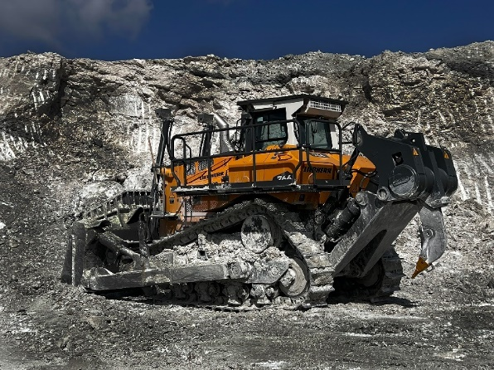Pictures

liebherr-img-5043.jpg  
Focus on efficiency: the Liebherr PR 766 undertaking tough tasks.

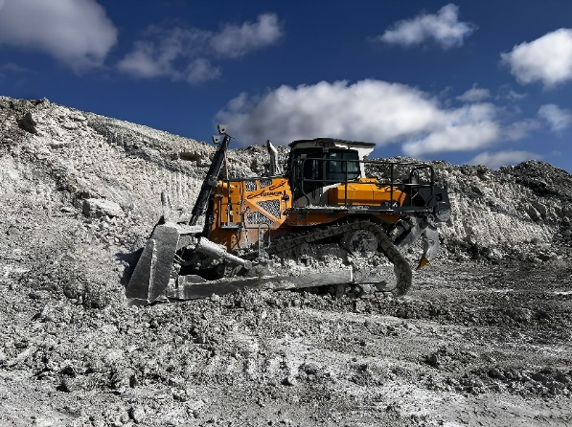

liebherr-img-5036.jpg  
The PR 766 proves itself as a strong partner for the mining industry.

**Contact**

Lisa Kahlig  
Marketing Manager PR and Press  
Phone: +43 690 500 644 96  
E-Mail: lisa.kahlig@liebherr.com

**Published by**

Liebherr- Werk Telfs GmbH  
Telfs / Austria  
www.liebherr.com