Press release

FPSO with two new Liebherr offshore cranes

⸺

Liebherr has successfully sold two Board Offshore Cranes of the type BOS 2600 to a Canadian customer

The BOS series offers flexible and easy-to-maintain solutions for platforms, jack-ups or on-board working

The BOS 2600 cranes will replace two well served Liebherr Compact Board Offshore (CBO) cranes that have been in service since 2006 and will contribute to safety and reliability on the Floating Production Storage Offloading unit (FPSO)

The two new Liebherr BOS 2600 cranes have been acquired by an integrated energy company located in Canada. The Board Offshore Cranes are destined for an FPSO unit operating off the coast of Newfoundland. The BOS crane series is one of the latest series of Liebherr offshore cranes. Known for its reliability and versatile deployment possibilities, it is the perfect choice for the FPSO unit in harsh environments.

Rostock (Germany), June 2024 – Out with the old, in with the new. The Compact Board Offshore cranes with their distinctive A-frame design have reached the end of their useful life after almost two decades in continuous operation. The cranes were commissioned in 2006. Since then, the two cranes from the CBO series have been providing service and are now replaced.

Liebherr was able to offer a convincing solution with the BOS series 2600 models. With a possible maximum reach of up to 60 metres and a lifting capacity of up to 100 tonnes, the BOS 2600 is suitable for dynamic lifting when servicing platforms, jack-up platforms or drilling rigs, for example, as well as for work on board. The BOS series is characterized by a modular design with standardised components for maximum reliability. These include the overload protection system (MOPS & AOPS) and Liebherr Litronic, the crane management system for highly efficient operation. “We always strive to meet our customer’s needs. We have been able in developing a customized solution that focuses on ease of maintenance without compromising on other aspects,” expresses Stefan Schneider, Global Application Manager General Purpose Offshore Cranes at Liebherr in Rostock.

Robust cranes for harsh offshore environments

The BOS 2600 series features many technical improvements. The crane has maximum stability and reliability thanks to the unique design. The slewing platform, which is the core element of the crane, contains the A-frame, the machine housing, the cabin, and the luffing winch. The machine housing is composed of durable steel parts and holds the components that are easy to access, such as the drive unit, the oil tank, and the control cabinets.

The focus of the completed project was on maximizing ease of maintenance. The northern Atlantic Ocean off the coast of Newfoundland is characterized by rough weather conditions, which can make maintenance work a challenge for the crew. High winds, corrosive seawater, and extreme temperatures make regular maintenance essential to prevent equipment failure, maximise efficiency, and ensure the safety of personnel.

Customised solutions enable greater ease of maintenance

In collaboration with the customer, additional technical innovations have been designed and implemented to make the cranes even easier to maintain in the future. If the main winch in the boom needs to be repaired or replaced, this is usually only possible by laboriously dismantling it into its individual parts. A drop hatch specially designed for the cranes makes this process much easier. The main winch is lowered to the deck level using a hatch and a new winch can be easily installed. This eliminates the need for time-consuming disassembly of the winch into its individual parts.

Walk-in facilities have been created that will simplify processes during operation. A platform has been installed in front of the cabin to make it easier to change the windscreen wipers. In addition, access is made possible by a staircase instead of ladders, which increases both the comfort and safety of the crane operator.

The successful completion of the project once again proved one of Liebherr’s core values – that Liebherr is a reliable partner. Erwin OBrien, Product Support Manager from Liebherr Canada, is satisfied: “The cooperation between Liebherr Canada and our colleagues in Germany to close the deal reflects the excellent collaboration. We can use our international presence to provide our customer with excellent solutions. Seamless communication, strong relationships within the Liebherr network, coupled with excellent customer service, are the key to providing the customer with an unforgettable customer experience.”

About Liebherr-MCCtec Rostock GmbH

Liebherr-MCCtec Rostock GmbH is one of the leading European manufacturers of maritime handling solutions. The product range includes ship, mobile harbour and offshore cranes. Reach stackers and components for container cranes are also included in the product portfolio.

About the Liebherr Group

The Liebherr Group is a family-run technology company with a highly diversified product portfolio. The company is one of the largest construction equipment manufacturers in the world. It also provides high-quality and user-oriented products and services in a wide range of other areas. The Liebherr Group includes over 140 companies across all continents. In 2023, it employed more than 50,000 staff and achieved combined revenues of over 14 billion euros. Liebherr was founded in Kirchdorf an der Iller in Southern Germany in 1949. Since then, the employees have been pursuing the goal of achieving continuous technological innovation, and bringing industry-leading solutions to its customers. Under the slogan ’75 years of moving forward’, the Group celebrates its 75th anniversary in 2024.

Images

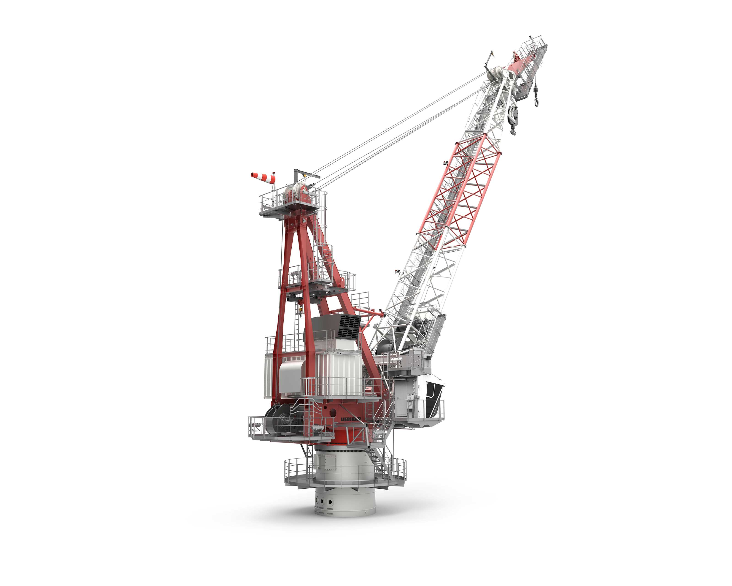

liebherr-bos2600-offshore-1.jpg  
The Board Offshore Crane 2600 is characterised by a maximum reach of up to 60 metres and a lifting capacity of up to 100 tonnes. The BOS series is an ideal solution for platforms, jack-ups or work on board.

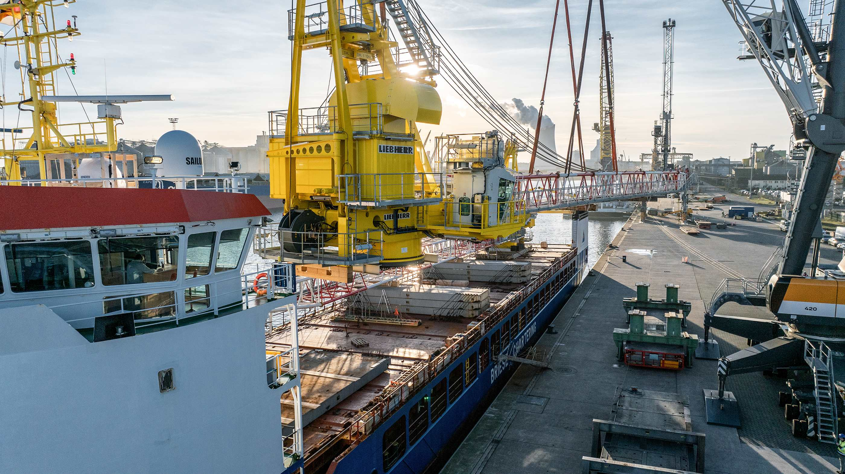

liebherr-bos2600-offshore-2.jpg  
The design of the cranes gives it maximum stability and reliability. The slewing platform, core element of the crane, contains the A-frame, the machine house, the cabin and the luffing winch.

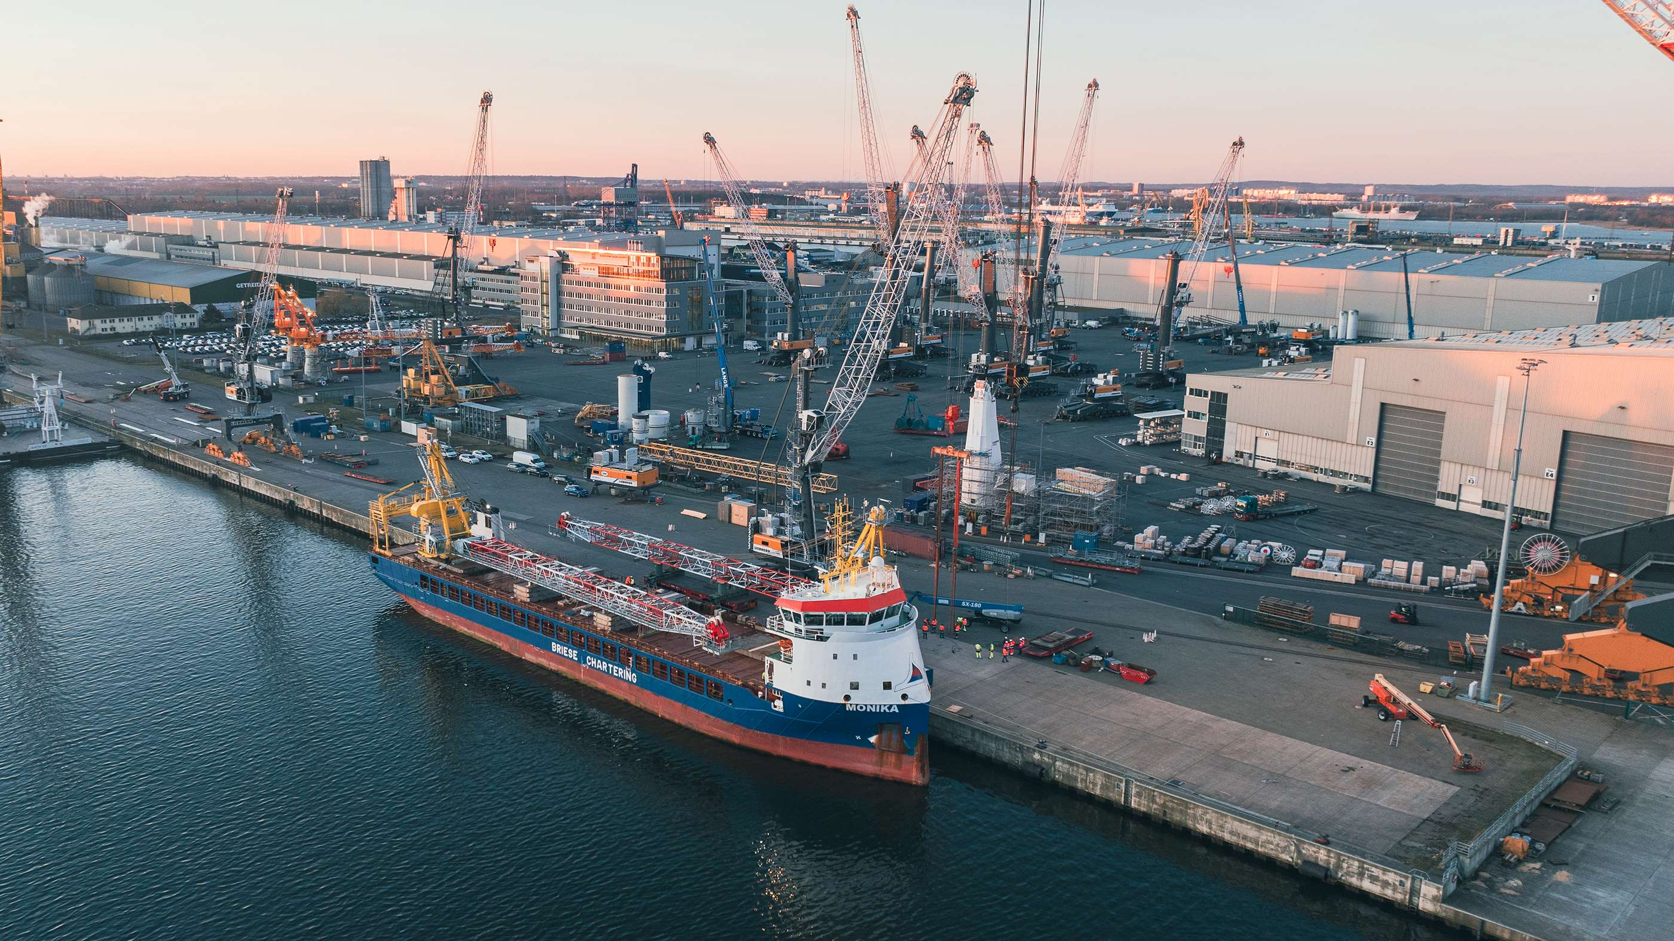

liebherr-bos2600-offshore-3.jpg  
The BOS 2600 features various technical specifications, such as a special drop hatch that makes it easier to replace or repair the winch or a special platform that makes it easier to change the windscreen wipers.

Contact

Constanze Jantsch

Marketing Manager - Offshore Cranes

Tel: +49 381 60065022

Email: constanze.jantsch@liebherr.com

Published by

Liebherr-MCCtec Rostock GmbH

Rostock / Germany

www.liebherr.com