Press release

Liebherr enters Kazakh railway market with air-conditioning units

⸺
- Delivery of 550 HVAC systems to Stadler Rail Group during the next six years
- Liebherr technology ensures travelling comfort on board trains in Kazakhstan
- The contract enlarges the footprint of Liebherr Transportation Systems (China) Co., Ltd.
in the international market
Liebherr Transportation Systems (China) Co., Ltd. will supply 550 HVAC systems to the rail vehicle manufacturer Stadler Rail Group. The air-conditioning systems are to be installed until 2030 in sleeper and couchette coaches ordered by the Federal Railways of Kazakhstan (KTZ).
Pinghu (China), July 2024 – Liebherr Transportation Systems (China) based in Pinghu was recently contracted by Stadler Rail Group through its local entity in Kazakhstan to manufacture and supply 550 heating, ventilation and air-conditioning (HVAC) systems until 2030. The units will be installed in Stadler sleeper and couchette passenger carriages, which will be operated by the Federal Railways of Kazakhstan.
“We are very honored to cooperate with Stadler,” said Roland Friedrich, Deputy General Manager of Liebherr Transportation Systems (China) Co., Ltd. and Key Account Manager for Stadler Rail Group. “The contract is our breakthrough and first milestone in the Kazakhstan railway market. We are happy to contribute our extensive experience and innovative technology solutions to this project. Our cooperation is not just a recognition of respective strengths of Stadler and Liebherr but represents a mutual deep commitment to improve the efficiency, sustainability and competitiveness of the rail industry.”

About Liebherr-Aerospace & Transportation SAS
Liebherr-Aerospace & Transportation SAS, headquartered in Toulouse (France), is one of 13 product segments of the Liebherr Group and a first-tier provider of on-board solutions in the aerospace and transportation industry, contributing to a more sustainable transport through innovative products, best in class services and performance excellence.
The aerospace product portfolio offered to civil and defense customers includes environmental control and thermal management systems, flight control and actuation systems, landing gears as well as on-board electronics. For rail vehicles of all kinds Liebherr offers heating, ventilation and air conditioning systems, passive and active hydraulic systems for braking, damping, axle steering and levelling. Furthermore, Liebherr serves the commercial vehicle market with trailer cooling systems.

About the Liebherr Group – 75 years of moving forward
The Liebherr Group is a family-run technology company with a highly diversified product programme. The company is one of the largest construction equipment manufacturers in the world. It also provides high-quality, user-oriented products and services in a wide range of other areas. The Liebherr Group includes over 150 companies across all continents. In 2023, it employed more than 50,000 staff and achieved combined revenues of over 14 billion euros. Liebherr was founded by Hans Liebherr in 1949 in the southern German town of Kirchdorf an der Iller. Since then, the employees have been pursuing the goal of achieving continuous technological innovation and bringing industry-leading solutions to its customers. Under the slogan ‘75 years of moving forward’, the Group celebrates its 75th anniversary in 2024.

Image
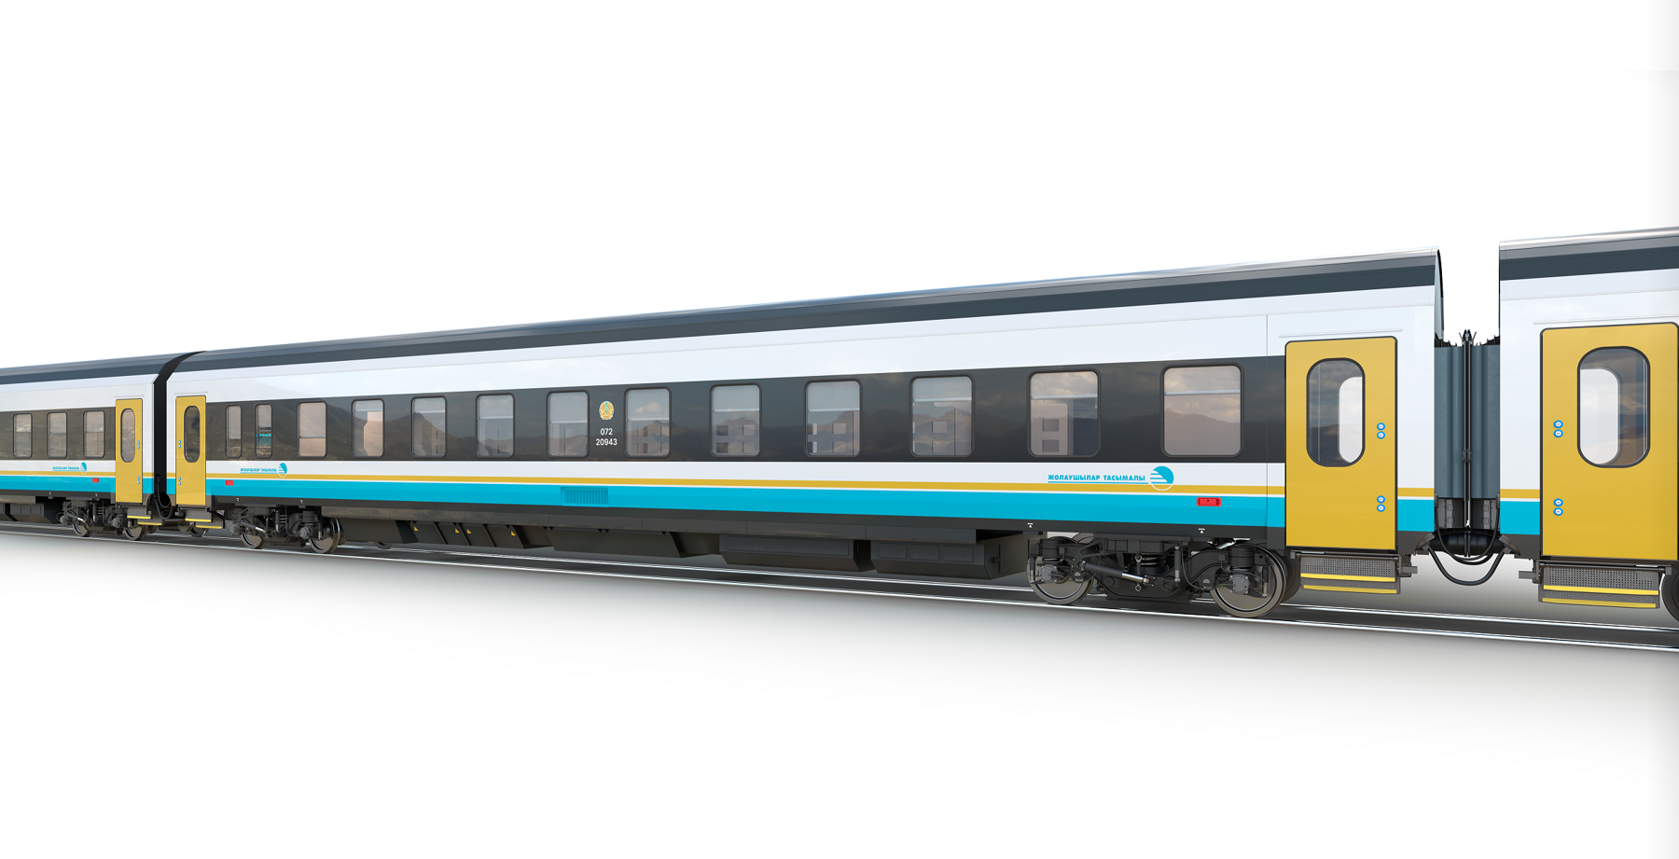
liebherr-stadler-ktz-copyright-stadler-rail-group.jpg
Liebherr supplies a total of 550 HVAC systems for Stadler sleeper and couchette passenger cars. - © Stadler Rail Group

Contact person
Ute Braam
Head of Corporate Communications
Phone: +49 8381 / 46-4403
E-mail: ute.braam@liebherr.com
Published by
Liebherr Aerospace & Transportation SAS
Toulouse / France
www.liebherr.com

