Press release

Liebherr delivers BHP’s first electric excavator

⸺

* **Earlier this year, Liebherr-Australia delivered an R 9400 E excavator to BHP’s Yandi mine in Western Australia – the first electric excavator in BHP’s fleet.**
* **The R 9400 E has also been equipped with Liebherr’s autonomous cable reel system to ensure optimal mobility of the excavator on site.**
* **The commissioning of this excavator is an important milestone in the collaborative working relationship between the two companies that has spanned 20 years.**

**At the beginning of 2024, Liebherr-Australia commissioned an R 9400 E 400-tonne class electric excavator for BHP at its Western Australia Iron Ore Yandi mine. This excavator is the first electric excavator in BHP’s worldwide fleet.**

Adelaide (Australia), 22 August 2024 – Liebherr-Australia and BHP recently celebrated the commissioning of the first electric excavator to join the BHP fleet: an R 9400E. The 400-tonne class backhoe excavator was delivered to BHP’s Western Australia Iron Ore Yandi mine, located in Western Australia’s Pilbara region.

This R 9400 E is also equipped with Liebherr’s cable reel – an autonomous cable management solution for Liebherr’s electric excavators that offers improved machine manoeuvrability and operator safety. Due to the dynamic and versatile nature of iron ore mining compared to traditional cable electric excavator applications, the added mobility offered by the cable reel will help maintain optimal productivity during operation.

‘Liebherr, as a company, has more than 40 years’ experience in the development and manufacturing of electric excavators, so electrification is part of our DNA,’ says Brian Boitano, executive general manager, sales and marketing, Liebherr-Australia. ‘In fact, we are excited to be expanding the reach of this technology into the Australian market. We’ve had multiple orders for electric excavators this year, with several electric excavators on our order books for 2024 and 2025.’

**Partner for success**

For two decades, Liebherr and BHP have enjoyed a strong and successful partnership based on shared values of safety, innovation and a commitment to delivering high-quality solutions that drive the mining industry forward.

‘The R9400 E is a testament to Liebherr’s dedication to providing innovative and efficient zero emission solutions for the mining sector. We are thrilled to partner with BHP to introduce our proven electric excavators into their operations,’ continues Boitano.

This milestone highlights Liebherr's role as a trusted partner and solutions provider within the mining sector. Liebherr’s ability to offer proven zero emission solutions – such as its range of electric excavators – to its customers is vital as the industry moves rapidly towards zero emissions.

‘We’ve set ourselves a clear goal to hit net zero operational greenhouse gas emissions by 2050,’ says Tim Day, asset president, Western Australia Iron Ore. ‘In order to get there, we’re working to electrify most of our mining fleet that currently runs on diesel. Having BHP's first electric excavator at Yandi is exciting and the trial is another step forward on our pathway to net zero. Liebherr is a great company and a great partner, and we are delighted to be working with them on such an important project.’

About the Liebherr Group

The Liebherr Group is a family-run technology company with a highly diversified product programme. The company is one of the largest construction equipment manufacturers in the world. It also provides high-quality, user-oriented products and services in a wide range of other areas. The Liebherr Group includes over 150 companies across all continents. In 2023, it employed more than 50,000 staff and achieved combined revenues of over 14 billion euros. Liebherr was founded by Hans Liebherr in 1949 in the southern German town of Kirchdorf an der Iller. Since then, the employees have been pursuing the goal of achieving continuous technological innovation and bringing industry-leading solutions to its customers. Under the slogan ‘75 years of moving forward’, the Group celebrates its 75th anniversary in 2024.

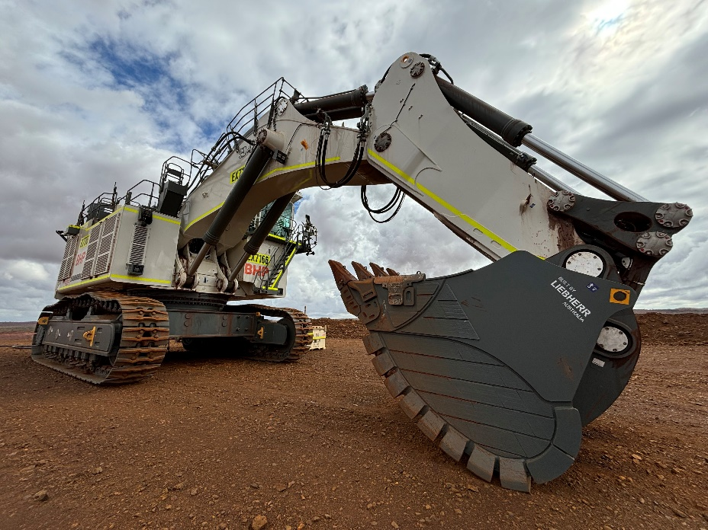Images

liebherr-BHP-R9400E-closeup-72dpi.jpg  
The first electric excavator in BHP’s worldwide fleet: the R9400E.

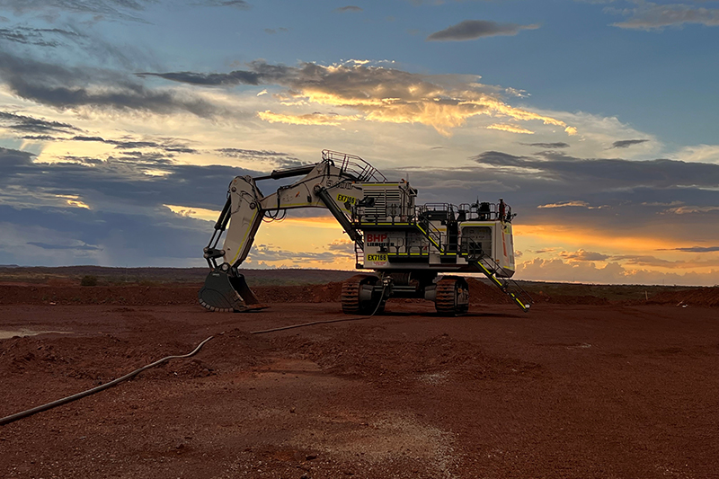

liebherr-BHP-R9400E-72dpi.jpg  
The R9400E is equipped with Liebherr’s cable reel solution for increased mobility on site.

Contact

Juan Lorenzo   
National Sales & Marketing Manager   
Phone: +61 7 3034 8814  
E-mail: [juan.lorenzo@liebherr.com](mailto:juan.lorenzo@liebherr.com)

Published by

Liebherr-Australia Pty. Ltd  
Adelaide / Australia  
www.liebherr.com