Press release

Tandem hoist on cellar ceiling: Haslach installs giant prestressed concrete trusses

⸺

Liebherr LTM 1230-5.1 and LTM 1300-6.3 from Haslach install prestressed concrete trusses

Prestressed concrete trusses weighing just under 100 tonnes and measuring 42 metres in length

LTM 1300-6.3 operates on a hall floor with cellar underneath

Haslach achieved successful deployment with a lot of planning: several prestressed concrete trusses weighing just under 100 tonnes were installed in the Austrian town of Bludenz for the construction of a new hall at the Getzner textile factory. The hall floor with full cellar running underneath and the limited footprint made the deployment a considerable challenge.

Ehingen (Danube) (Germany), 27. August 2024 – Heads were spinning during the planning: the objective was to install ten prestressed concrete trusses, each weighing 98 tonnes, for the roof in a hall that had a cellar running underneath. The hall floor's support load was limited, and space was also very restricted. Getzner's deliveries also had to continue uninterrupted. Tobias Haslach, owner of Kranverleih Haslach GmbH, recalls: “After extensive planning and many detailed calculations, we were able to come up with a solution for the installation work in conjunction with the other companies involved. We stabilised the cellar ceiling from underneath with ceiling supports in order to achieve the support strength required to allow our LTM 1300-6.3 to work on this cellar ceiling.” Alongside the 6-axle mobile crane, the special transport also drove onto the cellar ceiling to unload the 98-tonne concrete truss.

Haslach used an LTM 1230-5.1 as the second crane for the tandem hoist. Tobias Haslach recounts the challenges: “We set up the 5-axle vehicle on a specially filled embankment outside the hall. Due to the positioning behind a concrete wall, we were only able to coordinate with the work team via radiotelephony. The truss also had to be guided around the LTM 1300-6.3.” When lifting the truss from the truck, both mobile cranes were working at maximum capacity with a load of 51 tonnes each and a radius of 13 metres and 15 metres respectively. Two reinforced concrete trusses were installed in one day. With a length of 47.3 metres and a total weight of 148 tonnes, the transport required a special permit and was only allowed to travel at night. After each installation, both mobile cranes were moved with all their equipment including ballast and positioned for the lifting of the subsequent reinforced concrete trusses.

“The cooperation on the construction site was excellent. Operations at the Getzner textile factory continued virtually undisturbed. Our two crane operators were also delighted with the collaboration of everyone involved on site,” says Tobias Haslach. The family-run company Kranverleih Haslach is based in Wertach in southern Germany and relies entirely on Liebherr for its nine mobile cranes.

**About Liebherr-Werk Ehingen GmbH**

Liebherr-Werk Ehingen GmbH is a leading manufacturer of mobile and crawler cranes. Its range of mobile cranes extends from 2-axle 35 tonne cranes to heavy duty cranes with a lifting capacity of 1200 tonnes and a 9-axle chassis. Its lattice boom cranes on mobile or crawler travel gear deliver lifting capacities of up to 3000 tonnes. With universal boom systems and extensive auxiliary equipment, they can be seen in action on construction sites throughout the world. The Ehingen site has a workforce of 5,000. An extensive, global service network guarantees the high availability of Liebherr mobile and crawler cranes. In 2023, the Liebherr plant in Ehingen recorded a turnover of 2.81 billion euros.

About the Liebherr Group – 75 years of moving forward

The Liebherr Group is a family-run technology company with a highly diversified product programme. The company is one of the largest construction equipment manufacturers in the world. It also provides high-quality, user-oriented products and services in a wide range of other areas. The Liebherr Group includes over 150 companies across all continents. In 2023, it employed more than 50,000 staff and achieved combined revenues of over 14 billion euros. Liebherr was founded by Hans Liebherr in 1949 in the southern German town of Kirchdorf an der Iller. Since then, the employees have been pursuing the goal of achieving continuous technological innovation, and bringing industry-leading solutions to its customers. Under the slogan ‘75 years of moving forward’, the Group celebrates its 75th anniversary in 2024.

Images

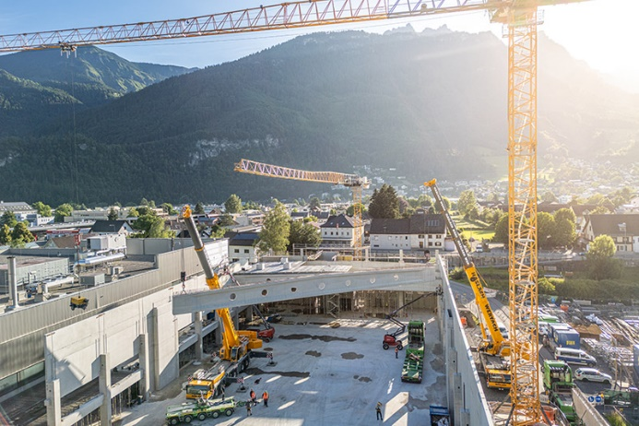

liebherr-ltm1300-6-3-haslach-01.jpg

The Vorarlberg Alps as a backdrop, framed by a Liebherr tower crane: two Liebherr mobile cranes from Kranverleih Haslach erected a total of ten prestressed concrete trusses for the construction of a new hall in Bludenz. The hall floor with cellar made the job a challenge.

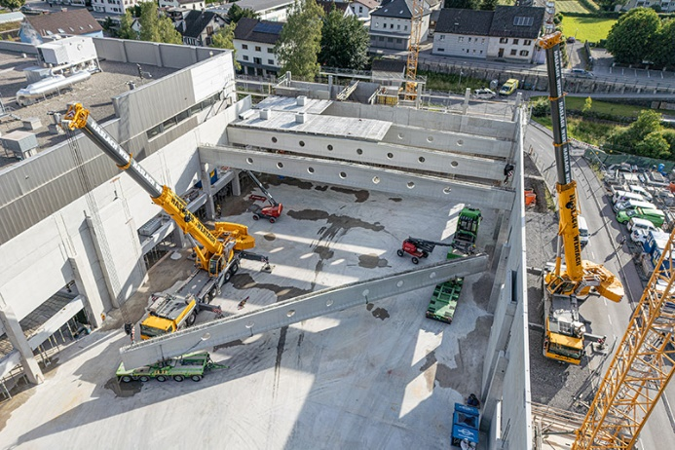  
liebherr-ltm1300-6-3-haslach-02.jpg

In tandem, a Liebherr LTM 1230-5.1 and an LTM 1300-6.3 shared the weight of the prestressed concrete truss – almost 100 tonnes.

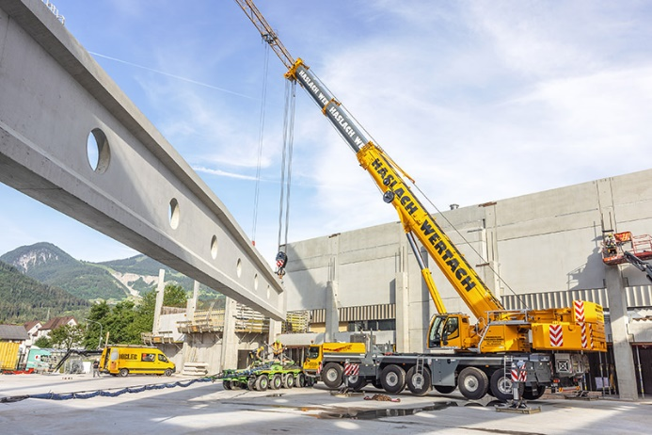

liebherr-ltm1300-6-3-haslach-03.jpg

When lifting the 42-metre-long truss from the truck, both mobile cranes were at maximum capacity with a load of 51 tonnes each.

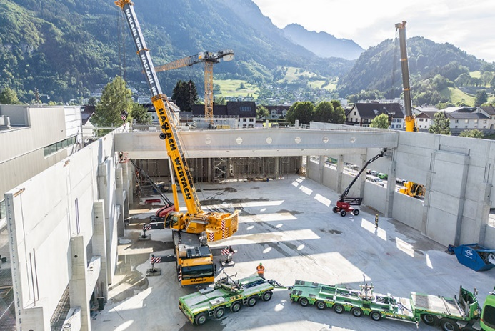

liebherr-ltm1300-6-3-haslach-04.jpg

Poor visibility: the LTM 1230-5.1 had to be positioned behind a wall. The coordination via radio worked smoothly.

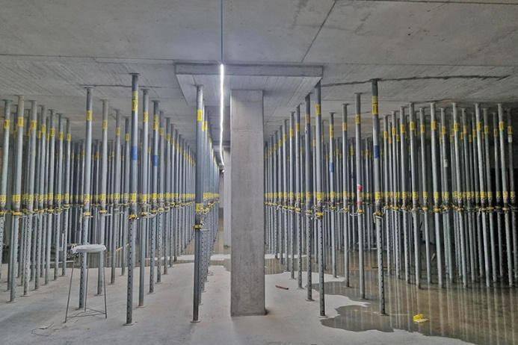

liebherr-ltm1300-6-3-haslach-05.jpg

Well supported: the hall floor had cellar running all the way underneath it and was stabilised with ceiling supports after thorough testing and many calculations.

**Contact**

Wolfgang BeringerMarketing and CommunicationPhone: +49 7391/502 - 3663Email: wolfgang.beringer@liebherr.com

**Published by**

Liebherr-Werk Ehingen GmbHEhingen (Donau) / Germanywww.liebherr.com