Press release

“Just a bike trip away!”: an unusual journey to the Liebherr production sites in Europe

⸺

Liebherr Europe Tour 2024: an unusual project that connects people

2,400 km by bike across Europe

Liebherr, SOMTP Bretagne and Liziard have been working together since 2020

Loïc Flochlay, commercial manager at the Liebherr authorized dealer, SOMTP Bretagne and Alexandre Leroux, managing director of Liziard, a company based in the French Department of Finistère, realised an extraordinary idea last May. The two men travelled by bike from Quimper in the far west of Brittany across half of Europe to Vienna in eight days. They visited various Liebherr production sites on their 2,400 km trip. They christened their exciting project the Liebherr Europe Tour 2024.

Colmar (France), 29 July 2024 − When the French company, Liziard wanted to procure a new crawler dozer from Liebherr at the start of 2024, Loïc Flochlay, the commercial manager at the Liebherr authorized dealer, SOMTP Bretagne, noted the proximity of the Liebherr production site for crawler dozers in Austria. Loïc Flochlay said that the factory, along with the Liebherr production sites in other European countries, was so close to customers that you could get there by bike. Alexandre Leroux, the managing director at Liziard, ultimately decided to purchase a crawler dozer from Liebherr. And he took Flochlay at his word. That gave rise to the idea to cross Europe by bike and to visit some of the sites for the earthmoving machinery production segment. Thus, the idea for the Liebherr Europe Tour 2024 was born and project planning could get started.

**Impressive sporting performance underlines the geographical proximity and partnership**

Alexandre Leroux and Loïc Flochlay decided to visit three Liebherr production sites by bike and therefore to cross half of Europe. The two men went off on their adventure in the week of 31st May to 7th June 2024. They visited Liebherr-France SAS in Colmar, where Liebherr produces its crawler excavators and then the Liebherr plant in Telfs in Austria, which builds crawler dozers for the Liebherr Group. Alexandre and Loïc’s route also passed the Austrian site in Bischofshofen, where Liebherr produces wheel loaders.

The Liebherr Europe Tour 2024 covered a total distance of 2,400 km. The trip from Quimper to Vienna was divided into eight stages. Each stage was around 300 km long and required height differences of up to 4,000 metres to be overcome. Along with the impressive sporting performance, the Liebherr Europe Tour 2024 highlighted the geographical proximity of the Liebherr production sites in Europe.

**Cooperation shaped by trust and production sites**

The cooperation between Liziard with its headquarters in Brittany and Liebherr with its local Liebherr authorized dealer, SOMTP Bretagne started during the pandemic. It mainly arose from the desire of the Breton company to cooperate with local companies that manufacture their machines in France and Europe. The SME from Brittany renewed its machine fleet with an R 926 Compact crawler excavator and two A 913 Compact wheeled excavators, and procured an R 914 Compact crawler excavator and a type L 556 XPower wheel loader.

**Liziard − an SME with numerous competencies**

Liziard, with its headquarters are in the Department of Finistère in Brittany, was founded in 1937. The SME employs around 100 people. It specialises in performing building and restoration work, structural and civil engineering, as well as asbestos removal and demolition work. Sustainable development takes high priority at the company.

About Liebherr-France SAS

Liebherr-France SAS, founded in 1961, is responsible for the development and production of crawler excavators for the Liebherr group of companies in Colmar, France. The current product range includes around 30 crawler excavator models, from the R 914 Compact to the R 998 SME, for use in earthworks and quarries. Its products also include a range of special equipment for specific tasks such as demolition, material handling and maritime/tunnel applications, as well as large-capacity electric excavators. Crawler excavators with an operating weight of 14 to 100 tonnes are equipped with Liebherr engines with an output of 90 to 420 kW. Liebherr-France SAS employs more than 1,260 people and generates a turnover of 605 million euros.

About the Liebherr Group

The Liebherr Group is a family owned technology company with a broadly diversified product range. The company is one of the largest manufacturers of construction machinery in the world. However, it also offers high-quality, user-oriented products and services in many other areas. Today, the group comprises more than 150 companies on all continents. In 2023, it employed more than 50,000 people and generated a total consolidated turnover of over 14 billion euros. Liebherr was founded in 1949 in Kirchdorf an der Iller in southern Germany. Since then, the employees have pursued the goal of convincing their customers with sophisticated solutions and contributing to technological progress. Under the slogan “75 years of moving forward”, the Group celebrates its 75th anniversary in 2024.

**Images**

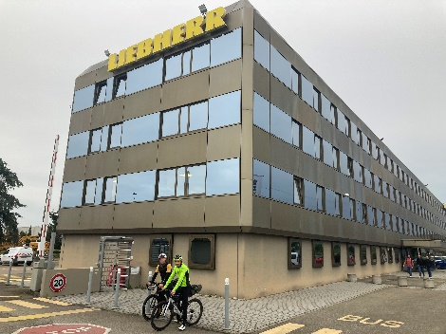

Liebherr-Europe-Tour-2024-1.jpg  
Managing director Alexandre Leroux took Loïc Flochlay from Liebherr at his word: They visited the Liebherr production sites by bike together. The image shows the two of them in front of the Liebherr-France SAS plant that manufactures crawler excavators.

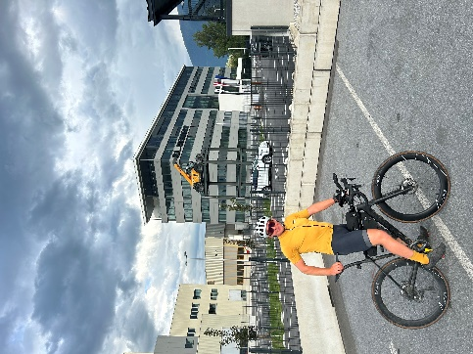

Liebherr-Europe-Tour-2024-2.jpg  
Next stop: the Liebherr plant in Telfs in Austria. Liebherr produces crawler dozers, crawler loaders, telescopic handlers and pipe-laying tools at this site.

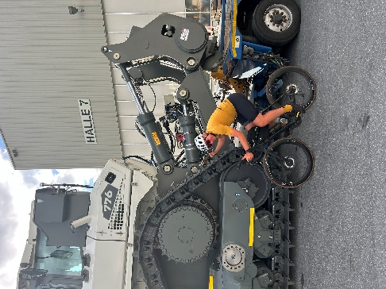

Liebherr-Europe-Tour-2024-3.jpg  
Alexandre Leroux poses in front of a crawler dozer manufactured by Liebherr-Werk Telfs GmbH in Austria.

Contact

Alban Villaumé  
Marketing and communication  
Telephone: +33 3 89 21 36 09  
E-mail: alban.villaume@liebherr.com

Published by

Liebherr-France SAS   
Colmar, France  
www.liebherr.com