Press release

For easier city access and even higher lifts: Comlev takes delivery of Liebherr LTM 1120-4.1

⸺
French lifting and transport company adds new Liebherr mobile crane to its fleet
Comlev: technology and customer service were important purchasing criteria
66-metre-long boom and 120-tonne load capacity
The French company ALKALINE has taken delivery of a new Liebherr crane. As the second largest crane in the fleet of its subsidiary Comlev, the LTM 1120-4.1 impresses with its mobility, flexibility and compact dimensions.
Ehingen (Donau) (Germany), 16 September 2024 – Comlev is expanding its fleet with a new Liebherr mobile crane, thereby increasing efficiency even in confined spaces. Now the company is not only ideally equipped for current tasks, but will also be able to tackle even more challenging projects in the future. “With a compact four-axle machine like the LTM 1120-4.1, we will have easier access to urban construction sites moving forward,” explain Karine and Laurent Lucas, the managing owners. This is ensured by the mechanically adjustable VarioBallast®, which allows the counter ballast radius to be reduced from 4.77 to 3.83 metres, for example. The Liebherr crane is also equipped with the proven VarioBase® technology, which increases safety during crane operations, especially in confined spaces. In addition, the 120-tonne machine offers higher lifting capacities and a larger working area when its support base is at the maximum setting. Added to this is its low total weight of 48 tonnes – the newly acquired mobile crane is road-ready with an axle load of twelve tonnes. “This means it can tackle jobs which would normally require a five-axle crane, with all the logistics work that involves. “All in all, the LTM 1120-4.1 gives us more flexibility and lower transport costs,” says Karine happily.
With its long 66-metre telescopic boom, the LTM 1120-4.1 can reach a lifting height of 64 metres in the upright position. The mobile crane is also equipped with the Telematik fast-cycle telescoping system to quickly and automatically raise the boom to the required length and achieve the highest possible lifting capacities.
Second-largest crane for industrial and urban applications
Comlev was founded over 40 years ago in response to growing demand in the material handling, lifting and industrial sectors in the Amiens region. Since then, the company’s growth has seen it open up additional business areas: it is now also active in the areas of working platforms and storage. Today, Comlev employs 16 people, including eleven crane drivers who are deployed on around 1,100 construction sites every year.
Comlev now has a total of six machines for lifting jobs. The new 120-tonne Liebherr crane is the second largest in its fleet and will be used primarily in industry and on urban construction sites. “In addition to their technology and excellent customer service, we value Liebherr’s reliability and professionalism – that’s why we opted for another Liebherr crane,” says Laurent.
About Liebherr-Werk Ehingen GmbH
Liebherr-Werk Ehingen GmbH is a leading manufacturer of mobile and crawler cranes. Its range of mobile cranes extends from 2-axle 35 tonne cranes to heavy duty cranes with a lifting capacity of 1200 tonnes and a 9-axle chassis. Its lattice boom cranes on mobile or crawler travel gear deliver lifting capacities of up to 3000 tonnes. With universal boom systems and extensive auxiliary equipment, they can be seen in action on construction sites throughout the world. The Ehingen site has a workforce of 5,000. An extensive, global service network guarantees the high availability of Liebherr mobile and crawler cranes. In 2023, the Liebherr plant in Ehingen recorded a turnover of 2.81 billion euros.
About the Liebherr Group – 75 years of moving forward
The Liebherr Group is a family-run technology company with a highly diversified product programme. The company is one of the largest construction equipment manufacturers in the world. It also provides high-quality, user-oriented products and services in a wide range of other areas. The Liebherr Group includes over 150 companies across all continents. In 2023, it employed more than 50,000 staff and achieved combined revenues of over 14 billion euros. Liebherr was founded by Hans Liebherr in 1949 in the southern German town of Kirchdorf an der Iller. Since then, the employees have been pursuing the goal of achieving continuous technological innovation, and bringing industry-leading solutions to its customers. Under the slogan ‘75 years of moving forward’, the Group celebrates its 75th anniversary in 2024.
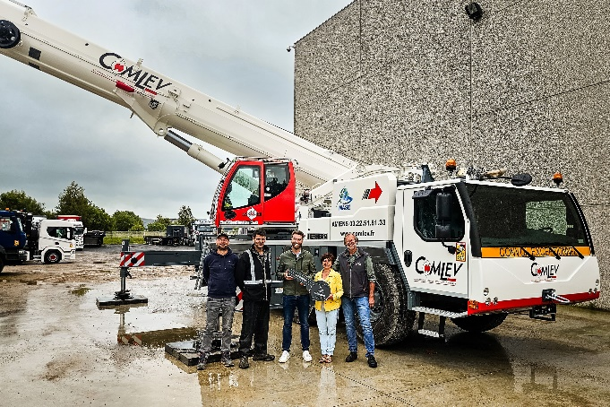
Image

liebherr-LTM-1120-4-1-comlev.jpg
A new mobile crane joins the Comlev fleet: Guillaume Gaeng from Liebherr (centre) hands over the LTM 1120-4.1 to Karine and Laurent Lucas (right), with crane driver Kevin and fitter Edgar (from left to right)
Contact
Berenike Nordmann
Marketing and Communication
Phone: +49 7391 / 502-0
Email: berenike.nordmann@liebherr.com

Published by
Liebherr-Werk Ehingen GmbH
Ehingen (Donau) / Germany
www.liebherr.com

