Press release

Liebherr maintains HVAC systems for Toronto Rocket Subway fleet

⸺
Energy savings despite high cooling capacity thanks to cleaned and maintained components
Regular inspections and customer tailored maintenance help to identify and rectify potential problems at an early stage before they lead to costly breakdowns or repairs
Liebherr has once again been contracted by the Toronto Transit Commission to maintain 40 HVAC systems. The preventive services are carried out as part of a maintenance program and ensure sustained operation of the units.
Korneuburg (Austria), September 2024 – Liebherr-Transportation Systems wins another contract for the maintenance of HVAC systems installed in the Toronto Rocket subway trains from Alstom. They have been operated by the Toronto Transit Commission (TTC) since 2008.
Following the successful completion of maintenance last year, the new contract includes the maintenance and inspection of an additional 40 passenger compartment air-conditioning systems from March 2024 until March 2025. They will be preventively maintained and technically inspected by qualified Liebherr service technicians at Liebherr-Canada Ltd. in Burlington (Canada). The customer tailored service for the HVAC systems enables both the highest possible availability of the vehicles and a high level of comfort for the passengers.
"We are proud that we have once again been able to gain the trust of our customer," says Wolfgang Boettcher, Head of Customer Support at Liebherr-Transportation Systems in Korneuburg (Austria). "This follow-up order confirms our high service quality and the expertise of our highly qualified employees. We look forward to continuing our successful collaboration and making an important contribution to the energy efficiency of our customer’s subway vehicles."
This follow-up order includes extensive inspections, cleaning the systems, checking and replacing worn parts and those that are subject to the preventive actions in the maintenance manual as well as ensuring the efficient and trouble-free operation of the HVAC units. This not only helps to extend the products’ life span, but also to reduce operating costs and improve the air quality in the passenger compartments.

About Liebherr-Aerospace & Transportation
Liebherr-Aerospace & Transportation SAS, headquartered in Toulouse (France), is one of 13 product segments of the Liebherr Group and a first-tier provider of on-board solutions in the aerospace and transportation industry, contributing to a more sustainable transport through innovative products, best in class services and performance excellence.
The aerospace product portfolio offered to civil and defense customers includes environmental control and thermal management systems, flight control and actuation systems, landing gears as well as on-board electronics. For rail vehicles of all kinds Liebherr offers heating, ventilation and air conditioning systems, passive and active hydraulic systems for braking, damping, axle steering and levelling. Furthermore, Liebherr serves the commercial vehicle market with trailer cooling systems.
About the Liebherr Group – 75 years of moving forward
The Liebherr Group is a family-run technology company with a highly diversified product programme. The company is one of the largest construction equipment manufacturers in the world. It also provides high-quality, user-oriented products and services in a wide range of other areas. The Liebherr Group includes over 150 companies across all continents. In 2023, it employed more than 50,000 staff and achieved combined revenues of over 14 billion euros. Liebherr was founded by Hans Liebherr in 1949 in the southern German town of Kirchdorf an der Iller. Since then, the employees have been pursuing the goal of achieving continuous technological innovation and bringing industry-leading solutions to its customers. Under the slogan ‘75 years of moving forward’, the Group celebrates its 75th anniversary in 2024.

Image
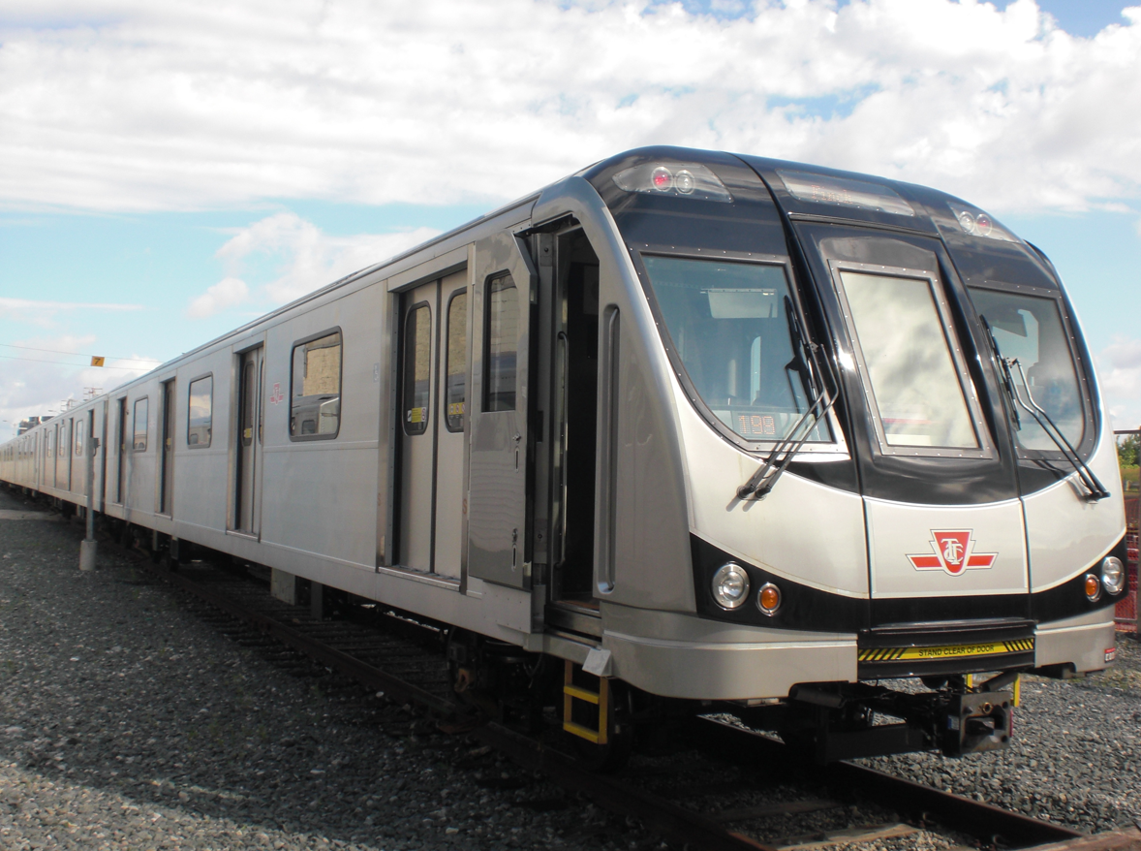
liebherr-toronto-rocket-subway-fleet-copyright-liebherr.jpg
Liebherr-Transportation Systems has once again been contracted to maintain 40 HVAC systems on the Toronto Rocket Subway fleet. - © Liebherr

Contact
Ute Braam
Head of Corporate Communication
Phone: +49 8381 / 46 - 4403
E-mail: ute.braam@liebherr.com
Published by
Liebherr-Aerospace & Transportation SAS
Toulouse / France
www.liebherr.com

