Press release

Liebherr’s mobile construction crane range is expanding

⸺
MK 120-5.1 now available to order
Compact size, maximum power: agile five-axle model with 52-metre radius and jib head lifting capacity of 2,100 kilograms
New display and optional smaller load hook available
The MK 120-5.1 is the latest addition to Liebherr’s mobile construction crane range. The five-axle machine bridges the gap between the MK 88-4.1 and the MK 140-5.1. Alongside plenty of lifting power, it features a new display and an optional smaller load hook for working in confined spaces.
Biberach (Riß) (Germany), 18 September 2024 – With a jib measuring in at 52 metres and a maximum lifting capacity of 2,100 kilograms at its jib head, the new MK 120-5.1 delivers impressive performance. The crane marks an expansion of Liebherr’s existing MK portfolio and bridges the gap between the MK 88-4.1 and the MK 140-5.1. One of the mobile construction crane’s key advantages is its agility; its small turning circle facilitates site access via narrow streets and intersections.
The new crane is based on the established MK 140-5.1. Crane operators who know how to operate this model can work with the new one without extensive additional training.
New crane, new display
The MK 120-5.1 is equipped with the new Liebherr TC-OS display. The TC-OS (Tower Crane Operating System) user interface focuses on ease of use and flexible customisation by the crane operator. Its 12-inch touch display can be used in split and full screen mode. This means that diverse information can be displayed across different screen areas. The display is set to replace the existing version in all mobile construction cranes by the end of 2025.
Smaller load hook for optimal load positioning
The MK 120-5.1 can be ordered with an optional smaller load hook. This version really comes into its own on sites with existing buildings where scaffolding is in place and the load has to be moved between the building and the scaffolding. It only takes a few minutes to change the load hook on site. The smaller load hook can handle the same lifting capacity as its large counterpart and will soon be available for all Liebherr mobile construction cranes.

“Exactly the right crane for our fleet”
The first customers are already full of praise for the latest addition to Liebherr’s mobile construction crane range. “The MK 120-5.1 is exactly the right crane for our fleet. Its jib length and lifting capacity make it ideal for our customers’ construction sites,” says Stephan Zaugg, Managing Director at Zaugg AG Rohrbach (Switzerland). “We are excited to be the first ever customer to acquire the new MK. Reliability, customer service and the great reputation of Liebherr’s mobile construction cranes were deciding factors for our purchase.” A company from Belgium has also already put in an order for the MK 120-5.1. Deliveries will start in summer 2025.
About the Liebherr Tower Cranes Division
More than seven decades of experience have made Liebherr a recognised specialist for lifting technology on all types of construction sites. The range of Liebherr Tower Cranes encompasses an extensive selection of high-quality tower cranes that are used worldwide. This includes fast-erecting, top-slewing, luffing jib and special-purpose cranes as well as mobile construction cranes. In addition to these products, Liebherr also offers a wide range of services that complete the company’s portfolio: Tower Crane Solutions, the Tower Crane Center and Tower Crane Customer Service.
About the Liebherr Group – 75 years of moving forward
The Liebherr Group is a family-run technology company with a widely diversified product programme. The company is one of the largest construction equipment manufacturers in the world. It also provides high-quality, user-oriented products and services in a wide range of other areas. The Liebherr Group includes over 150 companies across all continents. In 2023, it employed more than 50,000 staff and achieved combined revenues of over 14 billion euros. Liebherr was founded by Hans Liebherr in 1949 in the southern German town of Kirchdorf an der Iller. Since then, employees have been pursuing the goal of achieving continuous technological innovation, and bringing industry-leading solutions to its customers. Under the slogan ‘75 years of moving forward’, the Group celebrates its 75th anniversary in 2024.
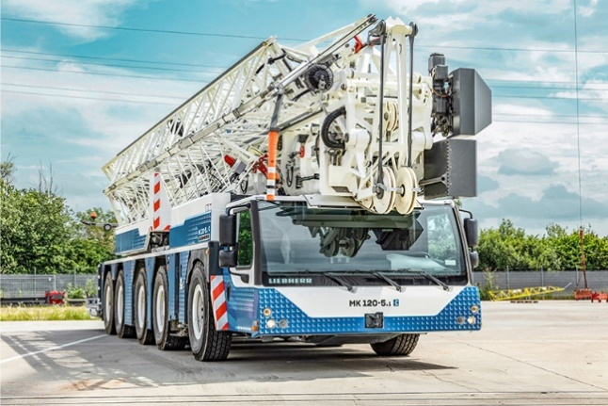
Images

liebherr-mk-120-5-1-01.jpg
Liebherr’s range of mobile construction cranes is expanding: the MK 120-5.1 is capable of lifting up to 2,100 kilograms at the jib head.

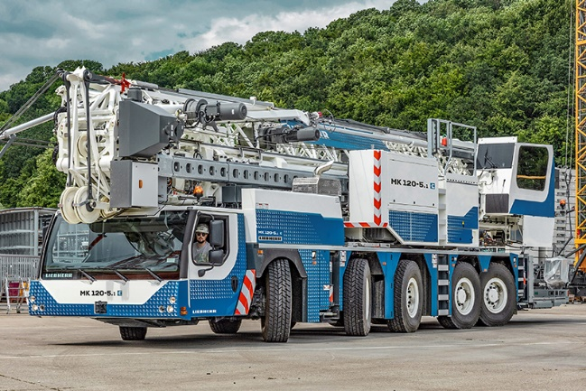

liebherr-mk-120-5-1-02.jpg
The five-axle crane is a perfect fit for the tried-and-tested taxi crane concept and can cover several sites in one day.

Contact
Astrid Kuzia
Communication Specialist
Phone: +49 7351 / 41 – 4044
Email: astrid.kuzia@liebherr.com
Published by
Liebherr-Werk Biberach GmbH
Biberach / Germany
www.liebherr.com

