Press release

S.A.S Group expands Liebherr crane fleet with LTM 1300-6.3 and LTM 1100-5.3

⸺
Two mobile cranes for Italian customer
Simply convincing – 100-tonne narrow track crane and 300-tonne model with impressive hoist height
The S.A.S Group’s fleet now contains more than 15 Liebherr cranes

The S.A.S Group has been a satisfied Liebherr customer for over twenty years. The latest additions to the Liguria-based customer, which has just expanded its Liebherr fleet with an LTM 1100-5.3 and an LTM 1300-6.3, once again include high quality and outstanding technical features.
Ehingen (Donau), (Germany), 20 September 2024 – The S.A.S. Group has expanded its Liebherr fleet with two mobile cranes – an LTM 1300-6.3 and an LTM 1100-5.3. Whilst the 300-tonne crane features compact dimensions and a large boom length, the 100-tonne model’s outstanding characteristics are its vehicle width and axle weight – both of which mean it can be moved between sites more quickly. Both cranes will be used in the petrochemicals, shipbuilding and chemical industries.
LTM 1100-5.3 – powerful lightweight with a narrow gauge
The LTM 1100-5.3 has a powerful 62 metre telescopic boom and can carry up to 16.9 tonnes of ballast on public roads with an axle load of just twelve tonnes. The consistent use of lightweight materials and sticking firmly to a vehicle width of just 2.55 metres means that the crane is economically mobile worldwide – it has an axle load of just nine tonnes and is flexible both on the road and on constricted sites. The crane features all the innovations from recent years, including VarioBallast®– and it is the second crane model with the new LICCON3 control.
LTM 1300-6.3 – 300-tonne crane delivering an enormous hoist height
A powerful fast-erecting crane, the LTM 1300-6.3 is the first 6-axle crane in the world to carry a 90-metre telescopic boom with an axle load of twelve tonnes. The chassis is particularly lightweight, which means that load-bearing parts have been reinforced and the boom extended. VarioBase®Plus ensures that a wide range of support options are possible. Other features, such as VarioBallast®, AutoBallast and Windspeed Load Charts round off the equipment package on the 300-tonne crane. Overall, they make it ideal for erecting tower cranes and servicing wind turbines. Thanks to its great compatibility with other Liebherr crane models, parts of the ballast, the detachable hook block and various lattice sections are interchangeable.
S.A.S Group – a loyal customer for over 20 years
“Liebherr is a global leader in its industry and is synonymous with value, image and quality. That is why we have been working with Liebherr for more than twenty years. Our fleet, which comprises more than 1000 vehicles, now includes more than 15 Liebherr cranes.”
The S.A.S. Group was founded in Novi Ligure in northern Italy, where its headquarters have been located for over 35 years. The company has experience in chemicals and petrochemicals, shipbuilding and construction. The S.A.S Group currently has a workforce of around 60 people and has an extremely modern fleet with the latest generation of green vehicles, including cranes, lifting platforms, telescopic loaders and vans.
About S.A.S. Group
The organisation has a quality management system certified to ISO 9001:15 and a safety management system certified to ISO 45001:18, which demonstrates the reliability and effectiveness of its operational processes, which are geared towards maximum customer satisfaction. At the same time, a process digitalisation project is currently underway to computerise the entire organisation in order to further increase the accuracy and efficiency of processes and offer customers a highly professional and competitive overall service. As further proof of reliable business relationships and as an important criterion in the so-called “rating della legalità”, the company has introduced the “Modello Organizzativo” in accordance with Legislative Decree 231/01.
About Liebherr-Werk Ehingen GmbH
Liebherr-Werk Ehingen GmbH is a leading manufacturer of mobile and crawler cranes. Its range of mobile cranes extends from 2-axle 35 tonne cranes to heavy duty cranes with a lifting capacity of 1200 tonnes and a 9-axle chassis. Its lattice boom cranes on mobile or crawler travel gear deliver lifting capacities of up to 3000 tonnes. With universal boom systems and extensive additional equipment, they can be seen in action on construction sites throughout the world. The Ehingen site has a workforce of 5,000. An extensive, global service network guarantees the high availability of Liebherr mobile and crawler cranes. In 2023, the Liebherr plant in Ehingen recorded a turnover of 2.81 billion euros.
About the Liebherr Group – 75 years of moving forward
The Liebherr Group is a family-run technology company with a highly diversified product programme. The company is one of the largest construction equipment manufacturers in the world. It also provides high-quality, user-oriented products and services in a wide range of other areas. The Liebherr Group includes over 150 companies across all continents. In 2023, it employed more than 50,000 staff and achieved combined revenues of over 14 billion euros. Liebherr was founded by Hans Liebherr in 1949 in the southern German town of Kirchdorf an der Iller. Since then, the employees have been pursuing the goal of achieving continuous technological innovation, and bringing industry-leading solutions to its customers. Under the slogan ‘75 years of moving forward’, the Group celebrates its 75th anniversary in 2024.

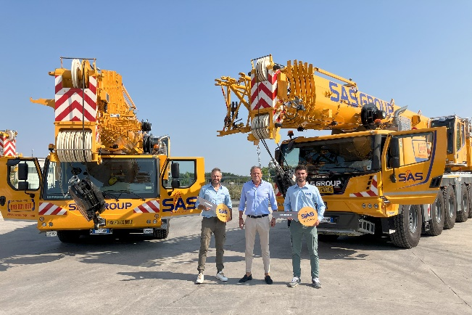
Image

liebherr-ltm-1300-6-3-ltm-1100-5-3-sas-group.jpg
The S.A.S Group takes delivery of two new Liebherr cranes - an LTM 1300-6.3 and an LTM 1100-5.3: Technical Manager Giacomo Torre, Managing Director Alessandro Carino and Alessandro Guido, responsible for the rental business (from right to left).

Contact
Berenike Nordmann
Marketing and Communication
Phone: +49 7391 / 502-0
Email: berenike.nordmann@liebherr.com
Published by
Liebherr-Werk Ehingen GmbH
Ehingen (Donau) / Germany
www.liebherr.com

