Press release

Modern cranes for Mexico: Magruber counts on Liebherr

⸺

Magruber relies on modern mobile cranes from Liebherr

Liebherr stands for quality and customer service

Local Liebherr subsidiary provides on-site support in Mexico

Over the past two years, the Mexican crane company Magruber has acquired six new mobile cranes from Liebherr. With lifting capacities ranging between 120 and 230 tonnes, these versatile and powerful cranes are perfectly suited for a variety of tasks in Mexico City, where the company is headquartered. Based on its positive experience, Magruber has now ordered a larger crane, which will join the fleet as its new flagship by the end of 2024. Alongside product quality, Magruber's strong and dependable partnership with Liebherr has been a key factor in their purchasing decisions.

Ehingen (Donau), Germany, 24. September 2024 – Magruber is a rapidly growing company that aims to serve the local crane market in Mexico City with high-quality and modern mobile cranes. It currently operates a fleet of twelve medium-sized mobile cranes, including three recently delivered LTM 1120-4.1 models, one LTM 1150-5.3, one LTM 1160-5.2 and a 230-tonne LTM 1230-5.1. A newly ordered large crane will soon further enhance the company’s capabilities. These investments underscore Magruber’s commitment to providing a powerful fleet that aligns with the latest technological advancements. The company's owner Salvador Berumen explains: "Our cranes have an average age of three years, reflecting both their high technical standard and performance. We operate the youngest crane fleet in Mexico City."

Magruber has deliberately chosen to work with Liebherr cranes, as Berumen highlights: "Liebherr is our preferred brand because it delivers outstanding product quality and first-class support, both during the purchasing process and in terms of after-sales service. Liebherr offers a complete service and always finds the right solutions." Magruber's point of contact is the local branch, Liebherr Mexico, S. de R.L. de C.V., based in Mexico City. The team there offers expertise in the local operating conditions, providing comprehensive support to crane operators, as well as reliable service. The partnership between the two companies is built on trust and mutual cooperation.

Salvador Berumen adds: "When selecting new cranes, we focused not only on lifting capacities and boom lengths, but also on compact dimensions. VarioBase® and VarioBallast® are crucial features for us, as they make it easier to manage numerous jobs in tight and complex work environments." Magruber ordered all its new cranes with a double folding jib to ensure added flexibility. The cranes are used for a wide range of lifting tasks in industrial and infrastructure projects across Mexico City.

**About Liebherr-Werk Ehingen GmbH**

Liebherr-Werk Ehingen GmbH is a leading manufacturer of mobile and crawler cranes. Its range of mobile cranes extends from 2-axle 35 tonne cranes to heavy duty cranes with a lifting capacity of 1200 tonnes and a 9-axle chassis. Its lattice boom cranes on mobile or crawler travel gear deliver lifting capacities of up to 3000 tonnes. With universal boom systems and extensive additional equipment, they can be seen in action on construction sites throughout the world. The Ehingen site has a workforce of 5,000. An extensive, global service network guarantees the high availability of Liebherr mobile and crawler cranes. In 2023, the Liebherr plant in Ehingen recorded a turnover of 2.81 billion euros.

**About the Liebherr Group – 75 years of moving forward**

The Liebherr Group is a family-run technology company with a highly diversified product programme. The company is one of the largest construction equipment manufacturers in the world. It also provides high-quality, user-oriented products and services in a wide range of other areas. The Liebherr Group includes over 150 companies across all continents. In 2023, it employed more than 50,000 staff and achieved combined revenues of over 14 billion euros. Liebherr was founded by Hans Liebherr in 1949 in the southern German town of Kirchdorf an der Iller. Since then, the employees have been pursuing the goal of achieving continuous technological innovation, and bringing industry-leading solutions to its customers. Under the slogan ‘75 years of moving forward’, the Group celebrates its 75th anniversary in 2024.

**About Liebherr-Werk Ehingen GmbH**

Liebherr-Werk Ehingen GmbH is a leading manufacturer of mobile and crawler cranes. Its range of mobile cranes extends from 2-axle 35 tonne cranes to heavy duty cranes with a lifting capacity of 1200 tonnes and a 9-axle chassis. Its lattice boom cranes on mobile or crawler travel gear deliver lifting capacities of up to 3000 tonnes. With universal boom systems and extensive additional equipment, they can be seen in action on construction sites throughout the world. The Ehingen site has a workforce of 5,000. An extensive, global service network guarantees the high availability of Liebherr mobile and crawler cranes. In 2023, the Liebherr plant in Ehingen recorded a turnover of 2.81 billion euros.

About the Liebherr Group – 75 years of moving forward

The Liebherr Group is a family-run technology company with a highly diversified product programme. The company is one of the largest construction equipment manufacturers in the world. It also provides high-quality, user-oriented products and services in a wide range of other areas. The Liebherr Group includes over 150 companies across all continents. In 2023, it employed more than 50,000 staff and achieved combined revenues of over 14 billion euros. Liebherr was founded by Hans Liebherr in 1949 in the southern German town of Kirchdorf an der Iller. Since then, the employees have been pursuing the goal of achieving continuous technological innovation, and bringing industry-leading solutions to its customers. Under the slogan ‘75 years of moving forward’, the Group celebrates its 75th anniversary in 2024.

Images

**Ein Bild, das draußen, Himmel, Landfahrzeug, Rad enthält.
**

lwe-magruber-ltm1120-4-1.jpg  
The LTM 1120-4.1 is characterised by its high lifting capacity and long boom. The handover of the first two 120-tonne cranes took place in Mexico (from left to right): Christian Tableros (Liebherr Mexico S. de R.L. de C.V.), Ana Maria Berumen, Salvador Berumen, Elvia Berumen (Magruber) and Salvador Flores (Liebherr Mexico S. de R.L. de C.V.).

**Ein Bild, das Himmel, draußen, Transport, Landfahrzeug enthält.
**

lwe-magruber-ltm1160-5-2-ltm1230-5-1.jpg  
The handover of the two 5-axle cranes, the LTM 1160-5.2 and LTM 1230-5.1 (from left to right): Julio Fuentes (Liebherr Mexico S. de R.L. de C.V.), Elvia Berumen, Ana Maria Berumen (Magruber), Christian Tableros (Liebherr Mexico S. de R.L. de C.V.) and Mike Mangold (Liebherr-Werk Ehingen GmbH).

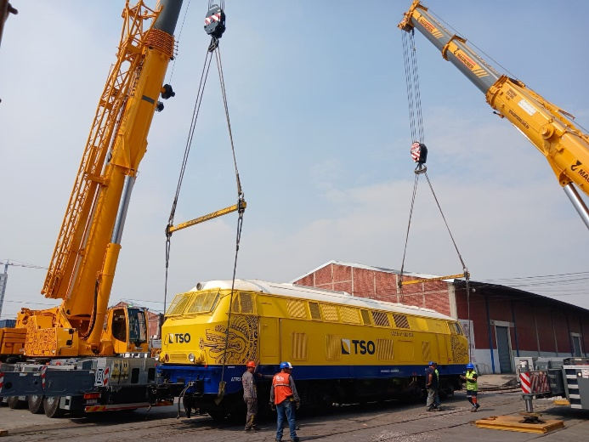

lwe-magruber-tren-maya.jpg  
In action: the new LTM 1230-5.1 and an LTM 1250-5.1 lift an 80-tonne locomotive for the "Tren Maya" rail project.

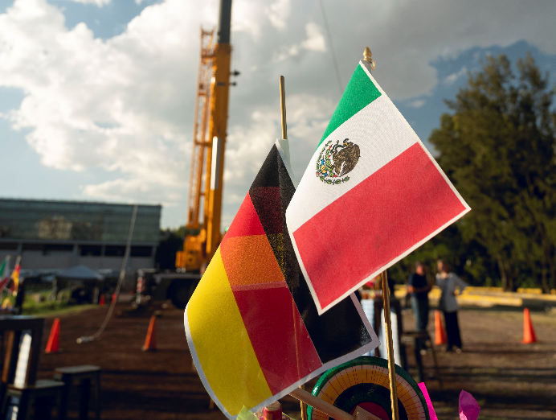

lwe-magruber-mexico.jpg   
The Liebherr México S. de R.L. de C.V. sales and service company celebrated its 10th anniversary this year. The Berumen family, owners of Magruber, were present with their new LTM 1230-5.1.

**Contact person**

Wolfgang Beringer  
Marketing and Communication  
Phone: +49 7391/502 - 3663  
E-mail: wolfgang.beringer@liebherr.com

**Published by**

Liebherr-Werk Ehingen GmbH  
Ehingen (Donau) / Germany  
www.liebherr.com