Press release

Liebherr and Bruno Generators Group announce joint project for green ammonia power generators

⸺

Liebherr and Bruno Generators Group have announced that they will work together on a feasibility study that focuses on green ammonia’s viability as the principal fuel for low and zero emission power generation solutions for the mining sector.

Green ammonia, as a hydrogen carrier, could provide low or zero emission ways of supplementing power supplies on site.

Liebherr and Bruno Generators Group have announced that they will join forces to investigate the feasibility of green ammonia as the principal fuel for low and zero emission power generation solutions for mining. If successful, these power generation solutions could offer yet another way for mining companies to reduce greenhouse gas emissions during operations.

Las Vegas (USA), 24 September 2024 – Liebherr’s mining and components product segments will work alongside Bruno Generators Group (BGG) to determine how each party’s expertise can be used to investigate low emission power generation with green ammonia as fuel. BGG is a premium Italian company that specialises in the design, development and production of cutting-edge power generators, battery energy storage systems and mobile energy solutions.

Liebherr has already investigated ammonia as a power source for dual-fuel internal combustion engines. The results of these investigations are promising and encourage the continued development of this solution.

**The potential of green ammonia**

Green ammonia is a hydrogen carrier that combines the advantages of lower transport and storage costs compared with compressed or liquified green hydrogen with its future usage as an energy vector in many areas of the world. Generators and off-board power units running on green ammonia could provide low or zero emission ways of supplementing power supplies on site. Green ammonia generators could provide a reduced emission method of alleviating energy variations or blackouts on site while mobile off-board power units running on green ammonia could power electric excavators just outside the pit, reducing both emissions and infrastructure requirements.

‘We’re thrilled to be working with BGG in this incredibly exciting project. Their innovative mindset and tracked development and delivery of low emission solutions are a perfect match for us as we work towards our zero emissions targets,’ says Oliver Weiss, executive vice president, R&D, engineering and production, Liebherr-Mining Equipment SAS. ‘When our combustion engines business unit saw promising results from ammonia as a low and zero emission power source after multiple test bench runs, we were excited to see how we could capitalise on this to provide even more ways our customers can pursue zero emissions.’

‘We are very proud of partnering and joining forces with Liebherr Mining in this project. Together, we share a common vision with an uncompromised commitment to sustainability, and we strive to lead the industry in responsible practices,’ says Renato Bruno, chief executive officer, Bruno Generators Group.

‘This partnership represents an incredible milestone in our pursuit of sustainable solutions for the benefit of our customers in the mining segment. Sharing and blending our respective expertise will further enhance and naturally boost our innovation mindset, accelerating our journey toward a net zero future.’

‘We are excited to lay the foundation for this important step towards a low and zero emission solution for our mining customers,’ says Steffen Apel, key account manager for combustion engines in the mining industry, Liebherr-Components AG.

About Liebherr Mining

Liebherr Mining is one of 13 product segments within the wider Liebherr Group and has been designing, manufacturing, and supporting mining equipment for over 50 years. The company provides a full range of solutions, including high-quality trucks, excavators, and dozers along with technology and service products that help customers get the very best out of their Liebherr machines. Liebherr Mining machines are built with in-house designed and manufactured high quality solutions such as electronic, hydraulic and drive train components. Liebherr Mining is following their roadmap which plans to offer low and zero emission options for all of its equipment to support customers as they embark on their decarbonisation journeys. The company has a global presence with over 4,400 employees in 70 countries around the world.

About Bruno Generators Group S.p.A.

BGG – Bruno Generators Group - is a holding of companies operating within the power generation and the energy industry. The company is specialised in designing, manufacturing, testing and distribution of power generators, battery energy storage systems and mobile energy solutions. BGG has its headquarters in Tribiano (Milan) and more than 40 years of successful history.

The Group's philosophy is to be vertically integrated to provide better and faster support to customer requests. BGG has historically been committed to investing in R&D and innovative solutions, delivering premium products that exceed expectations, with a continuous focus on quality and environmental sustainability.

BGG’s wide range of advanced energy and power solutions includes 4-poles super silent generators equipped with Stage V and Tier 4f engines, 2-poles generators, customised generators, 1+ Mw power stations, battery energy storage systems, lighting towers with LED technology, security and surveillance systems.

Images

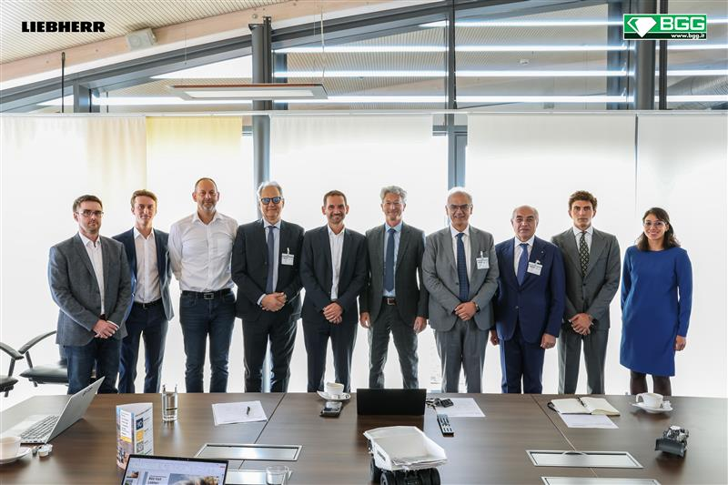

liebherr-BGG-ceremony-96dpi.jpg

Representatives from Liebherr-Components, Liebherr Mining and Bruno Generators Group at the ceremony.

liebherr-signing-the-agreement-96dpi.jpg

Mr Weiss of Liebherr Mining and Mr Renato Bruno of Bruno Generators Group sign the agreement.

Contact

Swann Blaise  
Divisional General Manager: Marketing & Business Intelligence  
Phone: +1 757 928 2239  
E-mail: swann.blaise@liebherr.com

Published by

Liebherr-Mining Equipment SAS   
Colmar / France  
www.liebherr.com