Press release

World premiere at MINExpo 2024: new Liebherr PR 776 Generation 8 crawler dozer

⸺

* Liebherr’s PR 776 Generation 8 (G8) provides ultimate efficiency through its proven hydrostatic drive technology
* This new dozer is compatible with the Liebherr Remote Control (LiReCon) system for improved safety, efficiency and operational comfort

At MINExpo 2024, Liebherr presents its flagship mining dozer, the PR 776, in the 8th Generation in full spec for tough mining and quarry operations. This state-of-art machine will be on display alongside with the Liebherr teleoperation system (LiReCon) which enhances both comfort and safety. The introduction of the PR 776 G8 further expands Liebherr's successful 8th generation crawler dozer. Together with the new PR 766 G8, introduced at the beginning of 2021, and the smaller PR 756 G8, Liebherr thus offers a comprehensive range of cutting-edge mining dozers.

Las Vegas (USA), 24 September 2024 – As the only mining dozers featuring a hydrostatic travel drive, the Liebherr fleet offers best-in-class efficiency for customers. The combination of powerful Liebherr diesel engines with the standard ECO mode allows operators to choose between high performance and maximum efficiency at any time. Customers worldwide benefit from the best-in-class efficiency of Liebherr’s mining dozers.

With an average of 38 litres of fuel burnt per hour, Liebherr’s flagship PR 776 sets the benchmark for efficient dozing in the mining industry. The availability of new assistance systems for these machines increases efficiency and ease of use.

**Liebherr OAS – Operator Assistance Systems**

The PR 776 Generation 8 crawler dozer integrates advanced Operator Assistance Systems (OAS), previously available only on smaller models, that offer two levels of assistance systems: ‘Free Grade’ for active blade stabilisation during fine grading and ‘Definition Grade’ for automatic blade positioning when creating 2D grades. With the ‘Auto Blade Pitch’ assistance system, the operator can save and call up three blade positions at the touch of a button: (1) perfect material penetration, (2) optimum material transport and (3) rapid blade clearing at the end of the push path. The assistance systems of the PR 776 G8 not only increase productivity and efficiency but also enhance operator comfort.

**Reliability: robust components from in-house production**

For decades, Liebherr diesel engines have proven their worth in construction equipment worldwide. Developed for the harshest operating conditions, their robust design and cutting-edge technology ensure maximum operational reliability and longevity. The tried-and-tested Liebherr hydrostatic drive system eliminates high-wear components such as gearboxes, steering clutches or service brakes. Instead, high-quality hydraulic pumps and motors operate virtually wear-free, offering exceptional operational dependability. Liebherr offers numerous factory-fitted, field-tested adaptations for its dozers to accommodate various environmental temperatures, from desert operations to extremely cold conditions.

**Maintenance made easy**

Optimal service accessibility and extended maintenance intervals are key features. Centralised maintenance points, wide-opening access flaps and engine compartment doors, a standard tiltable operator's cab and an optional swing-out fan for cleaning facilitate quick maintenance access and straightforward servicing of the new Liebherr dozer. The new PR 776 G8 boasts particularly long change intervals for operating fluids such as hydraulic or engine oil. When using Liebherr Plus oils, these intervals can extend up to 8,000 operating hours, depending on the application and with regular checks.

Liebherr mining dozers provide first-class cabin comfort. Operators appreciate the convenience and simplicity of a single joystick. Safety is enhanced via 360-degree blade and ripper visibility, provided by large panoramic windows and integrated ROPS / FOPS in the cab structure.

**Ready for the future: Liebherr Remote Control system for dozers**

When in a hostile work environment, for operators or machines, Liebherr Remote Control (LiReCon) boosts safety, comfort and productivity. The system is suitable for all dozer applications. It consists of the Liebherr Remote Control teleoperation stand; a state-of-the-art operator workspace including all required controls; and onboard dozer installations such as cameras for all different angles and views, microphones for recording machine sounds, radio link receiver and transmitter.

LiReCon allows fast shift changes between operators and consequently reduces idle and downtime. As the operator is no longer tied to the machine, it also enables customers to reach new extraction areas in hazardous zones, thus extending the range of applications for Liebherr mining dozers.

**Liebherr-Werk Telfs GmbH**

Liebherr-Werk Telfs GmbH has been producing and developing an ever-growing range of construction machines with hydrostatic drives since 1976. The company is able to draw on the many years of experience of the Liebherr Group with this type of drive. Whether it’s Crawler Dozers or Loaders, Telescopic Handlers or Pipe Layers – construction machinery from Telfs is consistently designed to keep you on the move with the highest efficiency and cost effectiveness. Then, increasing efficiency as well as reducing fuel consumption and CO2 emissions are a central focus. The latest computer-aided technologies are used both in development and production: from design engineering to welding robot processes, right through to computerised quality management.

**The Liebherr Group – 75 years of moving forward**

The Liebherr Group is a high technology company, in family ownership, with a diversified portfolio of products. The company is one of the largest construction machinery manufacturers in the world. But it also offers a range of high quality, high customer benefit products and services in many other areas. The Group currently consists of more than 150 companies across all continents. In 2023, it employed more than 50,000 people and generated a consolidated sales turnover of over €14 bn. Liebherr was founded by Hans Liebherr in 1949, in Kirchdorf an der Iller in southern Germany. From inception, the goal of the employees has been to delight their customers through novel contribution to technological progress and advanced technology solutions. In 2024 the Liebherr Group celebrates “75 years of moving forward”, to mark its 75th anniversary.

Images

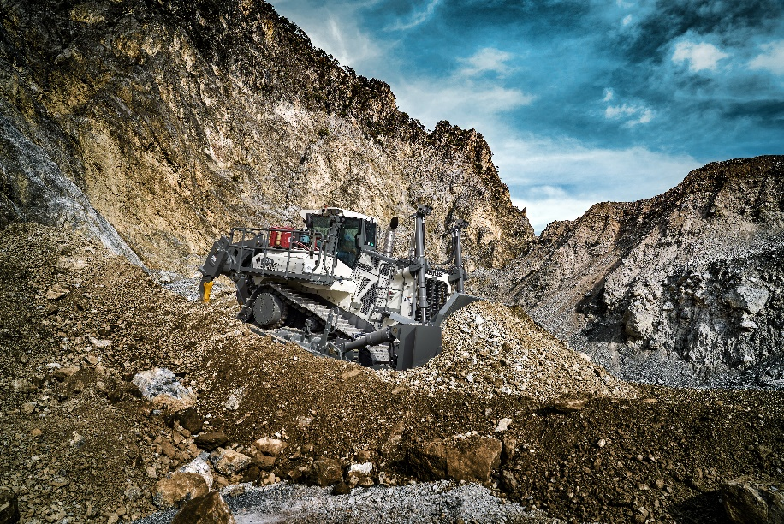

liebherr-PR776G8-96dpi.jpg  
Liebherr PR 776 G8: engineered for exceptional efficiency

**Contact**

Mag. Lisa Kahlig  
Marketing Manager PR and Press  
Phone: +43 690 500 644 96  
E-Mail: lisa.kahlig@liebherr.com

**Published by**

Liebherr- Werk Telfs GmbH  
Telfs / Austria  
www.liebherr.com