Press release

BHP and Liebherr sign new Global Framework Agreement at MINExpo 2024

⸺

* **Liebherr and BHP have signed a new Global Framework Agreement.**
* **Announced at MINExpo 2024 in Las Vegas, USA, the agreement highlights the continued preferred supply and deployment of Liebherr’s ultra-class equipment and the integration of technologies to reduce operational greenhouse gas emissions.**

**At MINExpo 2024, the world’s largest mining event, Liebherr and BHP announced the signing of a Global Framework Agreement. Built on an existing agreement, this renewed partnership solidifies Liebherr as one of BHP’s preferred mining equipment suppliers across the company’s global assets, strengthening their collaborative efforts with the aim of advancing operational innovation and reducing greenhouse gas emissions across BHP’s global operations.**

Las Vegas (USA), 26 September 2024 – Liebherr, a world leader in mining equipment innovation, and BHP, one of the world’s foremost resources companies, have announced a Global Framework Agreement (GFA). This agreement further cements the long-standing partnership, uniting both companies in their shared pursuit of cutting-edge mining solutions.

Building on a history of successful collaboration, the GFA merges BHP’s drive for responsible resource extraction with Liebherr’s technological expertise in heavy machinery. Together, they aim to continue pushing the boundaries of operational efficiency while enabling greenhouse gas emission reductions for BHP’s operations.

‘This extension is a testament to the strength of Liebherr’s relationship with BHP and our shared vision for the future of mining,’ says Dr Jörg Lukowski, executive vice president, sales and marketing, Liebherr-Mining Equipment SAS. ‘Over the years, we’ve worked closely with BHP to develop solutions that not only improve operational efficiency but also drive more sustainable outcomes. We are excited to continue this journey and deliver the latest advancements in automation, digitalisation and electrification to their operations globally.’

Under this agreement, Liebherr and BHP will collaborate closely on delivering world-class machine performance and integrating the latest advancements in safety, automation, digitalisation and electrification across BHP's global mining operations.

**Partner for success**

The partnership between Liebherr and BHP, which spans more than two decades, has seen the deployment of Liebherr ultra-class excavators across BHP’s global assets, including R 9600 Generation 8 machines. Notably, BHP's flagship South Flank iron ore operation in the Pilbara region of Western Australia received its first R 9600 in March 2020. In early 2024, BHP took delivery of its first electric excavator at its Yandi mine – a Liebherr R 9400 E. This machine is a fully electric version of the R 9400.

BHP’s chief commercial officer, Ragnar Udd, says, ‘This renewed agreement between BHP and Liebherr not only reaffirms our trusted partnership over the years but also signals our collective ambition towards helping to influence the future of mining through innovation, safety, productivity, operational excellence and greater sustainability.’

About the Liebherr Group

The Liebherr Group is a family-run technology company with a highly diversified product programme. The company is one of the largest construction equipment manufacturers in the world. It also provides high-quality, user-oriented products and services in a wide range of other areas. The Liebherr Group includes over 150 companies across all continents. In 2023, it employed more than 50,000 staff and achieved combined revenues of over 14 billion euros. Liebherr was founded by Hans Liebherr in 1949 in the southern German town of Kirchdorf an der Iller. Since then, the employees have been pursuing the goal of achieving continuous technological innovation and bringing industry-leading solutions to its customers. Under the slogan ‘75 years of moving forward’, the Group celebrates its 75th anniversary in 2024.

Images

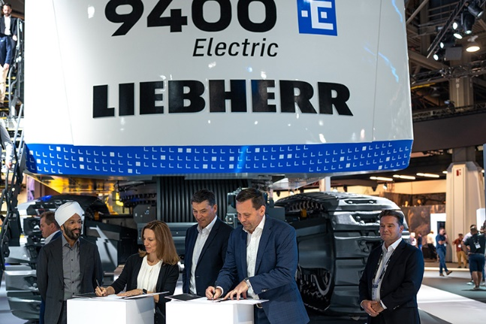

liebherr-bhp-minexpo-signing.jpg  
BHP and Liebherr sign new Global Framework Agreement.

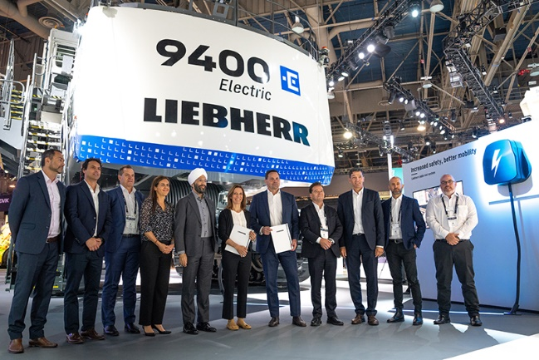

liebherr-bhp-minexpo-group.jpg  
BHP and Liebherr at MINExpo 2024.

Contact

Juan Lorenzo   
National Sales & Marketing Manager   
Phone: +61 7 3034 8814  
E-mail: [juan.lorenzo@liebherr.com](mailto:juan.lorenzo@liebherr.com)

Published by

Liebherr-Australia Pty. Ltd  
Adelaide / Australia  
[www.liebherr.com](http://www.liebherr.com)