Press release

Liebherr and Fortescue announce significant expansion of zero emission equipment partnership at MINExpo 2024

⸺

The partnership includes jointly developed technology that paves the way for carbon-free mining and features a total of 475 zero emission Liebherr machines – approximately 360 autonomous battery-electric trucks, presented to the industry at an exciting event at MINExpo; 55 electric excavators and 60 battery-powered dozers.

As part of the deal, Liebherr and Fortescue will deploy a complete autonomous battery-electric haulage solution for large scale mining operations.

A zero emission battery power system used in the battery-electric trucks has been developed by Fortescue Zero, Fortescue’s technology arm.

Fortescue Zero’s battery power system will also be integrated into an electric version of Liebherr’s flagship mining dozer, the PR 776.

The large scale zero emission mining ecosystem developed by Liebherr and Fortescue will be available to the rest of the mining industry in the near future.

This deal is expected to create one of the world’s largest zero emission mining fleets and represents a major breakthrough in the pursuit of a mining industry no longer reliant on fossil fuels.

It is the single largest equipment deal in the Liebherr Group’s entire 75-year history.

During an impressive event at this year’s MINExpo in Las Vegas, USA, Liebherr and Fortescue announced a significant expansion of their partnership and unveiled the jointly developed autonomous battery-electric T 264 truck. Both Dr Andrew Forrest and Dr Willi Liebherr attended the event to celebrate the historic deal. Together, the two companies will develop and validate a range of zero emission mining solutions, which will result in the supply of 475 new Liebherr machines featuring Fortescue’s innovative green technology to Fortescue’s operations in Western Australia. This represents about two thirds of the current mining fleet at Fortescue’s operations. Fortescue’s mining fleet consumed approximately 400 million litres of diesel in FY24 and accounted for 51 per cent of its Scope 1 emissions. Liebherr and Fortescue are committed to having a comprehensive and large scale zero emission mining ecosystem operational by 2030. Both companies have confirmed that, through their continued cooperation, customers will be able to access this ecosystem for their own operations in the coming years. The deal, with all of the equipment and technological innovations, amounts to the single largest deal made in the Liebherr Group’s 75-year history.

Las Vegas (USA), 24 September 2024. This historic deal for the development and supply of zero emission equipment was announced by Dr Willi Liebherr, member of the administrative board of Liebherr-International AG, and Dr Andrew Forrest, executive chairman of Fortescue, at an impressive event on the Liebherr booth at MINExpo. The agreement between Liebherr and Fortescue will help deliver the decarbonisation targets of both companies. Once the pioneering zero emission technologies developed within the partnership enter series production, they will become available for mining companies all over the world.

‘We are proud to have facilitated the single largest equipment deal in the entire 75-year history of the Liebherr Group. Especially as the expansion of our collaboration with Fortescue is an important step forward in our shared goal to decarbonise mining activities worldwide,’ says Dr Jörg Lukowski, executive vice president, sales and marketing, Liebherr-Mining Equipment SAS. ‘The technology developed as part of this record-breaking deal will not only support our customers along their decarbonisation journeys but also help us honour our commitment to offer completely fossil fuel free hauling, loading and dozing solutions by the end of the decade. In fact, in the coming years, Liebherr and Fortescue Zero will be able to offer more customers within the industry a proven, large scale zero emission mining ecosystem.’

‘Partnerships with companies and people like Liebherr and Willi Liebherr – where ambition is backed by action – are critical,’ Dr Forrest says. 'This is an important next step in our 2030 Real Zero target – to eliminate emissions from our Australian iron ore operations by the end of the decade. The world needs Real Zero now – it simply cannot afford to wait. The green solutions we need are here today, and Fortescue Zero is supplying them and rolling them out across our massive mining operations. Fortescue Zero developed this battery technology and jointly developed the Automated Haulage Solution, leading the way to provide green innovative solutions to eliminate emissions from heavy industry. We invite all companies in the mining, heavy industry and haulage sectors to join us. The solutions are there and the missing ingredient is leadership. The time of others persuading you that greenwashing is a better return to shareholders and your community is over. Fortescue invites you to join us. We can together be the trailblazers who forge the world's move away from fossil fuels.’

**Driving forward with the autonomous battery-electric T 264**

Of the 475 machines that make up this deal, about 360 will be autonomous battery-electric T 264 trucks, containing a battery electric power system developed by Fortescue Zero. This is triple the 120 trucks that were announced as part of the initial partnership between Liebherr and Fortescue in 2022. Fortescue considers this to be the optimal path for the replacement of critical diesel Heavy Mobile Equipment to meet its 2030 decarbonisation targets. All of the trucks in this fleet will ultimately be equipped with a zero emission battery power system developed by Fortescue Zero and the jointly developed Autonomous Haulage Solution (AHS) – both of which were built to be scalable so they can be retrofitted onto existing Liebherr haul trucks. This means that trucks purchased today are already futureproofed for tomorrow.

The AHS, which was co-developed using both companies’ expertise, also includes an Energy Management System that coordinates the static recharge assignments for the trucks and ensures the charger is fully utilised without causing queuing on site.

‘We wanted to design and build an intelligent, state-of-the-art AHS that not only includes the know-how from both an OEM and a mining operator generated over the last few years but will also be able to integrate with new zero emission solutions in the future,’ says Oliver Weiss, executive vice president, R&D, engineering and production, Liebherr-Mining Equipment SAS. ‘Therefore, control and command of zero emission mining technologies were included in the AHS from the outset. The fleet management assignment engine at the core of the AHS monitors fleet energy levels so that jobs and energy replenishment tasks can be assigned efficiently within zero emission fleets equipped with this system.’

Fortescue has developed the stationary fast charging solution to support the autonomous battery-electric truck. Equipped with robotic connection options, the charger can provide up to 6 MW of power and charge the current battery-electric T 264 in 30 minutes.

‘We have an enormous amount of expertise in autonomous haulage and have used that expertise to play a leading role in the development of this system,’ says Dino Otranto, chief executive officer, Fortescue Metals. ‘We have more than 200 autonomous trucks across our mine sites, travelling the equivalent of two trips to the moon and back each month. It is imperative that they operate efficiently and at maximum capacity. We have used our strong track record of being a first mover in autonomy and our technological know-how to derisk zero emission fleets to enable the industry to break free from the pilots and prototypes. The fully integrated AHS will be a game changer for us in reducing our carbon emissions.’

**The pathway to an autonomous battery-electric solution**

The T 264 battery-electric truck will commence onsite validation at the end of 2025. The approximately 360-strong T 264 truck fleet has already begun arriving to Fortescue’s Western Australian operations, with the first trucks delivered to Fortescue’s Eliwana mine in October 2023. The initial 240-tonne capacity trucks will be converted to zero emission powertrains before 2030. However, most of the fleet will be supplied in battery-electric configuration from first arrival.

Four autonomous trucks are currently in validation at Fortescue’s testing site, with the first deployment of operational autonomous trucks expected in Q1 2025. All T 264 trucks are arriving autonomy-ready and will be progressively deployed to autonomous operations across Fortescue’s sites.

Validation of the full autonomous battery-electric solution is expected to be complete in early 2026.

Pushing towards the future with battery dozers

Liebherr and Fortescue will combine their considerable expertise to jointly develop a zero emission dozer. Fortescue’s battery power system will be integrated into an electric version of the Liebherr’s flagship mining dozer, the PR 776, which is currently in development. Once developed, Liebherr will supply Fortescue with 60 units of this zero emission dozing solution to meet Fortescue’s Real Zero targets.

Proven technology for a new era of mining

This historic deal also includes the supply of 55 R 9400 E electric excavators. This fleet will be a mix of backhoe and face shovel configurations. Fortescue first adopted Liebherr’s electric excavator technology in 2023, with the commissioning of Australia’s first operational electric excavator in December of that year. Three R 9400 E excavators are already operational across Fortescue’s sites.

Increasing organisational capacity

Ensuring the successful delivery of all of these machines requires significant investment from both Liebherr and Fortescue.

‘We are on track with our investment plans to develop our global infrastructure to ensure that we can accommodate the expansion of our business and provide our customers with larger quantities and a wider range of zero emission technology,’ says Michael Arndt, executive vice president, service and quality, Liebherr-Mining Equipment SAS. ‘We will see the outcomes of these investments soon, with many more milestones to be implemented over the next five years.’

‘As the mining solutions we offer continue to expand, so must our capability and capacity to deliver and service these ever-advancing technologies. In addition to infrastructure, we are also investing heavily in our people and remote support services to be able to support these new products and technologies,’ continues Arndt.

Fortescue is also boosting its capacity to supply the hundreds of batteries required for these machines – both trucks and dozers.

‘The T 264 battery-electric truck, powered by a Fortescue Zero battery power system, will be one of the first zero emissions solutions for mine haulage in operation globally,’ Mr Otranto says. ‘It combines Fortescue Zero’s heritage of innovation, delivering a battery power system designed for best-in-class range and durability in all mining environments, with Liebherr’s proven haul truck excellence. The zero emission battery power system developed by Fortescue Zero also reflects Fortescue’s continued evolution into a leading technology company that is selling its innovative solutions to the world.’

Ensuring local capacity

The development and manufacture of this enormous fleet is not the end of the story. All 475 machines of this deal will become part of Fortescue’s iron ore hub in the Pilbara region of Western Australia. As such, Liebherr-Australia – Liebherr’s sales and service company in the country – has already begun its preparations for supporting this enormous fleet.

‘This large volume of machinery presents a unique growth opportunity for Liebherr-Australia. We are significantly ramping up investments in our branches, reman facilities and our people to ensure we have the capacity to safely and efficiently maintain not only this equipment but that of our other customers,’ says Trent Wehr, managing director, Liebherr-Australia Pty. Ltd.

About Liebherr Mining

Liebherr Mining is one of 13 product segments within the wider Liebherr Group and has been designing, manufacturing, and supporting mining equipment for over 50 years. The company provides a full range of solutions, including high-quality trucks, excavators, and dozers along with technology and service products that help customers get the very best out of their Liebherr machines. Liebherr Mining is also working hard to offer low and zero emission options for all of its equipment to support customers as they embark on their decarbonisation journeys. The company has a global presence with over 4,400 employees in 70 countries around the world.

About the Liebherr Group – 75 years of moving forward

The Liebherr Group is a family-run technology company with a highly diversified product programme. The company is one of the largest construction equipment manufacturers in the world. It also provides high-quality, user-oriented products and services in a wide range of other areas. The Liebherr Group includes over 150 companies across all continents. In 2023, it employed more than 50,000 staff and achieved combined revenues of over 14 billion euros. Liebherr was founded by Hans Liebherr in 1949 in the southern German town of Kirchdorf an der Iller. Since then, the employees have been pursuing the goal of achieving continuous technological innovation and bringing industry-leading solutions to its customers. Under the slogan ‘75 years of moving forward’, the Group celebrates its 75th anniversary in 2024.

About Fortescue

Fortescue is the technology, energy and metals group accelerating the commercial decarbonization of industry, rapidly, profitably and globally. Our Metals business comprises our iron ore operations in the Pilbara, Western Australia as well as a pipeline of exploration projects globally in Africa, Latin America and Australia. By 2030, we aim to have our Australian iron ore operations running on green energy, achieving Real Zero Scope 1 and 2 terrestrial emissions. Our Energy business is building a global portfolio of renewable green hydrogen and green ammonia projects and developing green technology solutions. As our business develops globally, our commitment to building thriving communities expands with us. Delivering positive social and economic change through training, employment and business development opportunities is a key focus.

fortescue.com

**Note**

‘Zero emissions’, when used in relation to vehicles or power systems means, that (a) a vehicle’s exhaust, or the power system, only emits water vapour when in operation or (b) if the vehicle is 100 % battery powered and the vehicle, or power system, does not emit any exhaust emissions.

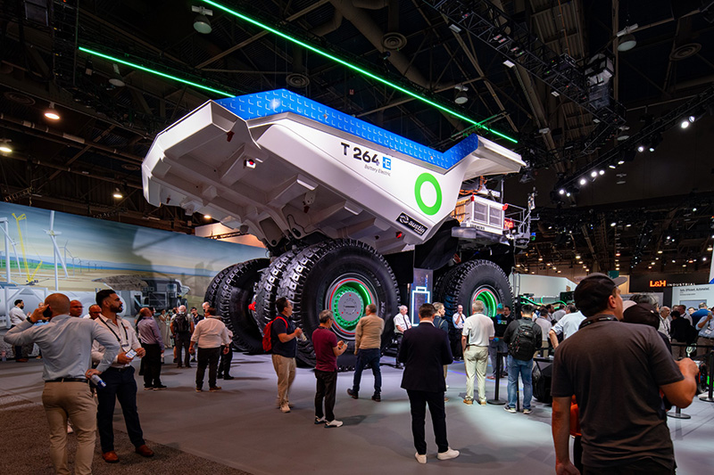Images

liebherr-T264-technology-reveal-72dpi.jpg  
The historic deal between Liebherr and Fortescue features a total of 475 zero emission Liebherr machines, including 360 autonomous battery-electric T 264 trucks.

liebherr-deal-signing-with-Fortescue-72dpi  
Dr Willi Liebherr of Liebherr and Dr Andrew Forrest of Fortescue officially signing the deal between the two companies.

Contact

Swann Blaise  
Divisional General Manager: Marketing & Business Intelligence  
Phone: +1 757 928 2239  
E-mail: swann.blaise@liebherr.com

Published by

Liebherr-Mining Equipment SAS   
Colmar / France  
[www.liebherr.com](http://www.liebherr.com)