Press release

Introducing IoMine: Liebherr’s expanded technology portfolio for integrated operations

⸺

* During this year’s MINExpo exhibition, Liebherr launched its expanded technology portfolio, IoMine.
* IoMine’s three product families – Operate, Automate and Maintain – are designed to optimise mining operations.
* A key part of the IoMine launch is the release of Liebherr’s Remote Service, Fleet Management System, Machine Guidance System and Autonomous Haulage Solution products.

Liebherr is presenting its updated and expanded technology portfolio, IoMine, at this year’s MINExpo, which is taking place at the Las Vegas Convention Center from 24 to 26 September. A number of new Liebherr technology products have also been introduced with the launch of IoMine, including Autonomous Haulage Solution, Machine Guidance System, Fleet Management System and Remote Service.

Las Vegas (USA), 24 September 2024. IoMine, Liebherr’s updated and expanded technology portfolio, features cutting-edge technology designed to optimise all aspects of day-to-day mining operations. Because the new technology portfolio is intended to support customers as more and more move to an integrated operations approach to mining, Liebherr wanted to highlight this in its choice of name.

‘An integrated operations approach uses a connected ecosystem of technologies to optimise the load and haul cycle. Enhancing these processes improves both productivity and safety – two vital criteria for our customers,’ explains Tristan Malec, general manager, digital technology products, Liebherr-Mining Equipment SAS. ‘We want customers to know from the outset that our products will support them in these endeavours.’

The expanded IoMine portfolio offers new command and control capabilities, data integration and remote support services, all of which allows customers to use the integrated operations approach to their advantage. Each product within the three distinct product families is designed to improve the safety, efficiency and profitability of customers' mining operations.

**Operate**

The IoMine Operate product family is designed to optimise and streamline daily mining operations by collecting, analysing and leveraging data from connected machines to efficiently manage fleet activities, monitor performance and improve decision-making in real time. Key products within the Operate family are the Fleet Management and Machine Guidance Systems, the Data Services range and assistance systems for Liebherr’s excavator fleet that provide operators with additional operational information.

The Fleet Management System (FMS) integrates mining operations to boost productivity, optimise haulage assignments and maximise fleet utilisation – all of which helps to reduce non-productive time across the entire load-haul-dump value chain. The FMS is also OEM-agnostic and delivers real-time, end-to-end monitoring for all connected assets to offer a strategic overview of onsite activities. Its integrated optimisation engine eliminates uncertainty and variations, enabling automated reassignment and communication that keep mining operations running smoothly and onsite personnel informed.

The Machine Guidance System (MGS) can be integrated with the FMS or Autonomous Haulage Solution and will be offered as a standalone product. It delivers critical material information to minimise ore variability and dilution, improving overall performance. Designed for flexibility, the MGS can be installed on multiple brands of loading and pushing machines and offers high-precision accuracy as well as real-time material tracking.

‘Our Machine Guidance System offers position control with a high level of accuracy,’ enthuses Malec. ‘This means that operators can distinguish between different grades and types of material with pinpoint precision.’

Liebherr’s Data Services, another feature of the Operate product family, provide adaptable solutions that enable data integration in customers’ onsite ecosystems to improve operations and processes.

**Automate**

IoMine’s Automate product family offers customers both fully and semi-autonomous solutions for their fleets, addressing the growing demand for automation in the mining industry. The Autonomous Haulage Solution (AHS) falls within this product family alongside Liebherr’s teleoperation system for its range of Generation 8 mining dozers, LiReCon. Liebherr has also expanded its comprehensive range of semi-autonomous assistance systems for its excavators and dozers.

The AHS is transforming mining operations by combining advanced automation with real-time data insights to enhance productivity, safety and efficiency. The system enables fully autonomous operation of Liebherr’s haul trucks, allowing for intelligent route optimisation and seamless, reliable performance without manual intervention. Designed for future sustainability, the AHS is compatible with both diesel-electric and zero emission energy systems, integrating with the FMS to manage energy replenishment for zero emission trucks.

Liebherr Remote Control, more commonly known as LiReCon, is also a feature within the Automate product family. This teleoperations system allows operators to control Liebherr’s Generation 8 dozers from a safe distance outside of the pit, reducing their exposure to potential hazards on site – particularly when a dozer is working in especially challenging conditions. The latest update to LiReCon, which was released for this year’s MINExpo, makes the teleoperation stand more compact and easier to transport. This means LiReCon can now be more easily integrated into a range of site infrastructure, including construction containers, mobile deployment vehicles and office applications.

**Maintain**

Alongside the launch of IoMine, Liebherr has also introduced Remote Service – a suite of digital tools within IoMine’s Maintain product family designed to streamline the issue resolution process for onsite personnel. Remote Service is comprised of three different tools – Troubleshoot Advisor, Content Delivery Portal and XpertAssist – each of which addresses different stages of issue resolution. Troubleshoot Advisor is a powerful diagnostic tool that guides technicians through a detailed, step-by-step problem identification process that can help speed up problem resolution. Content Delivery Portal houses all of Liebherr’s technical documentation for its machines, which operators can navigate with the user-friendly search functionality of the application, allowing them to easily find the information relevant to their situation. And when further expertise is required, XpertAssist connects technicians to Liebherr experts for real-time assistance via live video support and other dynamic features available within the app for seamless conversations.

‘We developed Remote Service after observing that approximately half of the technical inquiries we were receiving from customers could be solved remotely,’ says Malec. ‘By providing a product that allowed this remote problem-solving to occur, we are able to save considerable time and money for our customers by empowering their technicians to resolve issues directly, therefore reducing downtime.’

About Liebherr Mining

Liebherr Mining is one of 13 product segments within the wider Liebherr Group and has been designing, manufacturing, and supporting mining equipment for over 50 years. The company provides a full range of solutions, including high-quality trucks, excavators, and dozers along with technology and service products that help customers get the very best out of their Liebherr machines. Liebherr Mining is also following its roadmap, which plans to offer low and zero emission options for all of its equipment to support customers as they embark on their decarbonisation journeys. The company has a global presence with over 4,400 employees in 70 countries around the world.

About the Liebherr Group – 75 years of moving forward

The Liebherr Group is a family-run technology company with a highly diversified product programme. The company is one of the largest construction equipment manufacturers in the world. It also provides high-quality, user-oriented products and services in a wide range of other areas. The Liebherr Group includes over 150 companies across all continents. In 2023, it employed more than 50,000 staff and achieved combined revenues of over 14 billion euros. Liebherr was founded by Hans Liebherr in 1949 in the southern German town of Kirchdorf an der Iller. Since then, the employees have been pursuing the goal of achieving continuous technological innovation and bringing industry-leading solutions to its customers. Under the slogan ‘75 years of moving forward’, the Group celebrates its 75th anniversary in 2024.

Images

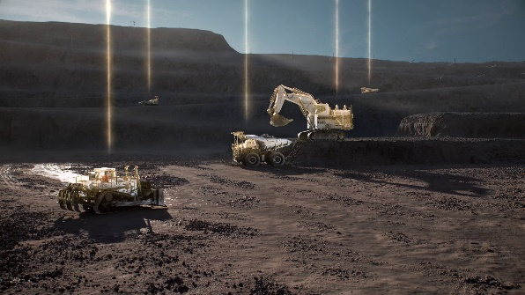

IoMine, Liebherr’s newly expanded technology portfolio, is designed to support customers adopting an integrated operations approach to mining.

liebherr-IoMine-72dpi.jpg

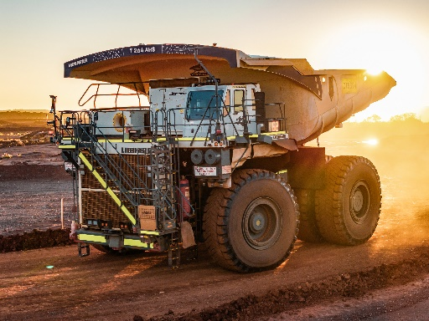

Liebherr’s Autonomous Haulage Solution, Fleet Management System and Machine Guidance System are some of the company’s most recent technological innovations and are a key part of the IoMine portfolio.

liebherr-autonomous-T264-96dpi.jpg

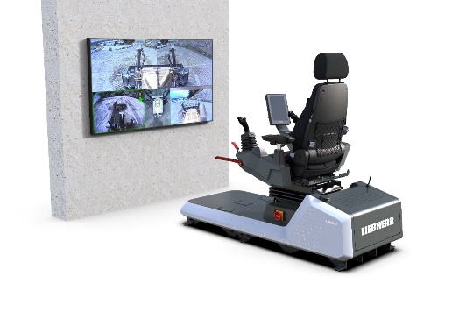

LiReCon, Liebherr’s teleoperation system for its Generation 8 dozers, improves the safety of dozing operations in especially hazardous areas on site.

liebherr-lirecon-system-96dpi.jpg

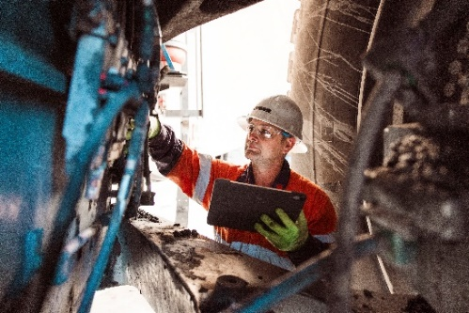

Remote Service is a suite of digital tools designed to streamline the issue resolution process.

liebherr-remote-service-96dpi.jpg

Contact

Swann Blaise  
Divisional General Manager: Marketing & Business Intelligence  
Phone: +1 757 928 2239  
E-mail: swann.blaise@liebherr.com

Published by

Liebherr-Mining Equipment SAS   
Colmar / France  
www.liebherr.com