Press release

Liebherr presents its latest mining technology at MINExpo 2024

⸺

* From 24 to 26 September, the Liebherr Group is exhibiting at MINExpo, the largest mining exhibition in the world, at booth #7832 in Central Hall of the Las Vegas Convention Center in Nevada, USA.

During the exhibition, Liebherr unveiled its autonomous battery-electric T 264 haul truck, announced the launch of the PR 776 Generation 8, and announced its rebranded technology portfolio, IoMine.

Visitors attending the exhibition in person and via online channels can learn about Liebherr’s high-quality equipment, decarbonisation solutions, technology products and services that make the OEM a fantastic partner for mining solutions.

At this year’s MINExpo, Liebherr is presenting advancements from its mining, earthmoving, mobile and crawler cranes, components and aerospace and transportation product segments. The company has made a number of product announcements during the exhibition, including the unveiling of its autonomous battery-electric T 264 haul truck, the new PR 776 Generation 8 dozer, and the expansion of its integrated technology portfolio, IoMine. In line with Liebherr’s motto for the event, ‘Your mining partner’, Liebherr is showcasing its reliability as a partner for best-in-class equipment, decarbonisation solutions, cutting-edge technology and service excellence for the mining industry.

Las Vegas (USA), 24 September 2024 – Liebherr is sharing its latest news, products, services and innovations for the mining sector at this year’s MINExpo INTERNATIONAL®, the world’s largest mining exhibition. Visitors can experience over 2,777 m2 (over 29,000 sq. ft) of Liebherr exhibits at booth #7832.

Liebherr’s battery T 264 haul truck revealed

At the impressive Technology Reveal hosted on the Liebherr booth earlier today, Liebherr and Fortescue unveiled the very first autonomous battery-electric T 264 haul truck. This truck represents the culmination of years of hard work and the joining together of the autonomy and zero emission arms of the Liebherr–Fortescue partnership. The autonomous battery-electric T 264 has a 3.2 MWh battery (developed by Fortescue Zero).

A static charging solution has been developed alongside the autonomous battery-electric truck. The static charger will be available in both manual and robotic versions and includes an automated quick charger of up to 6 MW with a megawatt charging system connector that can charge battery-electric T 264 trucks in 12–58 minutes.

The truck on display at MINExpo is equipped with the Autonomy Haulage Solution (AHS) that was jointly developed by the two companies. Within the AHS is an Energy Management System that coordinates the static recharge assignments for the trucks and ensures the charger is fully utilised without causing queuing on site. The T 264 battery-electric truck will commence onsite validation at the end of 2025.

The tyres on the T 264 at the exhibition are Michelin 50/80R57 XDR 4 SPEED ENERGYTM – the first energy efficient tyre for the mining industry. Because they are made with a new energy-saving rubber compound and have an optimised tread with increased flexibility, these tyres help reduce the amount of energy consumed by mining haul trucks. The 50/80R57 XDR 4 SPEED ENERGYTM tyres have been shown to reduce fuel consumption by 3.6 % in flat conditions when compared to the Michelin 50/80R57 XDR 250 C tyres running on a combustion-engine truck and are expected to have a positive impact on vehicle range for battery-operated trucks.

R 9400 E: more than 40 years of E-xperience

To highlight Liebherr as a reliable partner for decarbonisation solutions, the booth includes the R 9400 E 350-tonne electric excavator. This machine is not only a testament to Liebherr’s more than 40 years’ experience in the development and manufacture of electric excavators, but also features some of the mining product segment’s latest innovations. This machine is equipped with the company’s brand-new cable reel solution for increased manoeuvrability.

PR 776 G8: the next generation of dozing

Liebherr announced the release of its latest generation 70-tonne dozer this week: the PR 776 G8. Liebherr’s mining dozers excel at ripping, pushing, stockpiling, clearing and reclaiming in mines worldwide. The PR 776 G8 offers enhanced efficiency and constant power, thanks to its intelligent driveline and hydraulic system. Its combination of hydrostatic transmission and the Liebherr D9512 engine offers the lowest hourly fuel burn in the 70-tonne class. As well as this, the PR 776 boasts best-in-class efficiency, with its operator assistance systems further boosting performance and efficiency.

LRT 1100-2.1: the safe choice

The LRT 1100-2.1 rough-terrain crane is a highlight of the Liebherr booth from the company’s mobile and crawler cranes product segment. This rough-terrain crane has outrigger monitors as standard that automatically detect the support status of the crane and save it to the crane’s controller. The standard VarioBase® variable support base of the crane further optimises safety by enhancing flexibility on site and increasing the crane’s lifting capacity. The LRT 1100-2.1 has a telescopic boom with Liebherr’s tried-and-tested telematic telescoping system for rough-terrain cranes, on which the various telescoping sections can be extended independently with a single cylinder and then pinned to the telescopic section above.

Announcing IoMine, Liebherr’s technology portfolio

Liebherr has also launched its expanded technology portfolio, IoMine, at this year’s MINExpo. The products within IoMine are split into three distinct product families, each dedicated to a specific aspect of mining operations: Operate, Automate and Maintain. Operate products are designed to streamline and improve day-to-day mining activities by collecting, analysing and leveraging data from Liebherr machines. The Automate product family provides customers with both full and semi-autonomous solutions for their fleets. And the solutions within the Maintain product family are designed to streamline issue resolution for onsite personnel.

Visitors to the Liebherr booth will be able to take part in a demonstration of Liebherr Remote Control, more commonly known as LiReCon – which is an example of one of the Automate products within IoMine. LiReCon is the teleoperations system for Liebherr dozers that helps keep operators safe while increasing equipment uptime and productivity.

Service excellence: support when you need it, where you need it

At this year’s MINExpo, Liebherr is also showcasing its capabilities as a partner for service excellence with its range of service products for mining. As part of this, the company is shining a spotlight on its newly launched Remote Service product designed to help technicians onsite connect with Liebherr experts to help streamline the maintenance and repair process. Visitors to the Liebherr booth can also experience how the OEM supports customers from initial equipment consultation – with Liebherr’s highly skilled Application Engineering team – right through to machine maintenance, customer support and equipment upgrades.

Innovation Lab: tomorrow’s solutions, today

Featured at Liebherr’s Innovation Lab is a range of pioneering concepts for the future of mining from a number of Liebherr’s product segments. For this year’s exhibition, Liebherr’s mining product segment will present two new technological concepts: Liebherr Power Rail and the S1 Vision. Liebherr Power Rail is based on Liebherr’s proven trolley bar technology and is designed to be a class-agnostic trolley solution to encourage to growth of zero emission haulage fleets.

Liebherr’s components product segment is showcasing the innovative Liebherr technologies at the core of every powerful mining machine. Liebherr’s commitment to excellence and sustainability is demonstrated in every component and service on display – be it a hydrogen engine, a travel or a wheel drive, a CFRP hybrid hydraulic cylinder, an advanced slewing bearing with bearing clearance monitoring, or the remanufacturing program. These vital elements not only ensure the reliability of mining machines, but also provide their remarkable performance under the toughest conditions.

Another highlight on display in the Innovation Lab is a 55 kW compressor. Backed up by experience gathered during the last two decades and jointly developed by the Liebherr components and aerospace and transportation systems product segments, the high-speed compressor is driven by an electrical motor and features an air bearing. These compressors do not require any lubrication and supply clean, compressed air to the fuel cell stack, not adding any pollution to the membrane. Such technology is an enabler for the deployment of fuel cell propulsion systems that only emit water and heat, which aids in the movement towards more environmentally friendly transportation. Liebherr’s 55 kW compressor is based on a mature system with an optimised, cost-effective and standardised design that can be tailored to specific requirements at reduced costs. One of these compressors is currently in service on-board SNCF’s Autorail à Grand Capacité (AGC) trains by Bombardier, which are operated in the Occitania Region of France. The compressor is part of the air-conditioning system based on environmentally friendly air cycle technology that uses only ambient air as a coolant instead of conventional chemical refrigerants.

For more information, visit [liebherr.com/minexpo](http://www.liebherr.com/minexpo)

About the Liebherr Group – 75 years of moving forward

The Liebherr Group is a family-run technology company with a highly diversified product programme. The company is one of the largest construction equipment manufacturers in the world. It also provides high-quality, user-oriented products and services in a wide range of other areas. The Liebherr Group includes over 150 companies across all continents. In 2023, it employed more than 50,000 staff and achieved combined revenues of over 14 billion euros. Liebherr was founded by Hans Liebherr in 1949 in the southern German town of Kirchdorf an der Iller. Since then, the employees have been pursuing the goal of achieving continuous technological innovation and bringing industry-leading solutions to its customers. Under the slogan ‘75 years of moving forward’, the Group celebrates its 75th anniversary in 2024.

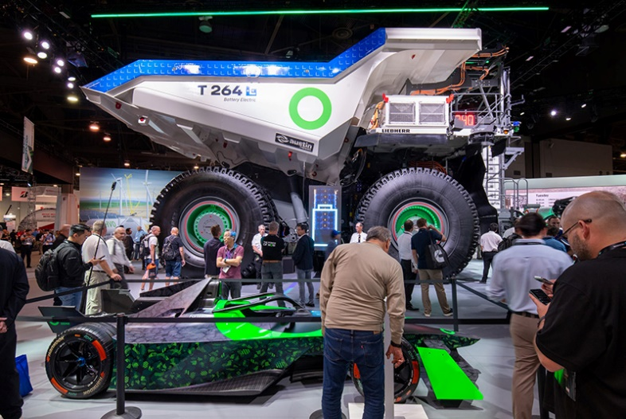Images

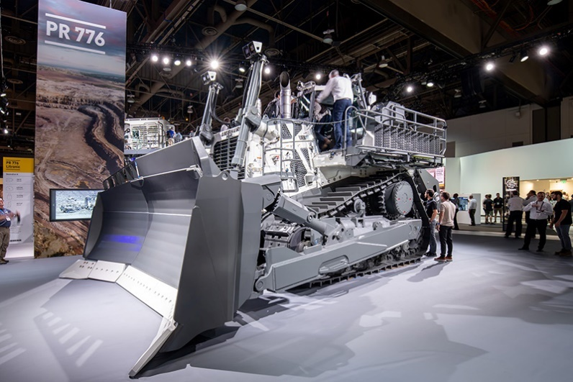liebherr-MINExpo-autonomous-battery-electric-T264-72dpi  
The very first autonomous battery-electric T 264 haul truck was unveiled at an impressive event hosted by Liebherr and Fortescue on the Liebherr booth.

liebherr-MINExpo-PR776-G8-72dpi  
Introducing the PR 776 G8, the latest generation of Liebherr’s flagship 70-tonne mining dozer.

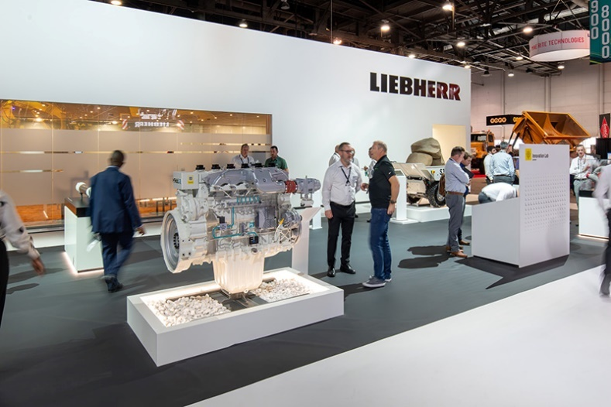liebherr-MINExpo-innovation-lab-72dpi  
The Innovation Lab at the Liebherr booth showcases a range of the Group’s pioneering concepts for the future of mining.

Contact

Larissa Lunitz  
Head of Public Relations  
Tel: +41 79 645 70 67  
Email: larissa.lunitz@liebherr.com

Published by

Liebherr-International AG

General-Guisan-Strasse 6  
5415 Nussbaumen, Switzerland  
www.liebherr.com