Press release

Liebherr presents the A 922 railroad excavator at Innotrans 2024

⸺

Liebherr Railroad excavator A 922 Rail Litronic at the Innotrans 2024

Can be used either on railway tracks or on the road

Decades of experience in the development and production of railroad excavators

New attachments especially for railroad excavators shown at the trade fair

Liebherr is presenting the A 922 Rail Litronic at Innotrans 2024. Because it is a railroad machine, the A 922 Rail is suitable for use on railway tracks and for road construction and is fast thanks to the mobile undercarriage. A rail travel drive is mounted on both sides of the undercarriage. When entering the rails, the rail travel drive lifts the tyres to rail height. The inside wheels of the dual tyres ensure travel of the excavator on the tracks.

Berlin (Germany), 25 September 2024 − With the A 922 Rail, Liebherr is offering the perfect overall package: the basic machine, the rail travel drive, the quick coupler system, attachments and all of the safety systems are developed by Liebherr and perfectly customised for the machine. Liebherr has been developing and producing railroad excavators for rail construction since 1967 and is global market leader in this segment as an OEM manufacturer.

Flexible use on road and rail: the Liebherr A 922 Rail road-rail excavator

The Liebherr A 922 Rail excavator impresses with its performance: With its 120 kW / 163 hp engine, the A 922 Rail achieves a high working speed with the usual smooth working movements. The innovative hydraulic concept of the A 922 Rail consists of a Liebherr variable displacement double pump with independent control circuits. High-performance, hydraulic attachments can thus be operated independently of the working and travel movements of the Liebherr railroad excavator. The delivery rate of the proven Liebherr variable displacement double pump was increased to 2 x 220 l/min for even better performance. The heavy ballast was also redesigned to yield the best bearing load values with improved weight distribution and a more compact rear dimension of 2,000 mm.

**Service-orientated machine design**

The service-orientated machine design of the A 922 Rail guarantees short maintenance times and minimises the associated maintenance costs thanks to the time savings. All maintenance points are easily accessible from the ground. The new generation has simplified access to important components even further; for example, air, oil and fuel filters, the main battery switch, the central lubrication point for the undercarriage and the pilot valves for the hydraulic system are much easier to access.

**Comfortable double cab**

The spacious double cab featuring standard roll over protective structure (ROPS) and a modern interior design offers the best conditions for comfortable, focused and productive work. Entrance lighting is provided to make accessing the cab easier. The usual generous use of glass and standard rear and side cameras provide an exceptional view of the working area and swing range. The touch-screen colour display used for display and operation purposes, as well as the other control elements on the console are all perfectly matched to one another to form the perfect unit.

**Security systems direct from the manufacturer**

Occupational safety is extremely important in track construction. Liebherr therefore offers their own safety systems which are perfectly tailored to the machine requirements. The safety technologies include load torque, height and sway limitation and the virtual wall.

**Liebherr undercarriage for use on tracks worldwide**

The A 922 Rail is available with various undercarriage versions with different track widths and rail wheels, which make it possible to use it on tracks worldwide. An independent variable displacement pump for the rail travel drive provides the best traction and safe propulsion at all times. Standard integrated brakes in the rail wheel shorten the braking distance in both the lowered and elevated position and thus enhance safety.

**New Liebherr attachments and proven quick coupling system Solidlink 33-9**

In order to meet the various construction site requirements economically and reliably, Liebherr offers an extensive portfolio of attachments for the A 922 Rail and is presenting a selection of these at Innotrans. The new rail tongs, which have been specially designed for the proven gripper mechanism of the GMZ 22, will be shown for the first time. The attachment, which has been specially developed for Liebherr's Railroad excavators, was designed in close collaboration with machine operators, and enables efficient and speedy work with the track strand. In addition, Liebherr is also presenting the new GMP 25 parallel grab and the SG 20B sorting grab with universal tongs at the exhibition. The exhibition appearance is rounded off in the attachments area with the Tiltrotator TR 25 and a grading bucket. The A 922 Rail exhibited at the Innotrans is also equipped with a Solidlink 33-9. The new Solidlink 33-9 model adds further couplings to the fully automatic quick coupling system, with all the advantages. The expansion of the couplings to include a second high pressure circuit also allows the use of hydraulic attachments such as tamping equipment in rail construction, mulchers with flaps or Liebherr stick extensions. The Solidlink fully hydraulic quick coupling system allows attachments to be changed quickly and safely from the operator's cab.

About the Liebherr Group - 75 years of moving forward

The Liebherr Group is a family-run technology company with a broadly diversified product programme. The company is one of the largest manufacturers of construction machinery in the world. However, it also offers high-quality, user-orientated products and services in many other areas. Today, the group of companies comprises over 150 companies on all continents. In 2023, it employed more than 50,000 people and generated a consolidated total turnover of over 14 billion euros. Liebherr was founded by Hans Liebherr in 1949 in Kirchdorf an der Iller in southern Germany. Since then, the employees have pursued the goal of convincing their customers with sophisticated solutions and contributing to technological progress. Under the motto "75 years of moving forward", the group of companies will be celebrating its 75th anniversary in 2024.

Picture

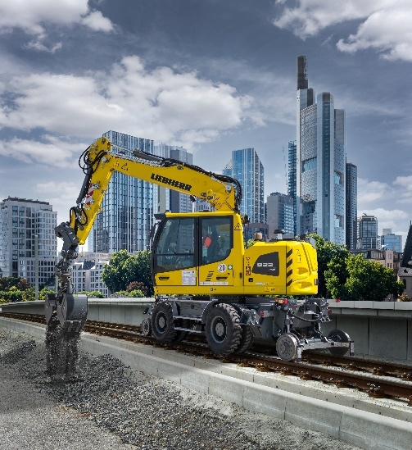

liebherr-a922rail-innotrans.jpg  
Liebherr is presenting the A 922 Rail Litronic, a representative of its successful railroad excavators, at Innotrans 2024.

Contact

Marc Wiedenmann   
Marketing   
Phone: +49 7354 / 80 - 8494   
Email: marc.wiedenmann@liebherr.com

Published by

Liebherr-Hydraulikbagger GmbH   
Kirchdorf an der Iller / Germany  
[www.liebherr.com](http://www.liebherr.com)