Press release

New Liebherr mobile cranes for Scotland

⸺

New Liebherr LTM 1150-5.3 for Stoddart Crane Hire

10-tonne axle load crucial for many routes in the Highlands

Family business focuses on crane jobs on Scotland’s islands

To mark its 20th anniversary, Stoddart Crane Hire gave itself a special gift: just in time for its planned summer celebrations, the Scottish crane service provider put a new Liebherr LTM 1150-5.3 mobile crane into operation. The family-run business, based in Muir of Ord, west of Inverness and about 10 kilometres from the famous Loch Ness, has made a name for itself as a crane service provider on Scotland's islands, among other areas.

Ehingen (Donau) (Germany), 25 September 2024 – "Besides the Highlands, the islands off the Scottish coast are a major part of our large operating area," says Ewan Stoddart, who runs the company alongside his sister Kerri and his father David. "We’ve done jobs with our mobile cranes on most of the inhabited islands here, and we usually have one or more cranes in operation on the islands." Often, due to a lack of alternatives, the cranes and heavy transporters need to be transported to the islands by landing craft, which is always a major logistical challenge. Currently, Stoddart's LTM 1040-2.1 and LTM 1090-4.2 are in operation on the Shetland Islands. "On Unst, Scotland's northernmost inhabited island, about 400 kilometres away, we're currently building a new launch ramp for the local spaceport. Our new LTM 1150-5.3 has already been deployed in this island group as well," says Ewan Stoddart.

"Twenty-nine tonnes of ballast while driving is impressive"

"A key factor in acquiring the new 150-tonne mobile crane was the ability to drive it on public roads with a 10-tonne axle load. This is often a requirement en route to our customers," explains Stoddart. "The narrow roads here in the Highlands and on the islands frequently cause us problems, but we can usually manage thanks to the flexible ballast configurations on Liebherr cranes. This flexibility is also a major advantage on the ferries that transport us to the islands."

"Another key advantage of the new crane is that it can carry an impressive 29 tonnes of ballast, reducing the need to transport additional ballast," says Ewan Stoddart. "Not having to deliver additional ballast blocks by truck means significant cost savings for us and our customers."

Stoddart Crane Hire presented its new addition to a large group of customers and guests during the company's anniversary celebrations this summer. The family business, founded by Ewan's father David 20 years ago, employs 34 people and currently operates seven smaller crawler cranes, along with a fleet of 14 mobile cranes, which will gradually be replaced exclusively with Liebherr models. In the last three years alone, six LTM cranes have been added to Stoddart's fleet. Its most powerful crane is the LTM 1230-5.1.

**About Liebherr-Werk Ehingen GmbH**

Liebherr-Werk Ehingen GmbH is a leading manufacturer of mobile and crawler cranes. Its range of mobile cranes extends from 2-axle 35 tonne cranes to heavy duty cranes with a lifting capacity of 1200 tonnes and a 9-axle chassis. Its lattice boom cranes on mobile or crawler travel gear deliver lifting capacities of up to 3000 tonnes. With universal boom systems and extensive additional equipment, they can be seen in action on construction sites throughout the world. The Ehingen site has a workforce of 5,000. An extensive, global service network guarantees the high availability of Liebherr mobile and crawler cranes. In 2023, the Liebherr plant in Ehingen recorded a turnover of 2.81 billion euros.

**About the Liebherr Group – 75 years of moving forward**

The Liebherr Group is a family-run technology company with a highly diversified product programme. The company is one of the largest construction equipment manufacturers in the world. It also provides high-quality, user-oriented products and services in a wide range of other areas. The Liebherr Group includes over 150 companies across all continents. In 2023, it employed more than 50,000 staff and achieved combined revenues of over 14 billion euros. Liebherr was founded by Hans Liebherr in 1949 in the southern German town of Kirchdorf an der Iller. Since then, the employees have been pursuing the goal of achieving continuous technological innovation, and bringing industry-leading solutions to its customers. Under the slogan ‘75 years of moving forward’, the Group celebrates its 75th anniversary in 2024.

Images:

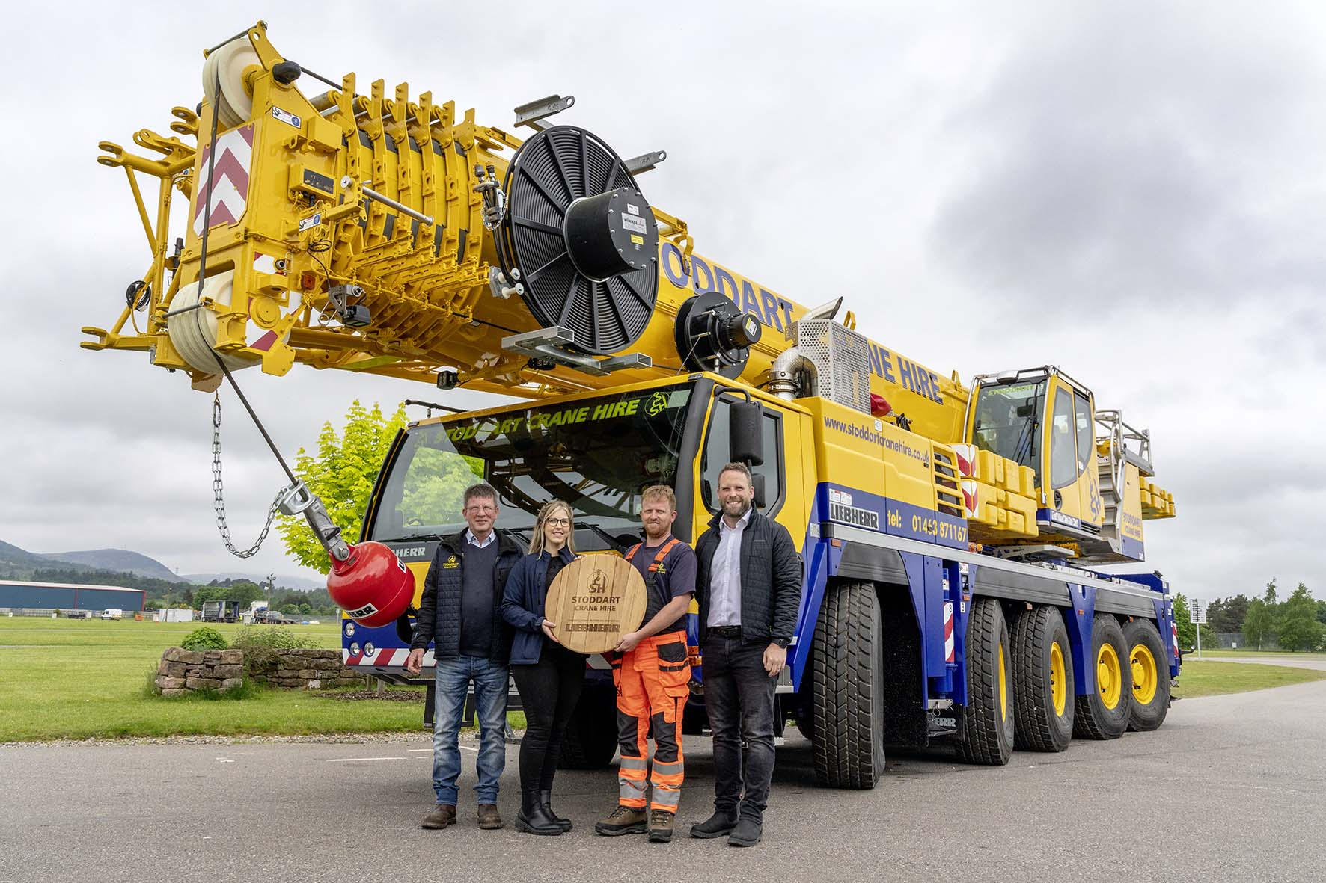

Liebherr-ltm1150-5.3-handover.jpg   
Company founder David Stoddart (left) with his daughter Kerri and son Ewan, receiving the new LTM 1150-3.1 from Lyle Sibbald (Liebherr-Great Britain Ltd.).

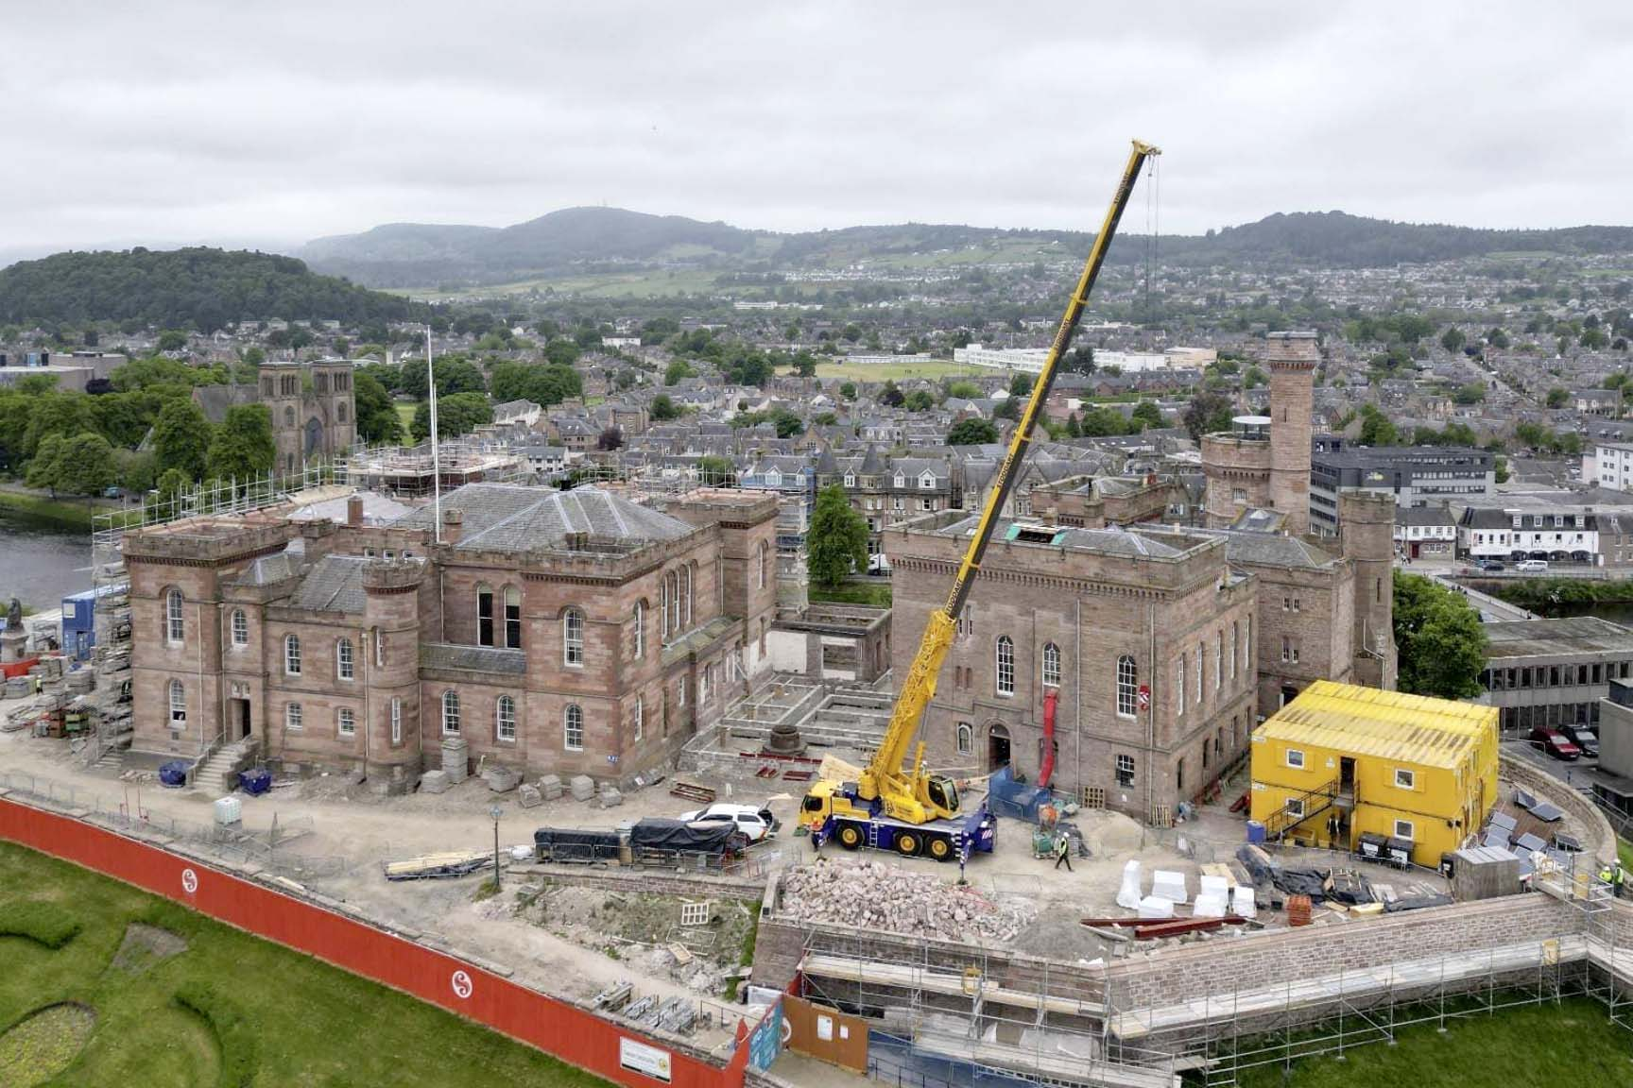

liebherr-ltm1060-3.1-stoddart.jpg   
An LTM 1060-3.1 from Stoddart Crane Hire at work at "Inverness Castle" in the capital of the Scottish Highlands.

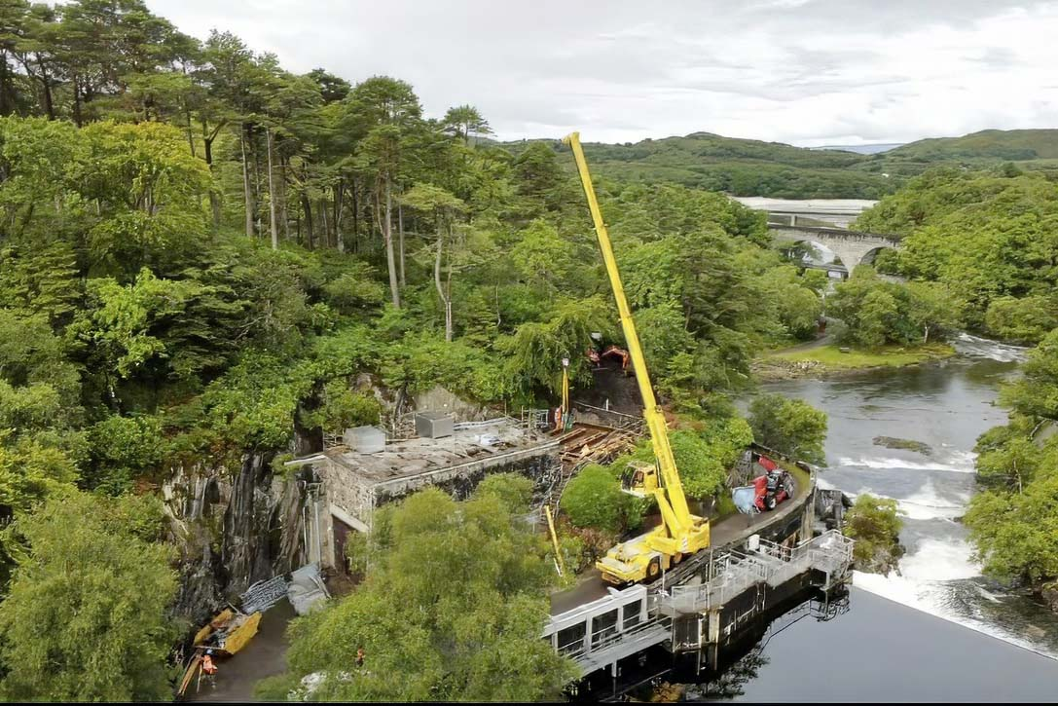

liebherr-ltc1045-3.1-stoddart.jpg   
The company's fleet also includes an LTC 1045-3.1, which can be seen here in operation on the River Morar on Scotland's west coast. "On cramped construction sites like this one," notes Ewan Stoddart, "the flexible VarioBase® crane outriggers are usually indispensable."

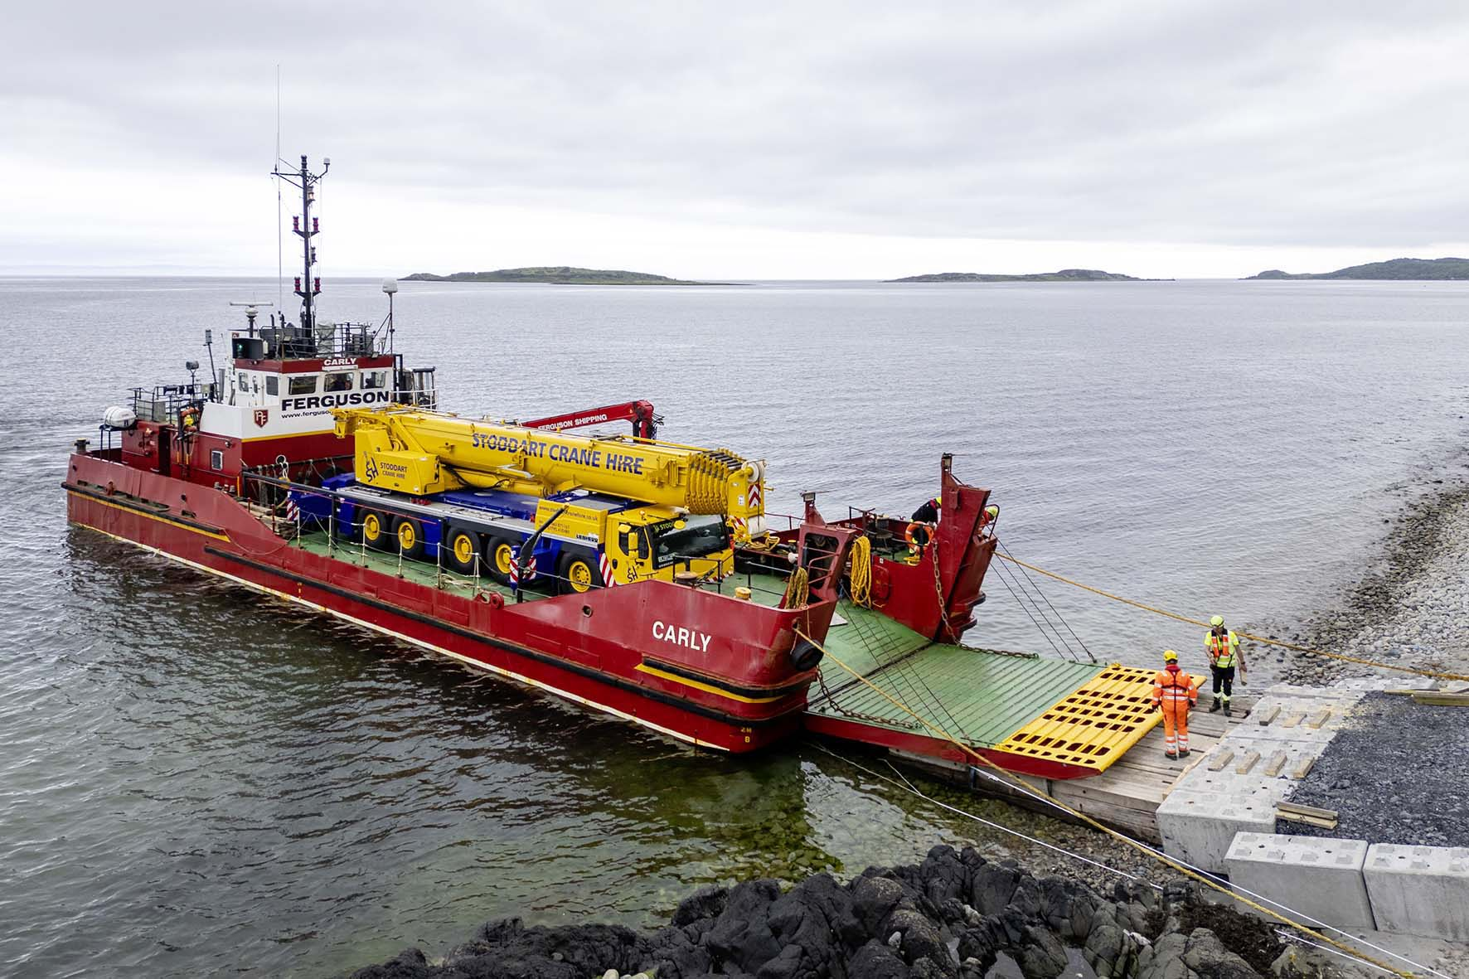

liebherr-ltm1230-5.1-stoddart.jpg  
Stoddart cranes regularly tackle jobs on the islands off the Scottish coast. In this case, the company’s most powerful crane, a Liebherr LTM 1230-5.1, is being prepared for sea transport on a landing craft. The entire ballast and hook block have been removed to reduce the crane's weight.

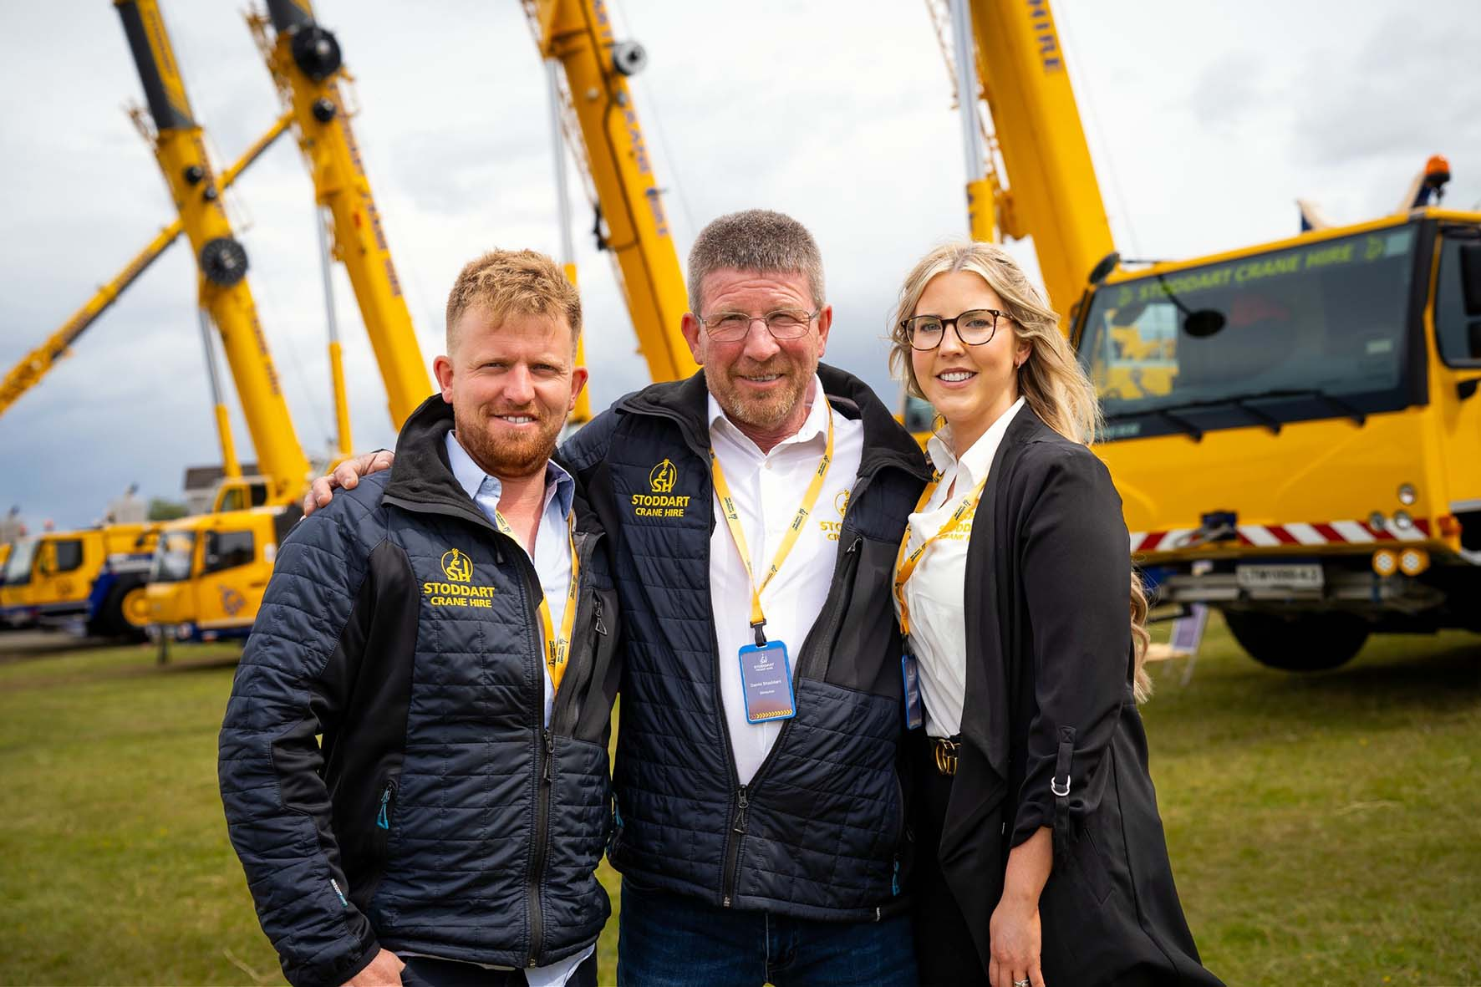

Stoddart-family.jpg  
Company founder David Stoddart with his daughter Kerri and son Ewan at the company’s anniversary celebrations. They jointly manage the continuously expanding family business.

**Contact person**

Wolfgang Beringer  
Marketing and Communication  
Phone: +49 7391 / 502-0  
Email: wolfgang.beringer@liebherr.com

**Published by**

Liebherr-Werk Ehingen GmbH  
Ehingen (Donau) / Germany  
www.liebherr.com