Press release

Better in every detail: the new 440 HC-L from Liebherr

⸺

Out-of-service position under eleven metres

First ever use of aramid fibre guying for a luffing jib

Improved performance values and optimised assembly times

The next generation of Liebherr luffing jib cranes has arrived. The 440 HC-L easily manages an out-of-service position of less than eleven metres, reducing the space required. Lifting capacity has been increased, new materials have found their way into crane production and assembly times are now shorter.

Biberach (Riß), Germany, 26 September 2024 – Liebherr’s new 440 HC-L luffing jib crane is a response to ever faster constructionß site cycles. This evolution of its successful predecessor, the 357 HC-L, comes with improved performance values and is available in two versions: the 440 HC-L 12/24 and the 18/36. The maximum lifting capacity of the 440 HC-L 18/36 has increased from 32 to 36 tonnes. It has also been possible to raise the tower height of both crane versions by one tower section compared to the previous model.

Out-of-service position under eleven metres

The new 440 HC-L requires very little space for a crane of its size: an out-of-service position of up to 10.7 metres or a minimum working radius of less than four metres is possible. In practical terms, this means that the crane can be set up closer to buildings, property boundaries or another luffing jib crane, which makes site planning easier. Depending on the situation, the out-of-service position makes it possible to accommodate and operate an additional crane on site.

New crane, new material

This is the first time aramid fibre guying is being used for a luffing jib crane. The lightweight material reduces weight on the jib, resulting in a higher lifting capacity. Significant weight is saved compared to the use of steel ropes; dead load can consequently be transformed into load capacity. An aramid fibre guying system also offers advantages for crane assembly and disassembly owing to its lighter weight. Aramid fibre has already proven itself and become an established material with other Liebherr Group cranes, including crawler and maritime cranes.

Faster assembly possible

The 440 HC-L only requires one central switchgear cabinet. Electronic components are arranged in a plug-and-play set-up, which significantly reduces assembly time.

Assemblies are pre-assembled at the factory prior to the crane being delivered, thereby optimising transport costs and enabling the crane to be unloaded more quickly on site. The counter-jib ballast, which consists of a single block, also contributes to faster assembly and disassembly. Only nine transport units are needed for the slewing section at full jib length, including its counter-ballast.

Improved performance values

The 440 HC-L's maximum radius has increased to 65 metres and its jib head lifting capacity by up to 52 percent. The jib can be extended in five metre increments. Thanks to Load Plus, performance can be increased by up to 22 per cent at the touch of a button. With a 50-metre jib, for example, the maximum jib head lifting capacity increases from 7.5 tonnes to 9 tonnes. Tower heights have also been significantly improved: the free-standing height has been increased by up to 5.8 metres, the maximum assembly height (free-standing) measures in at up to 76.4 metres. This makes planning climbing steps more flexible.

The luffing jib crane is available with Liebherr’s own trusted drives and the latest TC-OS control unit for simple crane operation.

About the Liebherr Tower Cranes Division

More than seven decades of experience have made Liebherr a recognised specialist for lifting technology on all types of construction sites. The range of Liebherr Tower Cranes encompasses an extensive selection of high-quality tower cranes that are used worldwide. This includes fast-erecting, top-slewing, luffing jib and special-purpose cranes as well as mobile construction cranes. In addition to these products, Liebherr also offers a wide range of services that complete the company’s portfolio: Tower Crane Solutions, the Tower Crane Center and Tower Crane Customer Service.

About the Liebherr Group – 75 years of moving forward

The Liebherr Group is a family-run technology company with a widely diversified product programme. The company is one of the largest construction equipment manufacturers in the world. It also provides high-quality, user-oriented products and services in a wide range of other areas. The Liebherr Group includes over 150 companies across all continents. In 2023, it employed more than 50,000 staff and achieved combined revenues of over 14 billion euros. Liebherr was founded by Hans Liebherr in 1949 in the southern German town of Kirchdorf an der Iller. Since then, employees have been pursuing the goal of achieving continuous technological innovation, and bringing industry-leading solutions to its customers. Under the slogan ‘75 years of moving forward’, the Group celebrates its 75th anniversary in 2024.

Ein Bild, das Himmel, Wolke, draußen, Kran enthält.
Images

liebherr-440-hc-l-01.jpg  
The 440 HC-L is capable of lifting up to 36 tonnes.

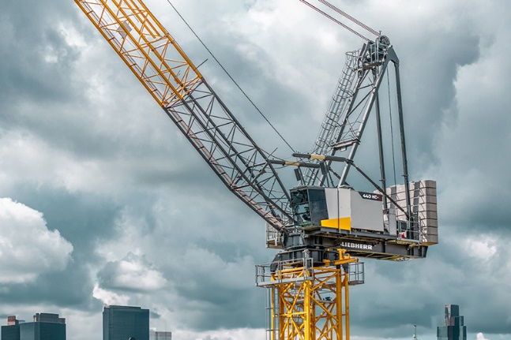

liebherr-440-hc-l-02.jpg  
The new and improved crane has an out-of-service position of less than 11 metres.

Contact

Astrid Kuzia  
Communication Specialist  
Phone: +49 7351 / 41 – 4044  
Email: astrid.kuzia@liebherr.com

Published by

Liebherr-Werk Biberach GmbH  
Biberach / Germany  
[www.liebherr.com](http://www.liebherr.com)