Press release

Compact and powerful: R. Kölch & Sohn GmbH takes delivery of LTM 1090-4.2

⸺
The Liebherr LTM 1090-4.2 features compact dimensions
Kölch will use the Liebherr 90 tonne model universally
Positive contact with Liebherr and smooth procedures
Alexander and Kurt Kölch paid a visit to Liebherr-Werk Ehingen in July 2024 with very good reason – the owners of Richard Kölch & Sohn GmbH were in Ehingen to take delivery of the keys for their new LTM 1090-4.2. After receiving induction training on the mobile crane, the LTM 1090-4.2 immediately set off from the manufacturing plant to its first job, the erection of a prefabricated house.
Ehingen (Donau) (Germany), 6 September 2024 – “The 90 tonner from Liebherr made a massive impression on us with its compact dimensions”, explains Alexander Kölch, Managing Director of Franconian company, Richard Kölch & Sohn GmbH. “Machine relocation and transport jobs are a big area for us. The jobs often take place in constricted areas which is why we were looking for a powerful, compact crane.” The LTM 1090-4.2 impressed the family-run company with its width of just 2.55 metres. The maximum support base is 7.46 metres by 7.3 metres. Thanks to its VarioBase® variable supporting base, the 90 tonne machine is flexible enough to adjust to any site – the sliding beams can accept a load at any point and can be extended to any positions. At the same time, the LTM 1090-4.2 has high lifting capacities and a large working area due to its 60 metre telescopic boom. Short set-up times mean that the 90 tonne machine can quickly be readied for use at the site.
Alexander Kölch also says that in addition to the technical features, personal contact with Liebherr played a major role in deciding to buy from the company: “We are completely delighted with the whole procedure. From the initial talks and the demonstration to the final delivery, everything was very positive and we felt valued by Liebherr.”
The new LTM 1090-4.2 will supplement and improve the Richard Kölch & Sohn GmbH crane fleet. The Fürth-based family-run company operates throughout Germany and has an extensive fleet of mobile cranes which are used for a wide range of hoisting jobs in various industries. The Liebherr 4-axle model fits perfectly into the company’s fleet thanks to the fact that it is designed for universal use.

About Liebherr-Werk Ehingen GmbH
Liebherr-Werk Ehingen GmbH is a leading manufacturer of mobile and crawler cranes. Its range of mobile cranes extends from 2-axle 35 tonne cranes to heavy duty cranes with a lifting capacity of 1200 tonnes and a 9-axle chassis. Its lattice boom cranes on mobile or crawler travel gear deliver lifting capacities of up to 3000 tonnes. With universal boom systems and extensive additional equipment, they can be seen in action on construction sites throughout the world. The Ehingen site has a workforce of 5,000. An extensive, global service network guarantees the high availability of Liebherr mobile and crawler cranes. In 2023, the Liebherr plant in Ehingen recorded a turnover of 2.81 billion euros.
About the Liebherr Group – 75 years of moving forward
The Liebherr Group is a family-run technology company with a highly diversified product programme. The company is one of the largest construction equipment manufacturers in the world. It also provides high-quality, user-oriented products and services in a wide range of other areas. The Liebherr Group includes over 150 companies across all continents. In 2023, it employed more than 50,000 staff and achieved combined revenues of over 14 billion euros. Liebherr was founded by Hans Liebherr in 1949 in the southern German town of Kirchdorf an der Iller. Since then, the employees have been pursuing the goal of achieving continuous technological innovation, and bringing industry-leading solutions to its customers. Under the slogan ‘75 years of moving forward’, the Group celebrates its 75th anniversary in 2024.

Caption
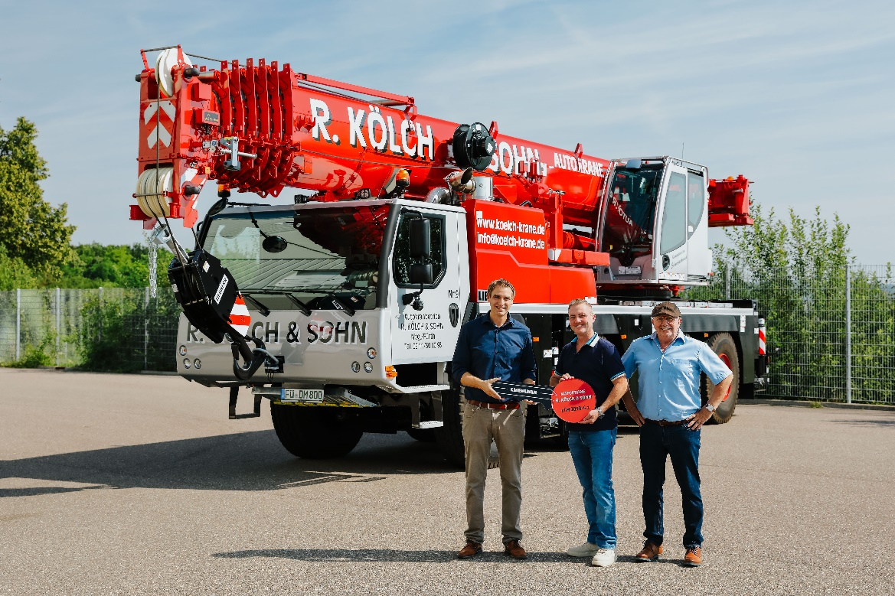
liebherr-ltm1090-4.2-koelch.jpg
Crane handover in Ehingen (from left to right): Florian Maier (Liebherr-Werk Ehingen), Alexander Kölch, Kurt Kölch (both from R. Kölch & Sohn GmbH)

Contact person
Wolfgang Beringer
Marketing and Communication
Phone: +49 7391/502 - 3663
E-mail: wolfgang.beringer@liebherr.com
Published by
Liebherr-Werk Ehingen GmbH
Ehingen (Donau) / Germany
www.liebherr.com

