Press release

Liebherr RL series powers 2 GW platforms for Dragados Offshore

⸺

Liebherr closes a deal of 10 units of the Ram Luffing RL 2600 offshore crane

The cranes, known for their distinctive and compact design, will be supplied over the next five years

The Liebherr RL series ensures operability in extreme conditions without compromising maximum reliability in demanding offshore environments

The RL 2600 cranes have been acquired by Dragados Offshore, located in Spain. With a maximum lifting capacity of 35 tonnes and an outreach of 45 metres, the crane is perfectly suited for maintenance and supply operations in the offshore sector. Its versatility allows it to handle a wide range of tasks, from routine maintenance to supply operations, ensuring that offshore platforms remain productive and well-maintained. This crane is the most compact one in Liebherr’s offshore portfolio. The well-designed, compact, and weight-optimised crane construction of the RL series ensures optimal utilisation, even in confined spaces.

Rostock (Germany), September 2024 – A breath of fresh air from the North Sea with the offshore all-rounder RL 2600 from Liebherr. At Dragados Offshore’s facilities in Puerto Real, Cadiz, a frame agreement has been signed between Liebherr and the engineering, procurement and construction (EPC) contractor. The agreement guarantees the supply of 10 RL 2600 offshore cranes to be used on the platforms that Dragados Offshore will manufacture for European companies and which will be delivered to the North Sea.

Both parties already share a common history. The close collaboration between Liebherr and Dragados Offshore goes back more than a decade, since Liebherr began supplying Dragados Offshore with crawler cranes for the assembly of the impressive structures that Dragados Offshore designs and builds at its facilities in the Bay of Cadiz. “The new deal validates Liebherr’s expertise in the offshore wind sector and is a significant opportunity to strengthen the existing relationships that both companies have in the offshore industry,” expresses Matti Basan, Senior Sales Manager at Liebherr-MCCtec Rostock GmbH.

The latest generation of the RL series

The equipment chosen by Dragados Offshore is the RL 2600. Its compactness is underlined by a sleek design. It is therefore an ideal solution for operators where space is limited as it offers a reduced tail radius. With a possible maximum outreach of up to 45 metres and a lifting capacity of up to 35 tonnes, it is an ideal choice for maintenance and supply work, especially in the wind power industry. This also benefits Dragados’ latest generation of 2 GW platforms, which perform the function of an electrical substation. They collect the energy from the wind turbines, convert it and deliver it to land.

Liebherr Intelligent Maintenance for modern maintenance

Additionally, Dragados Offshore opted in for the sophisticated maintenance system, Liebherr Intelligent Maintenance, or LiMain. It revolutionises maintenance for Liebherr maritime cranes by enabling remote service from shore. This innovative approach minimises the need for on-site visits, reducing costs and environmental impact. Operators can select from various modules to tailor intelligent maintenance to their specific needs. Whether it’s monitoring or maintenance, LiMain ensures efficient, sustainable crane operation, independent of location or time.

Marco Gonzalez, Sales Manager for maritime cranes at Liebherr Ibérica, commented: “We’re proud to close this significant contract with Dragados Offshore. Liebherr is actively collaborating with Dragados Offshore, and Liebherr Ibérica will play a key role in assembling the equipment and providing technical support.”

About Liebherr-MCCtec Rostock GmbH

Liebherr-MCCtec Rostock GmbH is one of the leading European manufacturers of maritime handling solutions. The product range includes ship, mobile harbour and offshore cranes. Reach stackers and components for container cranes are also included in the product portfolio.

About the Liebherr Group – 75 years of moving forward

The Liebherr Group is a family-run technology company with a highly diversified product programme. The company is one of the largest construction equipment manufacturers in the world. It also provides high-quality, user-oriented products and services in a wide range of other areas. The Liebherr Group includes over 150 companies across all continents. In 2023, it employed more than 50,000 staff and achieved combined revenues of over 14 billion euros. Liebherr was founded by Hans Liebherr in 1949 in the southern German town of Kirchdorf an der Iller. Since then, the employees have been pursuing the goal of achieving continuous technological innovation, and bringing industry-leading solutions to its customers. Under the slogan ‘75 years of moving forward’, the Group celebrates its 75th anniversary in 2024.

About Dragados Offshore

Founded in 1972, Dragados Offshore, S.A.U. has five decades of experience in the management of offshore and onshore projects within the energy, oil and gas sector. This gives them a solid track record, assuring their clients that their most complex and demanding projects are planned, developed and delivered successfully. They are a solutions-based company with an optimal and effective corporate structure that allows them to offer flexibility by tailoring their work to the exact needs of each client. They provide an effective method of integral project development, safety, quality and compliance with the established schedule.

Images

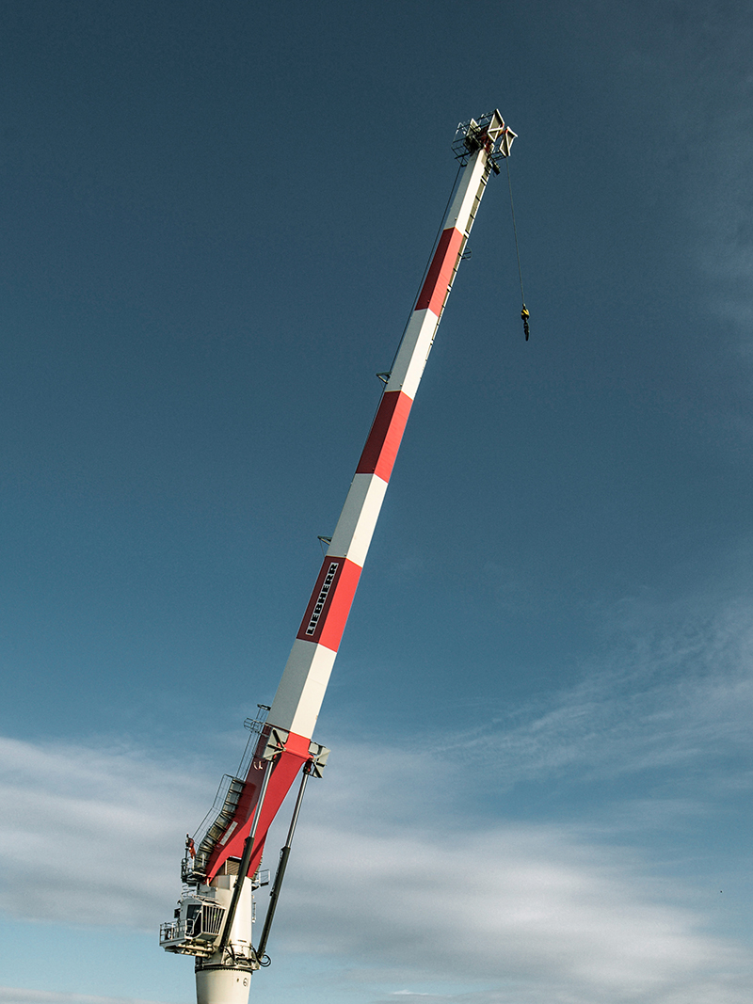

liebherr-rl2600-dragados-offshore-1.jpg  
The Ram Luffing Crane RL 2600 is characterised by a weight-optimised and compact design. Especially in the wind power industry, the RL cranes are mainly used for maintenance and supply work.



liebherr-rl2600-dragados-offshore-2.jpg  
The compactness of the RL series results in a reduced construction height and a small tail radius. The elimination of a machinery house allows the crane to operate in confined space conditions and environments.

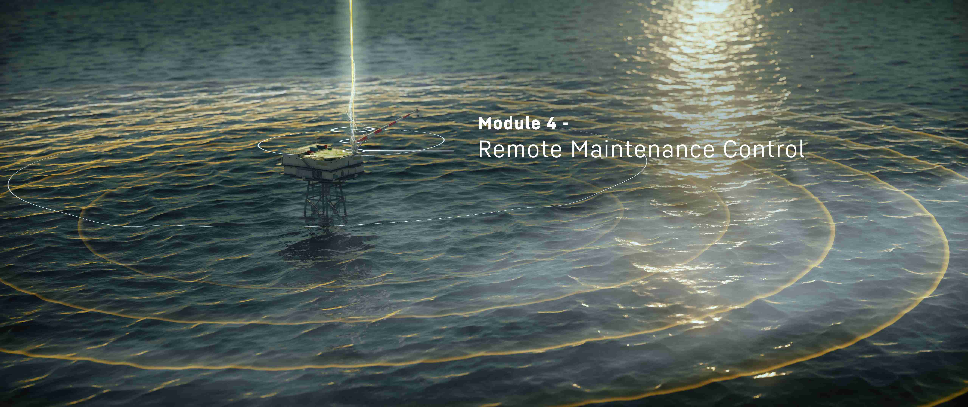

liebherr-rl2600-dragados-offshore-3.jpg  
LiMain empowers maintenance regardless of time or location. Platform operators have the flexibility to select from a range of modules, allowing them to customise the level of autonomy and the extent of intelligent maintenance for the crane.

Contact

Constanze Jantsch

Marketing Manager - Offshore Cranes

Tel: +49 381 60065022

Email: constanze.jantsch@liebherr.com

Published by

Liebherr-MCCtec Rostock GmbH

Rostock / Germany

www.liebherr.com