Press information

111 years of Hüffermann:   
EUR 222 million invested in Liebherr cranes over the last three years

⸺

Hüffermann has evolved from a wagon workshop to a full-service provider

Liebherr cranes have played a major role in the company's growth

Liebherr’s e-learning services support Hüfferman's training strategy

**This year, Hüffermann is celebrating its 111th anniversary. Through strategic growth, the company based in Wildeshausen, Lower Saxony, has evolved from a wagon workshop to a corporate group with over 800 employees. Hüffermann is a full-service provider for heavy-duty crane and project engineering solutions. Its ongoing procurement of Liebherr mobile and crawler cranes, as well as Liebherr tower cranes since 2021, has played a significant role in the company’s expansion.**

Ehingen (Donau) (Germany), 11 September 2024 – Over the past three years, the Hüffermann Group has purchased Liebherr cranes worth a total of 222 million euros. Managing Partner Daniel Janssen explains: "This kind of growth is only possible with strong partners who guarantee cutting-edge technology and modern equipment, while recognising market needs. When it comes to cranes, Liebherr ticks all these boxes for us."

Hüffermann purchased its first Liebherr mobile crane back in the 1960s. During the 1970s and 1980s, Liebherr was at the forefront of technical advancements in mobile cranes, introducing the all-terrain crane concept with its LTM series. Numerous innovations followed, including the recent Liebherr VarioBase® system. Over the decades, Hüffermann has consistently invested in new Liebherr crane models and technology.

**Expansion into the large-crane segment**

In 2014, Hüffermann expanded its fleet with a Liebherr LTM 1350-6.1, marking the company’s entry into the large-crane segment. Just a year later, the addition of a LTM 1500-8.1 significantly enhanced the fleet’s capabilities. Growth continued as the Hüffermann Group acquired more mobile cranes, including the LTM 1750-9.1 and LG 1750. Simultaneously, the company expanded its crane fleet in the lower lifting capacity segment with the acquisition of Liebherr telescopic crawler cranes, including the LTR 1220, and mobile construction cranes, such as the MK 140. In 2017, Hüffermann entered the large-crawler-crane segment by purchasing the LR 1750/2. In 2021, a Liebherr LR 11000 was added, increasing the fleet's maximum lifting capacity to 1,000 tonnes.

**Tower cranes broaden the portfolio**

In 2021, Hüffermann took a major strategic step towards becoming a full-service provider by acquiring its first tower cranes. The company now owns 250 units, including top-slewing models ranging from the 125 EC-B to the 520 EC-B Fibre, as well as fast-erecting cranes from the 13 HM to the 125 K. Christoph Rieß, Head of Hüffermann’s Tower Crane Department, says: "We exclusively rely on Liebherr in the tower crane sector, which enables us to offer the latest technology and control systems on the market. Although demand for tower cranes in the construction industry has declined, they are currently in high demand in sectors like energy supply and infrastructure. Our strong partnership with Liebherr extends well beyond the initial purchase. Alongside excellent collaboration with the sales team, the Tower Crane Solutions department offers us valuable support for large and specialised projects. Through digital project planning, we develop site layouts, perform specialised structural calculations and create customised solutions."  
  
**Crane academy for comprehensive training**  
Hüffermann prioritises comprehensive employee training, incorporating Liebherr’s e-learning offerings. Daniel Janssen explains: "Liebherr's e-learning modules perfectly complement our crane operator training and continuous education programmes. We've established a crane academy in Wildeshausen to focus on practical training, while theoretical knowledge, technology and safety practices are covered through e-learning. This allows participants to access materials and review practical topics at their own pace."

**The Hüffermann Group**

Today, the Hüffermann Group employs around 800 people across twelve locations in seven German federal states. Since 2018, Hüffermann has expanded its operations through the acquisition of several crane companies, including Autodienst West Ganske GmbH, velsycon GmbH, Eisele AG – Crane & Engineering Group, the Thömen Group, and Knaack AG. "These are long-established medium-sized crane companies that were sold due to succession issues," says Janssen. "We have retained their staff and are continuing to develop their locations. Most of our growth has occurred in the operational sectors. This expansion also includes adapting our organisational structure to meet new requirements, such as Environmental, Social and Governance (ESG) considerations. At the Hüffermann Group, we are deeply committed to protecting both people and the environment. Our philosophy is grounded in ethical corporate governance, respect, economic and ecological responsibility, and forward-thinking solutions. Protecting our employees and the business is our top priority."

**About Liebherr-Werk Ehingen GmbH**

Liebherr-Werk Ehingen GmbH is a leading manufacturer of mobile and crawler cranes. Its range of mobile cranes extends from 2-axle 35 tonne cranes to heavy duty cranes with a lifting capacity of 1200 tonnes and a 9-axle chassis. Its lattice boom cranes on mobile or crawler travel gear deliver lifting capacities of up to 3000 tonnes. With universal boom systems and extensive additional equipment, they can be seen in action on construction sites throughout the world. The Ehingen site has a workforce of 5,000. An extensive, global service network guarantees the high availability of Liebherr mobile and crawler cranes. In 2023, the Liebherr plant in Ehingen recorded a turnover of 2.81 billion euros.

**About the Liebherr Group – 75 years of moving forward**

The Liebherr Group is a family-run technology company with a highly diversified product programme. The company is one of the largest construction equipment manufacturers in the world. It also provides high-quality, user-oriented products and services in a wide range of other areas. The Liebherr Group includes over 150 companies across all continents. In 2023, it employed more than 50,000 staff and achieved combined revenues of over 14 billion euros. Liebherr was founded by Hans Liebherr in 1949 in the southern German town of Kirchdorf an der Iller. Since then, the employees have been pursuing the goal of achieving continuous technological innovation, and bringing industry-leading solutions to its customers. Under the slogan ‘75 years of moving forward’, the Group celebrates its 75th anniversary in 2024.

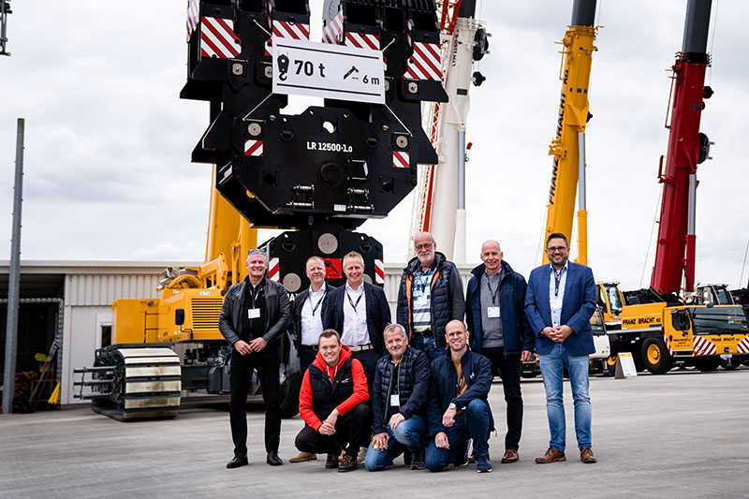Captions

liebherr-hueffermann-2024.jpg  
Hüffermann’s Managing Partner Daniel Janssen (top row, third from left) with his team at the 2024 Customer Days at Liebherr in Ehingen-Berg.

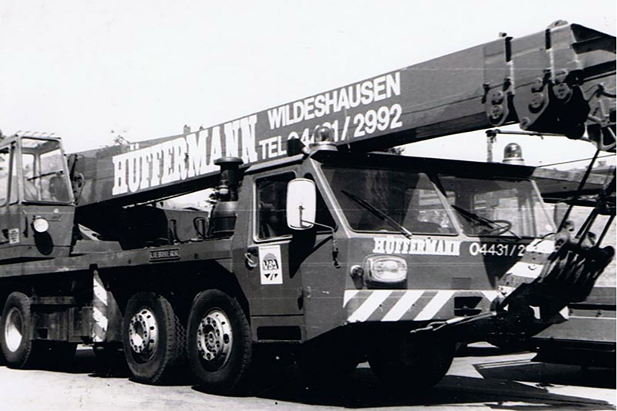

erster-kran-hueffermann-liebherr.jpg  
Hüffermann began purchasing Liebherr mobile cranes as early as the 1960s and 1970s.

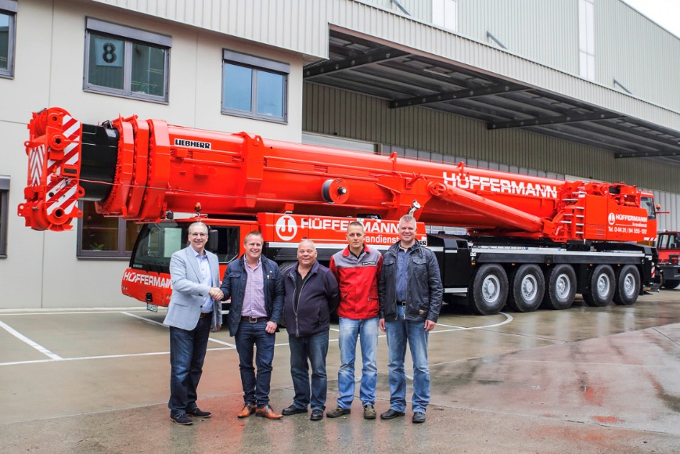

liebherr-ltm-1500-8-1-hüffermann  
The acquisition of its first LTM 1500-8.1 in 2015 was a milestone in Hüfferman's history.

Contact person

Wolfgang Beringer  
Marketing and Communication  
Phone: +49 7391 / 502-0  
E-mail: wolfgang.beringer@liebherr.com

Published by

Liebherr-Werk Ehingen GmbH  
Ehingen (Donau) / Germany  
www.liebherr.com