Press release

Liebherr unveils new Freestanding bottom freezers

⸺
Seven new products reveal elegant and sustainable options for the American kitchen.
Liebherr Refrigerators and Freezers introduces new 30” freestanding bottom freezers as portfolio expansion of recently launched 24” products, meeting industry needs with sustainable technology and best in class Energy Consumption.
Miami, FL (USA), September 13th, 2024 – Liebherr USA, Co., Refrigerators and Freezers - For more than 70 years, Liebherr has been pushing the limits of technology, efficiency and design. With the debut of the newest models within the freestanding collection, Liebherr is once again showcasing its revolutionary technology and expertise within the refrigeration and freezing appliance category.
Under its initiative of "shaping the future of freshness,” Liebherr’s products are geared towards accomplishing a more sustainable future. The new bottom freezers have been developed with the goal of achieving high levels of energy efficiency, longer service life and reducing food waste through BioFresh technology.
BioFresh offers sophisticated technology that extends the lifespan of your organic food in the refrigerator fresh for even longer – giving you more time to enjoy it and reducing food waste. In the different drawers, all groceries get the exact individual climatic conditions they need. BioFresh also ensures that vitamins and other ingredients are preserved in the best possible way and that everything comes out of the refrigerator just as fresh and appetizing as when it was put in, even after being in there for a while. No matter whether it is fruit and vegetables, meat or fish.
Additional to its timeless elegant design, other features included are DuoCooling, BioFresh Professional with HydroBreeze and Fish&Seafood, VarioTemp, InfinitySpring and LightTower.
With the expanded portfolio, Liebherr offers valued solutions not only for niches of 24 & 30”, as well for niches of 48 and 60”, as several models can be combined in side-by-side installations creating a food preservations center with 4 to 6 precise temperature zones to keep food and drinks to the right temperature for long lasting preservation and consumption.
Following our compromise with the planet, the latest Liebherr freestanding appliances provide customers with effective energy consumption, being all listed 2024 EnergyStar Most Efficient bottom freezers. Liebherr achieves this by using innovative technology – only high-quality vacuum insulation panels with silica are used in the appliances. The silica ensures that energy consumption stays low even after many years of use. Optimally harmonized electronics and compressor performance also help ensure that the appliances only require a little electricity despite continuous operation.
“Liebherr is proud to be expanding the product portfolio for North America,” said Alex Squarize, Divisional Director of the Refrigerators and Freezers division at Liebherr USA, Co. “These demonstrate the very best in food preservation while wrapped in European style design.”
Liebherr’s reputation as a world leader in technology and design stems from listening to what matters most to customers, then meeting their needs with sustainable technology, in the most attractive forms. Products are created to integrate seamlessly into all styles of American kitchens, providing energy efficiency, sustainable technology, and an elegant look with cutting-edge features.
For more information on Liebherr and the latest products, please visit home.liebherr.com
About the Liebherr USA, Co.
Liebherr USA, Co. based in Newport News, VA provides sales and service on behalf of ten different Liebherr product segments: earthmoving, material handling, mining, mobile and crawler cranes, tower cranes, concrete technology, deep foundation machines, maritime cranes; components, and refrigeration and freezing.
About the Liebherr Group – 75 years of moving forward.
The Liebherr Group is a family-run technology company with a highly diversified product portfolio. The company is one of the largest manufacturers of construction equipment in the world. It also provides high-quality, user-oriented products and services in a wide range of other areas. The Liebherr Group includes over 150 companies across all continents. In 2023, it employed more than 50,000 staff and achieved combined revenues of over 14 billion euros. Liebherr was founded by Hans Liebherr in 1949 in the southern German town of Kirchdorf an der Iller. Since then, the staff have been pursuing the goal of achieving continuous technological innovation and bringing industry-leading solutions to its customers. Under the slogan ‘75 years of moving forward’, the Group celebrates its 75th anniversary in 2024.
Images
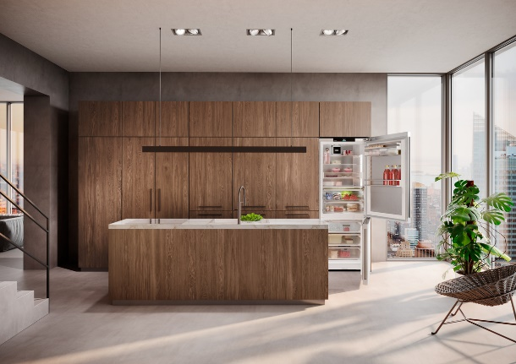
liebherr-usa-model-CB7790IM.jpg
Liebherr refrigerators and freezers offer many features including DuoCooling, BioFresh Professional with HydroBreeze and Fish&Seafood, VarioTemp, InfinitySpring and LightTower.

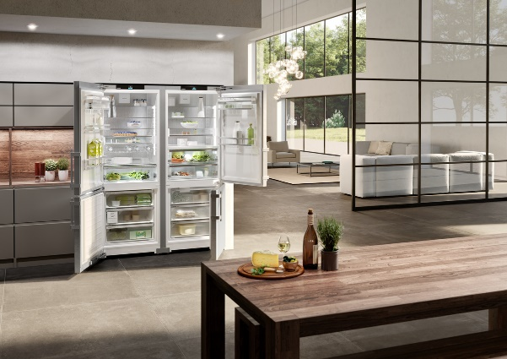
liebherr-usa-model-SC7751_SCB7760IM.jpg
Liebherr Refrigerators and Freezers introduces new 30” freestanding bottom freezers as portfolio expansion of recently launched 24” products.
Contact

Ana Cabiedes  Head of Marketing  Liebherr USA, Co.  Phone: +1 757 240 4250  E-mail: ana.cabiedes@liebherr.com | Silvia Puigdemont  Regional Product Manager  Liebherr USA, Co., Refrigerators and Freezers  Phone: +1 305-817-7500  E-mail: silvia.puigdemont@liebherr.com
Published by
Liebherr USA, Co.
Newport News / USA
www.liebherr.com

