Press release

Liebherr delivers high-quality ship to shore (STS) container crane from Ireland to PSA Penn Terminals

⸺

This is the third Liebherr STS at PSA Penn Terminals in the Port of Philadelphia

Crane designed and manufactured in Ireland and delivered to Eddystone, Pennsylvania

Liebherr provides cutting-edge, reliable, and cost-effective solutions for US ports, ensuring enhanced operational performance and long-term value

Liebherr announces the handover of an additional STS crane to a longstanding customer, continuing its track record of providing state-of-the-art container handling technology to the North American market. With over 130 Liebherr maritime cranes playing a crucial role in the region, Liebherr remains a trusted partner for US ports.

Liebherr Container Cranes Ltd. Killarney, Ireland, October 1, 2024 – PSA Penn Terminals in Philadelphia, PA has received a third Liebherr STS crane, further expanding their fleet of Liebherr equipment. This delivery reflects Liebherr’s ongoing commitment to supporting its US customers with high-quality machinery and comprehensive local product support, ensuring smooth and efficient port operations. With customizable designs and various outreaches to suit specific needs, Liebherr has been providing container cranes to US ports from its Irish manufacturing base for over four decades.

“This delivery highlights Liebherr Container Cranes position as a trusted partner for US container ports. Manufactured in Ireland and supported by our experienced US-based team, our cranes provide secure, dependable, and high-efficiency solutions for ports across the country.” said Winston Ziegler, Head of Sales, Maritime Cranes, Liebherr USA, Co. “At a time when performance pressure is constant, Liebherr STS cranes offer industry-leading availability during vessel operations.”

Robust partnership

In September, PSA Penn Terminals received its third Liebherr STS crane, complementing the two commissioned in 2018. John Brennan, President, and CEO of PSA Penn Terminals commented “This new Liebherr ship to shore crane once again demonstrates our lasting commitment to being one of the best equipped, privately owned container terminals on the US East Coast. These facilities, combined with our dedicated and experienced work force, allow us to provide top-of-the-line efficient and reliable services to our customers.”

The new STS crane features an 157 ft (48 m) outreach, a 60 ft (18.288 m) span, and a 50 ft (15 m) back reach. With a lift height of 115 ft (35 m) over rail and a safe working load (SWL) of 66 tonnes. The STS crane is designed to significantly boost operational efficiency and capacity at the terminal.

The delivery strengthens the ongoing collaboration between Liebherr and PSA, reinforcing the terminal’s capacity for efficient, high-volume container handling. As a trusted partner, Liebherr remains focused on providing cutting-edge solutions that support the productivity and long-term success of key ports across the United STATES.

Speaking from Ireland, Declan O’Sullivan, General Manager Sales with Liebherr Container Cranes Ltd., said, “Our first container crane delivery to the USA was in 1978, and since then, we have continued to supply high-performing cranes to meet the needs of our customers. With Liebherr’s in-house design and manufacturing capabilities in Ireland and across Europe, we can provide prompt service and meet customer requirements across the USA.”

Liebherr remains committed to advancing container handling solutions for US ports, ensuring our customers stay at the forefront of innovation and operational efficiency.

About Liebherr USA, Co.

[Liebherr USA, Co](https://www.liebherr.com/en/usa/start/start-page.html). based in Newport News, VA provides sales and service on behalf of ten different Liebherr product segments: earthmoving, material handling, mining, mobile and crawler cranes, tower cranes, concrete technology, deep foundation machines, maritime cranes, components refrigeration and freezing.

About Liebherr Container Cranes

Liebherr Container Cranes Ltd. Is one of the world’s leading manufacturers of ship to shore container cranes, rail mounted gantry cranes and rubber tire gantry cranes. From a base in Killarney, Ireland, Liebherr Container Cranes Ltd designs, builds and exports container cranes worldwide. Founded in 1958 as the first Liebherr factory outside of Germany, today, container cranes manufactured by Liebherr in Ireland are renowned for their quality, longevity, and productivity.

About the Liebherr Group – 75 years of moving forward

The Liebherr Group is a family-run technology company with a highly diversified product portfolio. The company is one of the largest manufacturers of construction equipment in the world. It also provides high-quality, user-oriented products and services in a wide range of other areas. The Liebherr Group includes over 150 companies across all continents. In 2023, it employed more than 50,000 staff and achieved combined revenues of over 14 billion euros. Liebherr was founded by Hans Liebherr in 1949 in the southern German town of Kirchdorf an der Iller. Since then, the staff have been pursuing the goal of achieving continuous technological innovation and bringing industry-leading solutions to its customers. Under the slogan ‘75 years of moving forward’, the Group celebrates its 75th anniversary in 2024.

.

Images

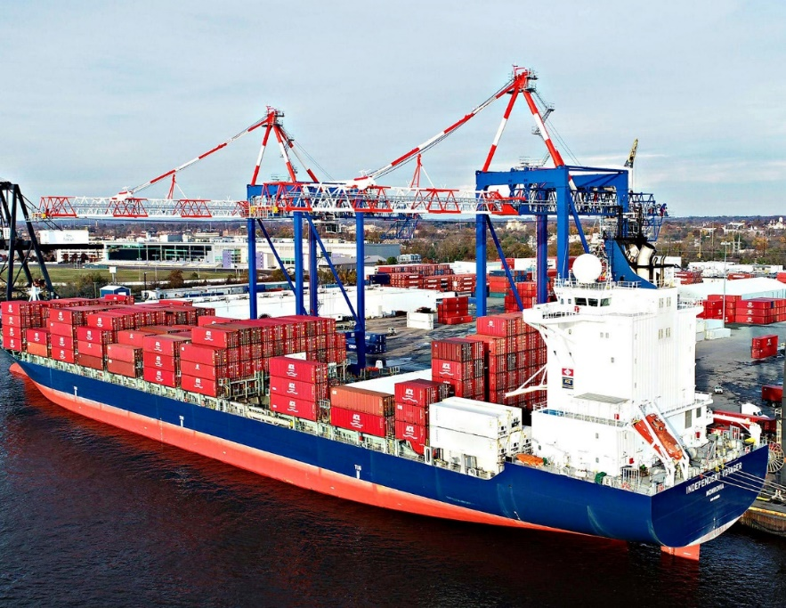

liebherr-psa-penn.jpg  
PSA Penn Terminals received their third STS container crane, the latest in a continuing partnership between PSA Penn Terminals and Liebherr

liebherr-sts-new.jpg  
The new Liebherr sts on the quayside at PSA Penn Terminals

Contact

|  |  |
| --- | --- |
| Ana Cabiedes  Head of Marketing  Liebherr USA, Co.  Phone: +1 757 240 4250  E-mail: Ana.Cabiedes@liebherr.com | Trevor O’Donoghue  Marketing Manager  Liebherr Container Cranes Ltd.  Phone: +353 (64)66 80459  E-mail: Trevor.ODonoghue@liebherr.com |

Published by

Liebherr Container Cranes Ltd.   
Killarney / Ireland   
www.liebherr.com