Press release

A Challenging Application: Hollaus company puts Liebherr to the test in reservoir construction

⸺
At more than 2,000 metres above sea level, the skiing in the Zillertal is impressive. To underpin long-term viability of the resort, the Hollaus construction company is building a reservoir
Equally impressive is the tremendous ripping and pushing performance of the Liebherr PR 766 G8 Crawler Dozer currently being put to the test in this rocky alpine terrain
Telfs (Austria), 4 October 2024 − Hollaus is an Austrian construction company renowned for its expertise founded on decades of experience and the application of the latest technology. The company equipment fleet is substantial and enables it to implement large, challenging construction projects in the Alpine region. Hollaus holds a pivotal role in the current construction project in the Austrian Zillertal: To underpin the viability of the ski resort, the company is constructing a reservoir, over 2,000 metres above sea level, which has a total usable holding capacity of 160,550 m³. "Due to the continued impact of climate change, the cold season is becoming shorter and shorter, multiplying the difficulties of ski resort operation. Water storage basins have therefore become an essential feature of reliable snow production, in order to underpin the future of winter tourism," explains Marco Gruber, the company's Construction Manager.
The PR 766 G8 Crawler Dozer rises to the demanding task
The earthwork and removal for the reservoir presents quite a challenge, which is why Hollaus puts its faith in the Liebherr PR 766 Crawler Dozer. The tasks involve extensive ripping and pushing operations, and this is where the PR 766 G8 excels in removing material. The PR 766 Generation 8 deploys the enormous thrust of the hydrostatic drive to make short work of moving the vast quantities of material to one side, for excavators to then load into dumper trucks. Due to the low centre of gravity of the drive, the Crawler Dozer is up to the most demanding tasks in difficult terrain. "Even with a banking gradient of 1:2, the Liebherr Crawler Dozer performs perfectly," remarks Marco Gruber. Due to the hard rock formations in the construction zone, the application of the right equipment is crucial. This is where the PR 766 G8 proves itself with its enormous breakout force.
The PR 766 G8 delivers an optimum combination of productivity, precision and power, which all comes down to the solid design and powerful hydrostatic drive. Equipment operator Florian Winter has over 20 years of experience, and particularly appreciates using Liebherr Crawler Dozers. "The hydrostatic drive makes a huge difference, especially for long working days. It’s not just significantly more comfortable to use, it also gives you much more precise control of the machine," explains Florian. As he also emphasises, "The high drive undercarriage with high-level sprockets provides extra traction in difficult terrain, which significantly increases productivity and safety during construction work”.
The PR 724 Crawler Dozer provides amazing precision and comfort
To remain competitive, when time and cost pressures continue to increase, construction equipment must meet the highest demands in terms of speed of operation and precision. As a result, automatic machine controls and Operator Assistance Systems are increasingly being used to improve productivity. These make use of digitised planning data to automatically control the machine equipment when removing or filling material. Using satellite support, complex surfaces and exact levels can be created quickly and precisely.
The Liebherr PR 724 Crawler Dozer, equipped with the Trimble control system, is indispensable for the precise execution of fine levelling work and the exact distribution of the underfill material. In addition, the machine takes on important tasks in constructing the roadways on site, as it fully meets the high demands on productivity and accuracy for the project. Alexander Plattner is a machine operator with decades of experience. He particularly enjoys using his skills for fine grading, but he is quick to point out the high level of sensitivity this task requires. This is where the PR 724 gives him optimum support, using the Trimble technology to enable accurate execution down to the nearest centimetre. This is crucial for the success of the project. And, he very much appreciates the outstanding operating comfort of the machine, both with the spacious cabin and the precise hydrostatic drive. It lets him relax and stay in perfect control, making a significant contribution to the overall construction process.
Effective construction site operation backed by the Liebherr Service Team
Regular maintenance and reliable service are crucial to maintain uninterrupted operation of Liebherr equipment on site. As Marco Gruber underscores: "Our machines have to function under extreme conditions without the slightest hiccup. It is vital that maintenance is carried out professionally and punctually, in the shortest time. We are extremely satisfied with the Liebherr Service Team. Their expertise and responsiveness keep down time to a minimum and operational readiness for our construction activities at the highest level."
After the primary construction work is finished, recultivation plays a critical role for full implementation of the reservoir. The Hollaus company gives close attention to restoring the original landscape through specific greening measures and embankment stabilisation. This is not just for aesthetic reasons. It also protects the local flora and fauna. By preserving and creating new natural habitats, recultivation helps to maintain and secure the ecological balance in the region for the longer term.

About the Liebherr facility in Telfs
Liebherr-Werk Telfs GmbH has been producing and developing an ever-growing range of construction machines with hydrostatic drives since 1976. The company is able to draw on the many years of experience of the Liebherr Group with this type of drive. Whether it’s Crawler Dozers or Loaders, Telescopic Handlers or Pipe Layers – construction machinery from Telfs is consistently designed to keep you on the move with the highest efficiency and cost effectiveness. Then, increasing efficiency as well as reducing fuel consumption and CO₂ emissions are a central focus. The latest computer-aided technologies are used both in development and production: from design engineering to welding robot processes, right through to computerised quality management.
The Liebherr Group − 75 years of moving forward
The Liebherr Group is a high technology company, in family ownership, with a diversified portfolio of products. The company is one of the largest construction machinery manufacturers in the world. But it also offers a range of high quality, high customer benefit products and services in many other areas. The Group currently consists of more than 150 companies across all continents. In 2023, it employed more than 50,000 people and generated a consolidated sales turnover of over €14 bn. Liebherr was founded by Hans Liebherr in 1949, in Kirchdorf an der Iller in southern Germany. From inception, the goal of the employees has been to delight their customers through novel contribution to technological progress and advanced technology solutions. In 2024 the Liebherr Group celebrates “75 years of moving forward”, to mark its 75th anniversary.

Images
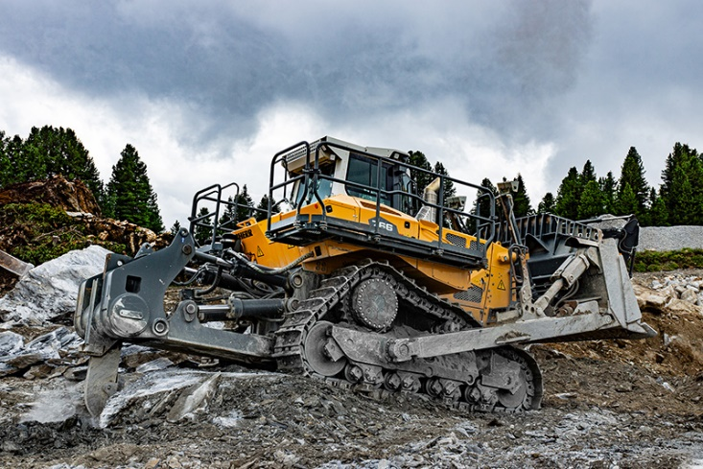

liebherr-hollaus-bau-004-name.jpg
The PR 776 excels in rocky terrain.

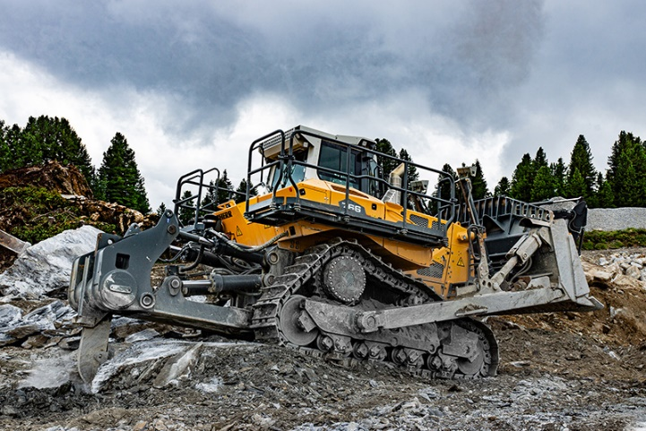

liebherr-hollaus-bau-001.jpg
The PR 766 proves its enormous tearing force in tough conditions.

Contact
Mag. Lisa Kahlig
Marketing Manager PR and Press
Telephone: +43 690 500 644 96
Email: lisa.kahlig@liebherr.com
Published by
Liebherr-Werk Telfs GmbH
Telfs/Austria
www.liebherr.com

