Press release

Liebherr supplies propane-based HVAC systems for Stadler's Nordic Express

⸺
Liebherr-Transportation Systems was commissioned by Stadler Rheintal AG to supply 166 heating, ventilation and air-conditioning (HVAC) units, which will be installed in Stadler’s NT FLIRT NEX trains, also known as Nordic Express. The HVAC systems use propane as refrigerant, a more climate-friendly alternative compared to conventional coolants.
Korneuburg (Austria), October 2024 – Liebherr-Transportation Systems has been selected by Swiss rail vehicle manufacturer Stadler Rheintal AG to provide and service heating, ventilation and air-conditioning (HVAC) systems. Delivery is planned to start in early 2025 and will last several years. The base order encompasses 34 cab units and 132 saloon HVAC units that will be installed on 17 Nordic Express trainsets. The NT FLIRT NEX trains represent a new series of long-distance trains based on Stadler’s FLIRT platform (Fast Light Innovative and Regional Train).
The HVAC system technology developed by Liebherr uses the refrigerant R290, i.e. propane. With a global warming potential (GWP) of three it is a more climate-friendly alternative in comparison to conventional chemical refrigerants. The units are manufactured at Liebherr-Transportation Systems Marica EOOD in Tsaratsovo/Plovdiv (Bulgaria), Liebherr’s center of excellence for HVAC systems manufacturing.
When it comes to customer service, the system can be serviced as usual, taking into account coolant-specific safety measures. Rail vehicle operators benefit from a reliable HVAC solution with minimal down time. “We are very happy and thank our customer Stadler for the trust placed in us,” said Roland Friedrich, Deputy General Manager/Business Management Liebherr-Transportation Systems Mannheim GmbH and Key Account Manager for Stadler Rail Group at Liebherr. “Propane is an efficient and ecofriendly refrigerant and our HVAC systems as well as our service concepts take all necessary safety requirements into account. We therefore offer a reliable in-service solution for more sustainable mobility.”

About Liebherr-Aerospace & Transportation SAS
Liebherr-Aerospace & Transportation SAS, headquartered in Toulouse (France), is one of 13 product segments of the Liebherr Group and a first-tier provider of on-board solutions in the aerospace and transportation industry, contributing to a more sustainable transport through innovative products, best in class services and performance excellence.
The aerospace product portfolio offered to civil and defense customers includes environmental control and thermal management systems, flight control and actuation systems, landing gears as well as on-board electronics. For rail vehicles of all kinds Liebherr offers heating, ventilation and air conditioning systems, passive and active hydraulic systems for braking, damping, axle steering and levelling. Furthermore, Liebherr serves the commercial vehicle market with trailer cooling systems.
About the Liebherr Group – 75 years of moving forward
The Liebherr Group is a family-run technology company with a highly diversified product programme. The company is one of the largest construction equipment manufacturers in the world. It also provides high-quality, user-oriented products and services in a wide range of other areas. The Liebherr Group includes over 150 companies across all continents. In 2023, it employed more than 50,000 staff and achieved combined revenues of over 14 billion euros. Liebherr was founded by Hans Liebherr in 1949 in the southern German town of Kirchdorf an der Iller. Since then, the employees have been pursuing the goal of achieving continuous technological innovation and bringing industry-leading solutions to its customers. Under the slogan ‘75 years of moving forward’, the Group celebrates its 75th anniversary in 2024.

Image
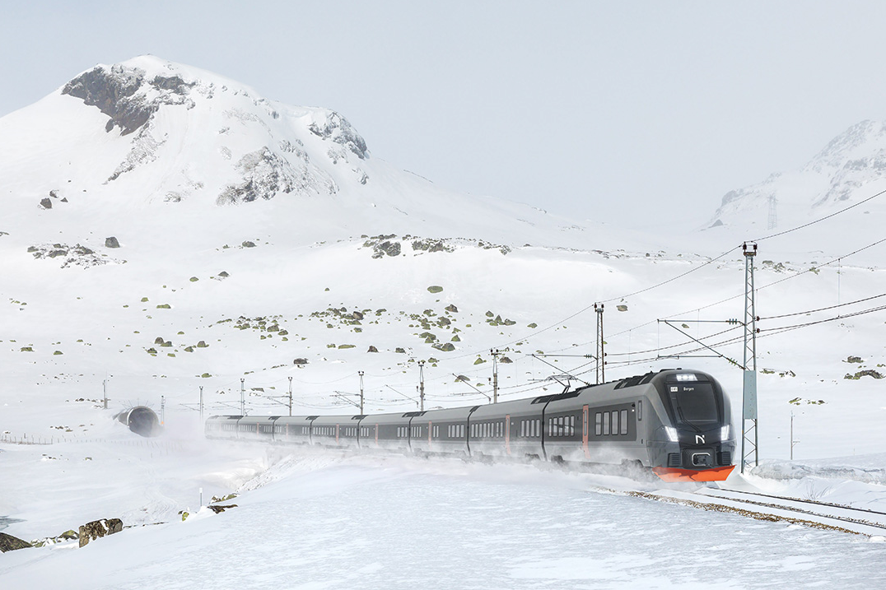
liebherr-stadler-nordic-express-copyright-stadler.jpg
With Liebherr’s HVAC technology on board, passengers can travel in comfort on board the Nordic Express. – © Stadler Rheintal AG

Contact
Ute Braam
Head of Corporate Communication
Phone: +49 8381 / 46 - 4403
E-mail: ute.braam@liebherr.com
Published by
Liebherr-Aerospace & Transportation SAS
Toulouse / France
www.liebherr.com

