Press release

Pioneering work in the quarry: Liebherr and STRABAG test hydrogen wheel loader

⸺

Cooperation between Liebherr and STRABAG for decarbonisation in the construction sector

STRABAG is the first Liebherr customer to test the L 566 H hydrogen wheel loader

Start of the first hydrogen pilot project between Liebherr and STRABAG

Alternative drive technologies as a key element for reducing CO2 emissions

Together with STRABAG, Liebherr is taking important steps towards a decarbonised construction site. In a project that recently started at the Kanzelstein quarry in Gratkorn, STRABAG is testing Liebherr’s large hydrogen-powered wheel loader over a period of two years. Energie Steiermark will supply green hydrogen for its own hydrogen filling station at the quarry. The L 566 H wheel loader is the world’s first large wheel loader with a hydrogen engine.

Gratkorn (Styria), October 2024 – Leonore Gewessler (Minister for Climate Action), Clemens Haselsteiner (CEO of STRABAG), Martin Graf (Director of Energie Steiermark) and Jan Liebherr (Chairman of the Board of Directors of Liebherr-International AG) attended a special event at the Gratkorn quarry to mark the start of the project for the first test use of the large hydrogen powered wheel loader. In addition to technical presentations and a tour of the quarry, the hydrogen-powered wheel loader was demonstrated in operation. For the next two years, STRABAG will be testing the L 566 H prototype on a daily basis. A hydrogen filling station is being built to refuel the wheel loader directly at the quarry. The energy supplier Energie Steiermark will provide the green hydrogen required for this.

Leonore Gewessler – Federal Minister for Climate Action, Environment, Energy, Mobility, Innovation and Technology – praised Liebherr’s exemplary commitment to reducing greenhouse and other harmful gases and its cooperation with STRABAG on testing hydrogen technology. “I am pleased to see innovative companies pushing ahead with pilot projects, especially in forms of mobility that are difficult to electrify, such as those in the construction sector,” says Gewessler. The cooperation with STRABAG, one of the foremost construction companies in Europe, shows what an important and positive development the Liebherr drive technology is. Liebherr is delighted to hear this appreciation and acknowledgement of the path that it has chosen.

STRABAG as the first test customer

As one of the biggest manufacturers of construction machinery, Liebherr has provided STRABAG with the L 566 H prototype as a test machine. The large wheel loader with a hydrogen engine should save up to 100 tonnes of CO2 each year, corresponding to about 37,500 litres of diesel. “We want to be climate neutral by 2040. The only way to achieve this is by consistently and comprehensively saving CO2, for example, in the operation of construction machinery,” explains STRABAG CEO Klemens Haselsteiner.

The L 566 H from Liebherr is the world’s first prototype large wheel loader with a hydrogen engine. “The technology also enables large vehicles that are difficult to electrify due to their high energy demand to be operated without CO2,” explains Dr.-Ing. Herbert Pfab, Technical Director of Liebherr-Werk Bischofshofen GmbH. The hydrogen engines are manufactured by the Liebherr components division’s own engine plant in Bulle, Switzerland. These engines will not only make it possible to emit zero greenhouse gases and almost no nitrogen oxides, but will also offer excellent efficiency.

**Pilot project for reducing emissions**

With the pilot project, Liebherr and STRABAG are demonstrating how emissions can be reduced in a sector that is difficult to decarbonise by means of alternative fuels. Climate-neutral hydrogen produced with wind and water power or solar energy can be a key enabler for achieving the goal of climate neutrality set by Austria’s politicians. “Green hydrogen is an indispensable element of our future energy. As an important and valuable energy source, it helps replace fossil natural gas – especially in industry,” said climate action minister Gewessler. What makes the two-year test deployment at the Gratkorn quarry such a showcase project is, above all, the joint approach of Liebherr and STRABAG: two companies that are actively pushing decarbonisation forward.

About STRABAG SE

**STRABAG SE**is a European construction technology company renowned for its innovation and capital strength. Our products cater for every area of the construction industry and cover the entire value chain. We benefit our customers by taking a comprehensive view of projects over their entire life cycle – from conception to planning and construction through operation and facility management all the way to conversion or demolition. We take responsibility for people and the environment. We are working on the future of construction, investing in more than 250 innovation projects and 400 sustainability projects that are currently ongoing. Thanks to the commitment of our c.86,000 employees, we generate an annual revenue of around €19 billion. With an extensive network of subsidiaries in many European countries and on other continents, we are expanding our activities far beyond Austria and Germany. In cooperation with powerful partners we pursue the clear goal of climate-neutral and resource-saving planning, building and operation. Information can also be found at [www.strabag.com](https://www.strabag.com/databases/internet/_public/content.nsf/web/www.strabag.com)

About Liebherr-Werk Bischofshofen GmbH

Liebherr-Werk Bischofshofen GmbH develops, produces and sells wheel loaders from the Liebherr Group. The plant in Salzburger Land (Austria) has grown steadily over the decades thanks to sustainable innovations, creative solutions and high quality standards. The wheel loader range is constantly being expanded and includes models in different product groups: compact loaders, stereo loaders, and mid-sized and large wheel loaders with impressive, innovative drive designs.

About the Liebherr Group – 75 years of moving forward

The Liebherr Group is a family-run technology company with a highly diversified product programme. The company is one of the largest construction equipment manufacturers in the world. It also provides high-quality, user-oriented products and services in a wide range of other areas. The Liebherr Group includes over 150 companies across all continents. In 2023, it employed more than 50,000 staff and achieved combined revenues of over 14 billion euros. Liebherr was founded by Hans Liebherr in 1949 in the southern German town of Kirchdorf an der Iller. Since then, the employees have been pursuing the goal of achieving continuous technological innovation, and bringing industry-leading solutions to its customers. Under the slogan ‘75 years of moving forward’, the Group celebrates its 75th anniversary in 2024.

Images

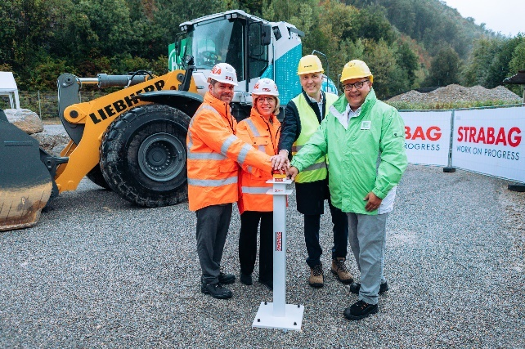

liebherr-wasserstoff-projektstart.jpg  
Formal launch of the project in the presence of Klemens Haselsteiner (CEO of STRABAG), Leonore Gewessler (Federal Minister for Climate Action, Environment, Energy, Mobility, Innovation and Technology), Jan Liebherr (Chairman of the Board of Directors of Liebherr-International AG) and Martin Graf (Director of Energie Steiermark) (from left to right).  
© STRABAG, Martin Anger

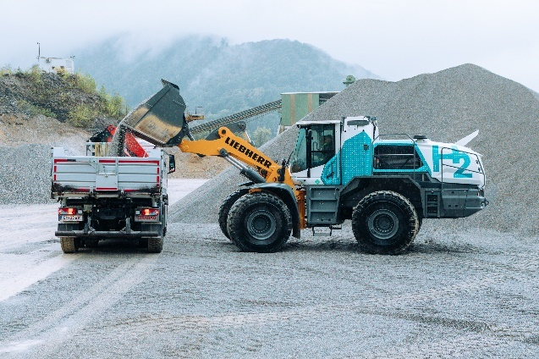

liebherr-wasserstoff-pilotprojekt.jpg  
The Liebherr large wheel loader with hydrogen engine will be trialled over several years at the quarry.  
© STRABAG, Martin Anger

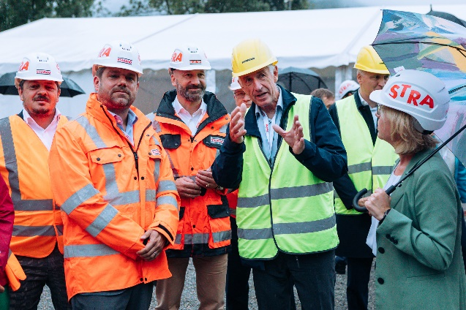

liebherr-wasserstoff-projektstart-gratkorn.jpg  
“The technology of the hydrogen engine allows large vehicles, which are difficult to electrify due to their high energy demand to operate without CO2,” explains Dr.-Ing. Herbert Pfab, Technical Director of Liebherr-Werk Bischofshofen GmbH.  
© STRABAG, Martin Anger

Contact

Anna Zögernitz  
Marketing and Public Relations  
Phone: +43 50809 12195  
E-mail: anna.zoegernitz@liebherr.com

Published by

Liebherr-Werk Bischofshofen GmbH  
Bischofshofen/Austria  
[www.liebherr.com](http://www.liebherr.com)