Press release

Liebherr USA, Co. holds 2024 North America Sales and Training Seminar

⸺

Liebherr’s earthmoving and material handling technology team hosted the 2024 North American Sales and Training Seminar in Richmond and Emporia, VA. More than 100 attendees participated in the two-day event receiving hands-on training of Liebherr’s earthmoving and material handling technology products.

Newport News, VA (USA), Liebherr USA, Co., October 18, 2024 – Liebherr USA, Co. earthmoving and material handling technology team held the 2024 North American Sales and Training Seminar for both internal and external distribution network participants. Liebherr employees from the US, Canada, and Europe participated and supported the event.

“We are thrilled to host this year’s North American Sales and Training Seminar. Based on the excellent feedback from last year’s national training, we are pleased to expand this event and welcome our colleagues and sales professionals from Canada further reflecting on the importance of the North American market to the Liebherr Group,” noted Kai Friedrich, Managing Director of Liebherr USA, Co., and Divisional Director of earthmoving and material handling technology.

Training for success

The two-day event allowed more than 100 participants to receive extensive hands-on training of multiple products across a variety of stations including [crawler excavators](https://www.liebherr.com/en/usa/products/construction-machines/earthmoving/crawler-excavators/crawler-excavators.html), [wheel loaders](https://www.liebherr.com/en/usa/products/construction-machines/earthmoving/wheel-loaders/wheel-loaders.html), [dozers](https://www.liebherr.com/en/usa/products/construction-machines/earthmoving/crawler-tractors/crawler-dozer-generation-8.html), [material handlers](https://www.liebherr.com/en/usa/products/material-handling-equipment/mobile-material-handling-machines/mobile-material-handling-machine.html), and the [TA 230 articulated dump truck](https://www.liebherr.com/en/usa/products/construction-machines/earthmoving/articulated-trucks/the-new-one.html). Each station was equipped with multiple machines, a digital display set up, and tents for onlookers. Additionally, each product manager gave multiple walk-around presentations during the event highlighting each machine's latest features and innovative technologies.

“The North American Sales and Training Seminar is crucial in equipping our extensive distribution network with the necessary tools to be successful. The training acts as driving force for our internal teams to provide informative resources and comprehensive support to our dealer sales channels,” said Nick Rogers, General Manager of Product Management. “We believe that by fostering a deeper understanding of our product lines and technologies, sales representatives will be better prepared to engage customers confidently, offering solutions that deliver results.”

This event enabled attendees to apply their product knowledge to real-world application scenarios, with the assistance of Liebherr’s certified product managers on-site. This training also provided an excellent chance for Liebherr’s distribution partners to participate in industry networking.

“This is a great opportunity to showcase Liebherr’s product quality, innovation, and support services across our local US distribution network. Together, we can show that Liebherr is a major player in the North American market, and we will continue to expand our presence,” said Friedrich.

**About Liebherr USA, Co.**

[Liebherr USA, Co.](https://www.liebherr.com/en/usa/start/start-page.html) based in Newport News, VA provides sales and service on behalf of nine different Liebherr product segments: earthmoving, mining, mobile and crawler cranes, tower cranes, concrete technology, deep foundation machines, maritime cranes; components, and refrigeration and freezing.

About the Liebherr Group – 75 years of moving forward

The [Liebherr Group](https://www.liebherr.com/en/usa/about-liebherr/about-liebherr.html) is a family-run technology company with a highly diversified product portfolio. The company is one of the largest manufacturers of construction equipment in the world. It also provides high-quality, user-oriented products and services in a wide range of other areas. The Liebherr Group includes over 150 companies across all continents. In 2023, it employed more than 50,000 staff and achieved combined revenues of over 14 billion euros. Liebherr was founded by Hans Liebherr in 1949 in the southern German town of Kirchdorf an der Iller. Since then, the staff have been pursuing the goal of achieving continuous technological innovation, and bringing industry-leading solutions to its customers. Under the slogan ‘75 years of moving forward’, the Group celebrates its 75th anniversary in 2024.

Images

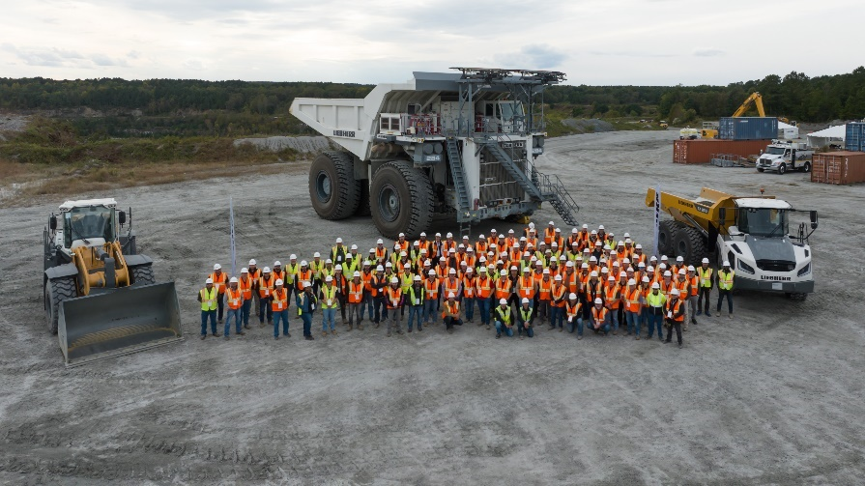

liebherr-USA-Seminar-Group-Photo.jpg  
Over 100 participants and staff from the US, Canada, and Europe gathered in Virginia for the 2024 North American Sales and Seminar Training.

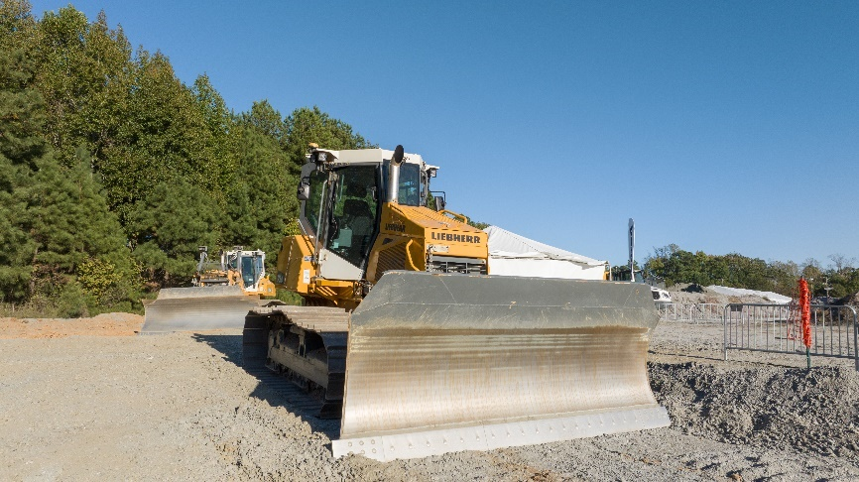

liebherr-USA-Seminar-dozer.jpg  
Participants were offered hands-on training and received individual seat time in the Liebherr dozers.

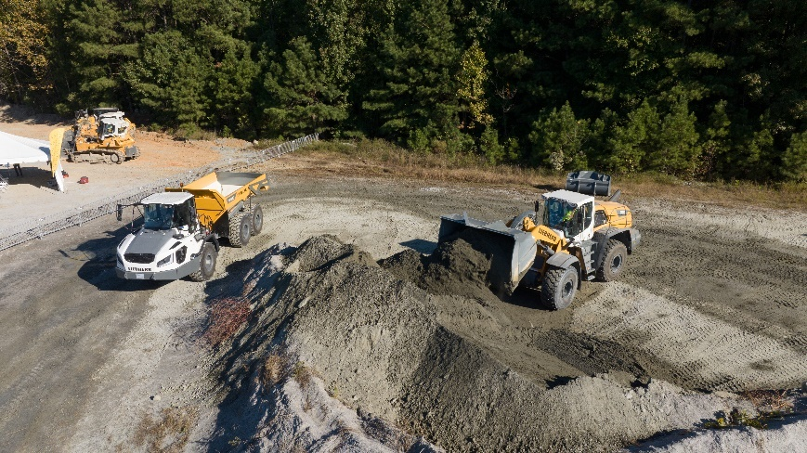

liebherr-USA-Seminar-wheel-loader.jpg  
Participants were offered hands-on training and received individual seat time in the Liebherr wheel loaders.

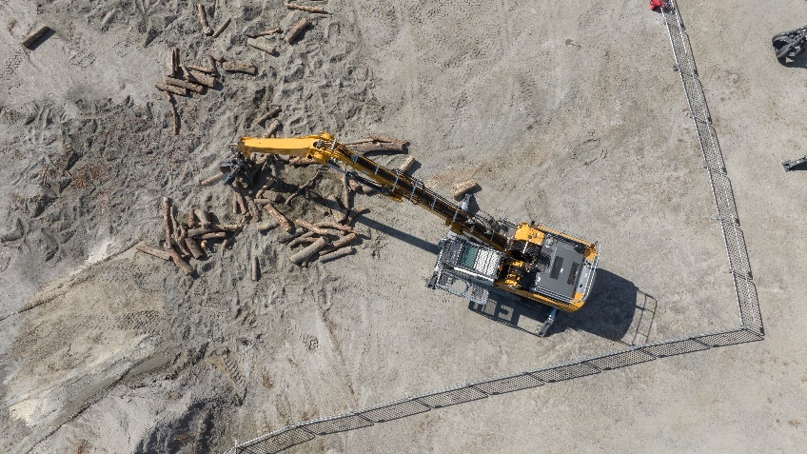

liebherr-USA-Seminar-material-handler.jpg  
Participants were offered hands-on training and received individual seat time in the Liebherr material handlers.

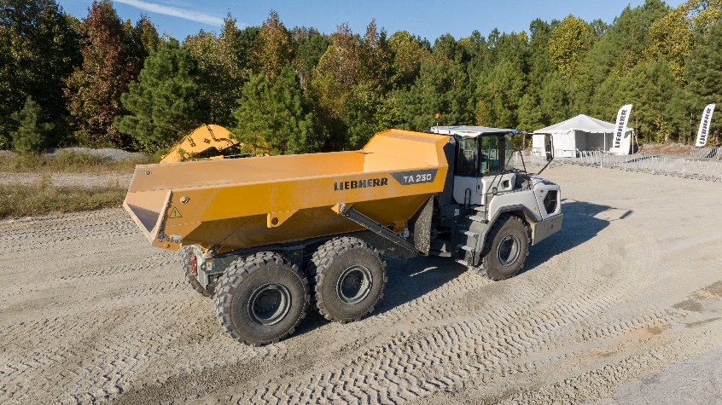

liebherr-USA-Seminar-articulated-dump-truck.jpg  
Participants were offered hands-on training and received individual seat time in the Liebherr TA 230 articulated dump trucks.

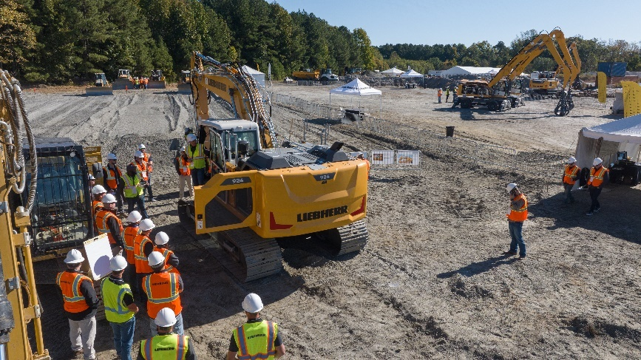.jpg  
Participants were offered hands-on training and received individual seat time in the Liebherr crawler excavators.

Contact

Ana Cabiedes Uranga  
Head of Marketing   
Liebherr USA, Co.   
E-mail: ana.cabiedes@liebherr.com

Published by

Liebherr USA, Co.   
Newport News / USA  
www.liebherr.com