Press release

Nine out of twelve delivered –
the German Federal Agency for Technical Relief places its trust in Liebherr compact cranes

⸺
THW purchased twelve Liebherr LTC 1050-3.1 mobile cranes
The main area of use of mobile cranes by THW is the construction of temporary bridges
The first crane in the THW order has now been delivered to Baden-Württemberg

The German Federal Agency for Technical Relief (THW) placed an order with Liebherr for twelve LTC 1050-3.1 mobile cranes. Liebherr has already delivered nine cranes to various local organisations. THW President Sabine Lackner says: “Cranes are an indispensable tool for the specialist bridge construction groups. They enable THW personnel to lift heavy bridge elements and assemble them into structures that can reach spans of over 80 metres. The fact that THW has erected over three dozen temporary bridges in the past three years shows how important these vehicles are.”
Ehingen (Donau) (Germany), 12 September 2024 – The LTC 1050-3.1 is a particularly compact mobile crane with a single cab which is used for both on-road driving and for crane operations. For driving on the road, the cab is moved forwards to the front of the vehicle using a telescopic arm, giving the driver better visibility and a better driving feel, particularly at high speeds. The optional elevating cab creates even greater flexibility and some significant benefits as it raises the operator to a height of 7.8 metres. This raised perspective not only provides an excellent view of the site situation, but also considerably enhances safety for complex crane work.
Andreas Schneider, who is responsible for vehicle procurement at THW, explains: “After 25 years of service, it was time for our mobile cranes to be replaced with new models. Liebherr was awarded the contract for the LTC 1050-3.1 in the tender. We wanted a compact, manoeuvrable mobile crane with high performance. The Liebherr 50 tonner meets all our requirements. We are now once again planning on a service life of 25 years for the new cranes.” Liebherr was initially awarded the order for nine cranes with the option for a further eleven. The THW has since ordered three LTC 1050-3.1 machines from this option and these are due to be delivered before the end of the year. These mobile cranes will be delivered to THW specialist bridge building groups throughout Germany.

Main area of use – temporary bridges
Bridge construction is one of THW's core skills. The construction of temporary bridges is especially important after natural disasters, since they are integral parts of local and national infrastructure. The THW has demonstrated its skills in temporary bridge construction at numerous locations both nationally and internationally. The THW's emergency response teams erected 30 temporary bridges in the Ahr valley following Storm “Bernd” in summer 2021. Last summer, they installed several bridges in Slovenia. In addition to bridge construction, the THW uses its mobile cranes for general handling and lifting work and also for responding to road accidents involving heavy vehicles. Several of the LTC 1050-3.1 cranes that have already been delivered have already been used by THW in practice.
The first crane in Baden-Württemberg is delivered to the local organisation in Müllheim
The first LTC 1050-3.1 from the THW order was delivered to the State of Baden-Württemberg is mid-July. It went to the local organisation in Müllheim. Among those who attended the official handover ceremony at Liebherr’s manufacturing plant in Ehingen were Dietmar Löffler, THW State Officer for Baden-Württemberg, and Martin Gerster, Member of the German Bundestag and President of the THW Federal Organisation (THW-BV). THW-BV regards itself as a communications hub and link between THW, the THW Youth Organisation, honorary officials, politicians and industry.
About the German Federal Agency for Technical Relief
THW is Germany’s honorary emergency response organisation. The commitment of around 88,000 volunteers throughout Germany provides the basis for THW’s work to protect its citizens. With its specialists, its equipment and its experience, THW is in demand all over the world on behalf of the German government when emergencies require its assistance. In addition to bilateral aid, this also includes technical and logistical work as part of the European Union’s disaster management system and on behalf of UN organisations.
About Liebherr-Werk Ehingen GmbH
Liebherr-Werk Ehingen GmbH is a leading manufacturer of mobile and crawler cranes. Its range of mobile cranes extends from 2-axle 35 tonne cranes to heavy duty cranes with a lifting capacity of 1200 tonnes and a 9-axle chassis. Its lattice boom cranes on mobile or crawler travel gear deliver lifting capacities of up to 3000 tonnes. With universal boom systems and extensive additional equipment, they can be seen in action on construction sites throughout the world. The Ehingen site has a workforce of 5,000. An extensive, global service network guarantees the high availability of Liebherr mobile and crawler cranes. In 2023, the Liebherr plant in Ehingen recorded a turnover of 2.81 billion euros.
About the Liebherr Group – 75 years of moving forward
The Liebherr Group is a family-run technology company with a highly diversified product programme. The company is one of the largest construction equipment manufacturers in the world. It also provides high-quality, user-oriented products and services in a wide range of other areas. The Liebherr Group includes over 150 companies across all continents. In 2023, it employed more than 50,000 staff and achieved combined revenues of over 14 billion euros. Liebherr was founded by Hans Liebherr in 1949 in the southern German town of Kirchdorf an der Iller. Since then, the employees have been pursuing the goal of achieving continuous technological innovation, and bringing industry-leading solutions to its customers. Under the slogan ‘75 years of moving forward’, the Group celebrates its 75th anniversary in 2024.

Images
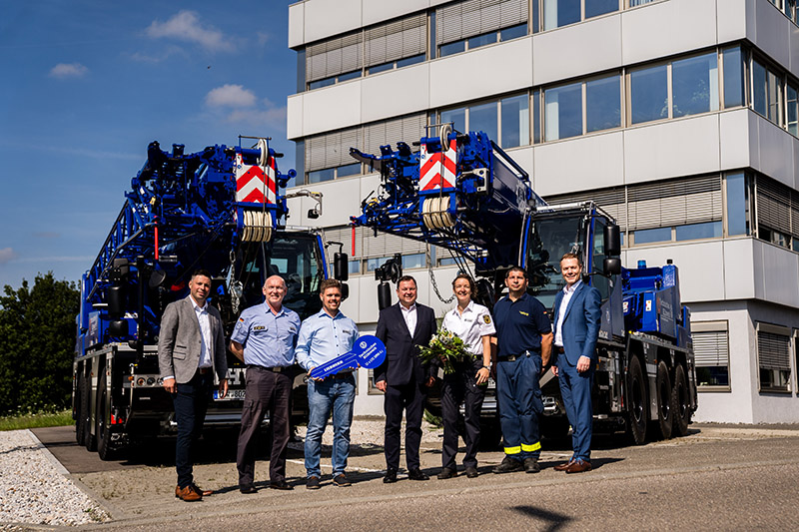
liebherr-ltc1050-3.1-thw-handover.jpg
Crane handover in Ehingen (from left to right): Alexander Schwald (Sales Liebherr-Werk Ehingen GmbH), Dietmar Löffler (THW State Officer for Baden-Württemberg), Jonas Lorenz (Executive, German Federal Agency for Technical Relief), Martin Gerster (President of the THW Federal Organisation / Member of the German Bundestag), Paula Rentzsch (Section Leader of Section E5 Engineering – THW management team), Marko Heinig (Emergency Deployment/Equipment for the State Organisation of Saxony and Thuringia, responsible for Dresden Local Organisation), Daniel Pitzer (Commercial Director, Liebherr-Werk Ehingen GmbH)

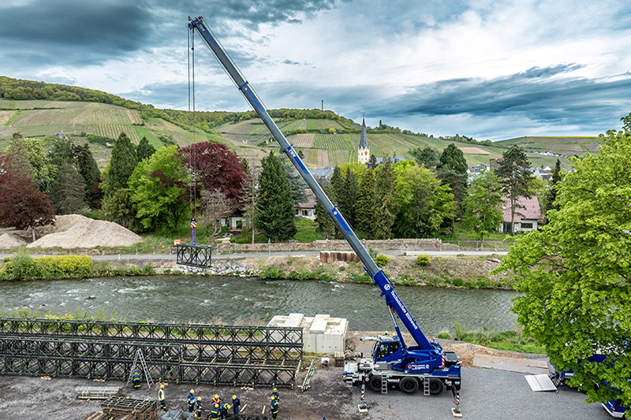
liebherr-ltc1050-3.1-thw-ahrtal.jpg
The LTC 1050-3.1 from the Witten THW Local Organisation supporting the dismantling of a temporary bridge in the Ahr Valley.

Contact person
Wolfgang Beringer
Marketing and Communication
Phone: +49 7391 / 502-0
Email: wolfgang.beringer@liebherr.com
Published by
Liebherr-Werk Ehingen GmbH
Ehingen (Donau) / Germany
www.liebherr.com

