Press release

Twelve mobile cranes in operation during the construction of a pipeline in Delft

⸺

A dozen mobile cranes from Boer B.V. laid a one-kilometre-long pipeline with a predefined curvature

The pipeline was drilled into the ground for the district heating network

Liebherr cranes performed reliably

A dozen strong for the energy transition: twelve mobile cranes with lifting capacities ranging from 90 to 400 tonnes were used to build a pipeline in Delft in the Netherlands. The mobile cranes lifted a pipeline with a total length of one kilometre in order to bring it into the correct position for insertion into the ground. The pipeline is part of the district heating network, which is currently being expanded in order to convert heating systems to sustainable energy sources.

Ehingen (Danube) (Germany), 5 March 2024 – Richard Rijbroek is an environmental manager at Denys and supervised the construction of the pipeline in Delft. The client is Nederlandse Gasunie NV. Rijbroek explains: “Preparations for the "WarmtelinQ" project have been underway for three years. We will use the residual heat from industry in the port of Rotterdam and from waste incineration plants to heat homes and businesses in South Holland.” The pipeline runs from the port of Rotterdam to The Hague via Vlaardingen.

Cranes bend the pipeline into a predefined curve

A drill head was installed on one side of the 1,000 metre long district heating pipeline, as Harm van Dijk, project manager of the Dutch crane operator Boer B.V., explains: “We are drilling a bore here for the heating network. The pipeline is drilled into the ground.” To do this, the pipeline has to be lifted up and placed in a certain curve so that it is drilled into the ground at a defined angle.

According to van Dijk, the length of the retractable arch is 275 metres: “To get the exact curvature, we form the arch with ten cranes. Each of these cranes lifts 18 tonnes. For this reason we need machines with a capacity of 90 – 140 tonnes here. On the other side of the motorway, we used a 300-tonne and a 400-tonne crane because of the large overhang." The kilometre-long pipeline cannot be completely pre-assembled on the ground, as a motorway and a bridge cross the route. It was therefore stored on containers at a sufficient height as required.

**About Liebherr-Werk Ehingen GmbH**

Liebherr-Werk Ehingen GmbH is a leading manufacturer of mobile and crawler cranes. Its range of mobile cranes extends from 2-axle 35 tonne cranes to heavy duty cranes with a lifting capacity of 1200 tonnes and a 9-axle chassis. Its lattice boom cranes on mobile or crawler travel gear deliver lifting capacities of up to 3000 tonnes. With universal boom systems and extensive additional equipment, they can be seen in action on construction sites throughout the world. The Ehingen site has a workforce of 4,300. An extensive, global service network guarantees the high availability of Liebherr mobile and crawler cranes. In 2022, the Liebherr plant in Ehingen recorded a turnover of 2.37 billion euros.

**About the Liebherr Group**

The Liebherr Group is a family-run technology company with a widely diversified product range. The company is one of the largest manufacturers of construction machines in the world. However, it also supplies high quality, user-focused products and services in many other sectors. The group currently comprises more than 140 companies based in every continent of the world. In 2022, it had a workforce of over 50,000 and recorded a consolidated total turnover of more than 12.5 billion euros. The company was founded in 1949 in Kirchdorf an der Iller in southern Germany. Since then, its aim has been to win customers by supplying high quality solutions and to contribute to technological progress.

Images

Ein Bild, das Himmel, draußen, Wolke, Bahn enthält.
l

lwe-12-krane-boer-1.jpg  
A dozen cranes in a row: the Boer B.V. cranes were used in tandem on a pipeline construction project for the district heating network in the Netherlands.

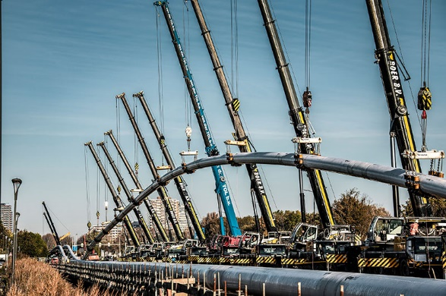

lwe-12-krane-boer-2.jpg  
The Liebherr mobile cranes applied a predefined curve to the pipeline so that it could be drilled into the ground.

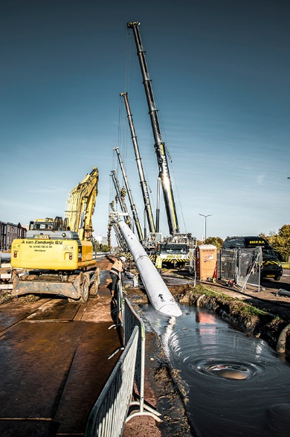

lwe-12-krane-boer-3.jpg  
For the bore, a drill head was installed at one end of the district heating pipeline.

**Contact**

Wolfgang Beringer  
Marketing and Communication  
Phone: +49 7391/502 - 3663  
Email: wolfgang.beringer@liebherr.com

**Published by**

Liebherr-Werk Ehingen GmbH  
Ehingen (Donau) / Germany  
www.liebherr.com