Press release

Liebherr presents new app: MyAssistant for Earthmoving

⸺

New smartphone app for Liebherr earthmoving and material handling machines

Comprehensive information on all aspects of machine operation and maintenance

Access to digital Liebherr operator's manuals and spare parts catalogue

Liebherr presents MyAssistant for Earthmoving, a new app that provides all relevant information about earthmoving and material handling machines in a digital format. Bundled in a mobile application, the app combines numerous features that offers significant added value, especially for machine operators. The MyAssistant for Earthmoving app provides contextual data from various databases around the world relating to the operation and maintenance of your machines – simply, quickly and intelligently.

Kirchdorf an der Iller (Germany), 11 March 2024 – Liebherr has developed MyAssistant for Earthmoving, a new app that will provide significant support for construction machinery operators in their daily work. The mobile application is available for wheeled excavators, material handling machines and wheel loaders of generation 6.0 and higher as well as for crawler excavators, graders and crawler loaders, pipelayers and articulated trucks of generation 8.0 and higher. The new mobile app can be downloaded now free of charge from the Apple App Store and the Google Play Store.

All on your smartphone: comprehensive information on machine operation and maintenance

After successful authentication via the MyLiebherr portal, the full range of features is available to the user. Once logged in, MyLiebherr makes all Liebherr earthmoving and material handling machines in the company's fleet available to the user via a drop-down menu. The machines can then be selected via the model designation and serial number. The resulting menu tiles "Operating instructions", "Spare parts catalogue" and "Scan operating symbol" that are displayed in the app refer exclusively to the machine selected by the user.

In addition, the entire Liebherr operator's manual is available to the user digitally via the app. Furthermore, any required spare parts can be selected in the menu tile of the same name and placed in the shopping cart. Depending on the user's authorisation level in MyLiebherr, a corresponding order can then be triggered.

The function "Scan operating symbol" can be used to identify unknown symbols on operating panels, keyboards and switches as well as on the control panel in the cab. The user can simply scan the symbol using the camera on their smartphone. Following a successful match in the symbol database, the user is shown the suggested solutions that fit the context as well as corresponding links to the Liebherr operator's manual. This quick analysis of the symbol in question not only saves the machine operator valuable time – by displaying and describing previously unknown or new symbols, the app increases clarity for the machine operator and thus also safety during daily operations on the construction site. Machine operators whose companies have a large fleet of machines that undergoes frequent changes, as well as newcomers to the profession and inexperienced machine operators, will find this feature especially useful.

About the Liebherr Group

The Liebherr Group is a family-run technology company with a highly diversified product portfolio. The company is one of the largest construction equipment manufacturers in the world. It also provides high-quality and user-oriented products and services in a wide range of other areas. The Liebherr Group includes over 140 companies across all continents. In 2022, it employed more than 50,000 staff and achieved combined revenues of over 12.5 billion euros. Liebherr was founded in Kirchdorf an der Iller in Southern Germany in 1949. Since then, the employees have been pursuing the goal of achieving continuous technological innovation, and bringing industry-leading solutions to its customers.

Image

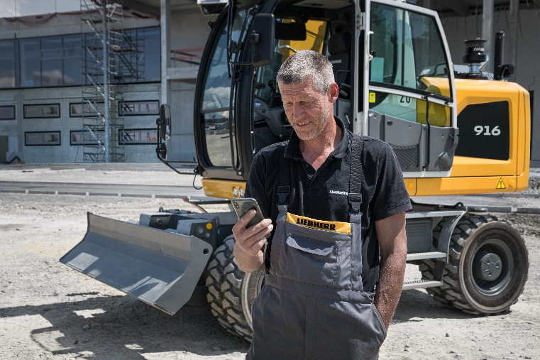

liebherr-myassistant-earthmoving-app.jpg  
The new MyAssistant for Earthmoving app digitally provides all relevant information on machine operation and maintenance for Liebherr earthmoving and material handling machines.

[MyAssistant for Earthmoving](https://www.liebherr.com/en/deu/products/construction-machines/earthmoving/customer-service/digital-services/myassistant.html)

Contact

Marc Wiedenmann  
Marketing  
Phone: +49 7354 / 80 - 8494  
Email: marc.wiedenmann@liebherr.com

Published by

Liebherr-Hydraulic Excavator GmbH  
Kirchdorf an der Iller / Germany  
[www.liebherr.com](http://www.liebherr.com)