Press release

Liebherr’s L series fast-erecting cranes: compact power – a fresh take

⸺

25 L and 33 L available to order now

Roll-out of a new crane control system with new operating system

Sway Control assistance system for load sway damping included as standard

Additional assistance systems are easy to retrofit

Compact power – a fresh take: this is Liebherr’s maxim for its fundamental overhaul of the L1-24 and L1-32 fast-erecting cranes. The two cranes feature new crane control and operating systems, new assistance systems and extensive crane component optimisation.

Biberach (Germany), 13 March 2024 – Liebherr’s fundamental revision of the L series sees the crane size specified in metre tonnes with immediate effect. The new cranes are therefore now known as the 25 L and 33 L. These new L cranes are being launched on the market with substantial changes to the structural steelwork, an improved hydraulic system and a new modular drive system. Another new feature is a standardised radio remote control for all new Liebherr bottom-slewing cranes. The standardised operating concept makes it easier to switch between the L and K series, which increases flexibility and reduces the amount of training required.

Liebherr’s own control system and new-generation operating system

The L series fast-erecting cranes are the first machines of their type to feature the fifth generation of Liebherr’s own control hardware, Liebherr Control 5. This control system is already being used by a number of other Liebherr Group construction machines, including mobile excavators, dumpers, deep foundation equipment, mobile harbour cranes, and wheel loaders. The control system is designed to be particularly robust and durable to meet the demands of such a diverse range of uses. Strong vertical integration within the Liebherr Group ensures that spare parts are available long term.

Software wise, the cranes are fitted with the second generation of the Tower Crane OS (Tower Crane Operating System 2). This means that the cranes feature a new user interface, which top-slewing cranes from the EC-B series began using in 2021. The new control system is also an important step towards the cranes' future viability as it opens the door to new assistance systems, and the software architecture itself is designed for future expansion. Software updates are also easy. Assistance systems that are possible with the new control system are designed to further increase safety and efficiency around operations and processes on site.

Sway Control assistance system fitted as standard

All L series models come equipped with the Sway Control assistance system for load sway damping. In line with the theme “Drive the load, not the drives”, the system detects movements in the direction of slewing and trolley travel that can cause loads to sway. The intelligent load sway damping system actively counteracts and corrects such movements. This can be particularly helpful for inexperienced users or those who only occasionally operate a crane. Sway Control assists with the avoiding of critical safety situations and facilitates even more efficient and safe load handling. The L series offers a first look at further Liebherr assistance systems that will be easy to retrofit.

Compact dimensions, powerful performance

“The L series marks the start of a new development generation and sets the standard for future products,” says Clemens Maier, product manager at Liebherr-Werk Biberach GmbH. “Nothing has changed in terms of the cranes’ compact dimensions and powerful performance. The new Liebherr control system provides us with new, innovative crane operator assistance systems and is optimally designed for current and future requirements.”

The cranes offer the fine positioning mode Micromove, which enables careful and precise positioning of loads. This protects the prefabricated parts being positioned as well as the surrounding structure. In addition to this, the Speed2Lift function saves time when it comes to load handling, as it always automatically selects the maximum speed possible with each load.

As with the fast-erecting cranes of the previous L1 series, the jib lengths remain unchanged: 25 or 27 metres for the 25 L and 30 metres for the 33 L. The already familiar ballast and transport axle options are also available for the L series, allowing the machines to be used with flexibility. Intelligent assistance systems, quick assembly and easy handling coupled with a compact footprint make the cranes a great choice for construction firms and crane rental businesses as well as for timber frame companies.

About the Liebherr Tower Cranes Division

More than seven decades of experience have made Liebherr a recognised specialist for lifting technology on all types of construction sites. The range of Liebherr Tower Cranes encompasses an extensive selection of high-quality tower cranes that are used worldwide. This includes fast-erecting, top-slewing, luffing jib and special-purpose cranes as well as mobile construction cranes. In addition to these products, Liebherr also offers a wide range of services that complete the company’s portfolio: Tower Crane Solutions, the Tower Crane Center and Tower Crane Customer Service.

About the Liebherr Group

The Liebherr Group is a family-run technology company with a highly diversified product portfolio. The company is one of the world's largest manufacturers of construction machinery. It also offers high-quality, user-oriented products and services in multiple other areas. Today, the group consists of more than 140 companies across all continents. In 2022, it employed more than 50,000 people and achieved combined revenues of over 12.5 billion euros. Liebherr was founded in 1949, in Kirchdorf an der Iller in southern Germany. Ever since then, the company’s employees have been committed to satisfying customers with advanced solutions and to helping drive technological progress.

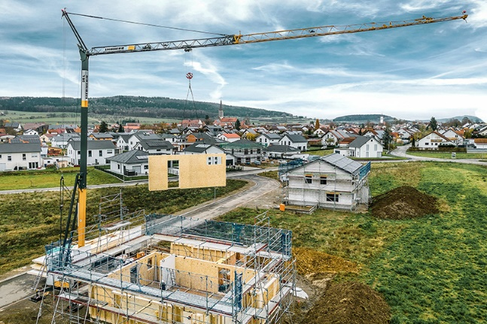Images

liebherr-25-l.jpg  
The L cranes are flexible in use and ideal for house construction, renovations and roof work, as seen here with the 25 L, which is being used to lift prefabricated elements.

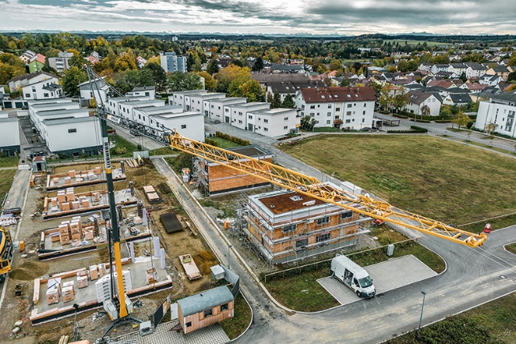

liebherr-33-l.jpg  
Put through its paces: the 33 L has already demonstrated its capabilities on test construction sites.

Contact

Astrid Kuzia  
Communication Specialist  
Phone: +49 7351 / 41– 4044  
Email: astrid.kuzia@liebherr.com

Published by

Liebherr-Werk Biberach GmbH  
Biberach / Germany  
www.liebherr.com