Press release

Four Liebherr Electric Rubber Tyre Gantry Cranes for Italy

⸺
First Liebherr RTGs for Italy
Ten wide RTG is amongst the largest RTGs delivered by Liebherr
Sustainability is a key consideration
Liebherr Container Cranes Ltd. is proud to announce the handover of four electric rubber tyre gantry cranes (ERTG) to customers in Italy. One ERTG has been delivered to Salerno Container Terminal (SCT), controlled by Gallozzi Group, while three have been delivered to Consorzio Napoletano Terminal Containers, Naples (Conateco), an MSC company. The cranes were handed over in recent weeks and will make a valuable contribution to the economies of Southern Italy and beyond.
Killarney (Ireland), March 2024 – The ERTG delivered to SCT will work container stacks ten wide and 6 high. It is amongst the largest RTGs delivered by Liebherr. Like the three ERTGS delivered to Naples, the machines have a hybrid powertrain, operating on both diesel and electricity via cable reeling drum. This offers emission free container handling when connected to the grid and delivering substantial energy savings through onboard power regeneration.
Sustainability at the centre
Sustainability is a cornerstone of both projects. Salerno Container Terminal, Conateco and Liebherr Container Cranes Ltd. all have sustainability deeply ingrained in their operations, evident in their comprehensive sustainability and CSR policies and commitments. All three companies are ardent supporters of the United Nations Global Compact on Human Rights, sharing a common dedication to acting responsibly and collaborating with others in seeking solutions to address the global challenges of today and those that will shape the future of global businesses. Together, they are committed to fostering resilient and sustainable supply chains and accelerating the transition to a net-zero future.
Liebherr local support via Macport
Liebherr have long been a key supplier to Italy via its longstanding agent Macport. Macport play a key role in the sales and service of Liebherr maritime cranes in Italy, Bulgaria, and Albania. The ERTG for SCT is the latest Liebherr machine to be delivered to the terminal and joins four Liebherr Harbour Mobile cranes in container handling configuration and six Liebherr reachstackers already at the port. Conateco are beginning their journey with Liebherr and can look forward to experiencing the full benefits of owning Liebherr machines in terms of quality, performance, and reliability along with the peace of mind from the proximity to experienced Liebherr technicians and engineers. The new Liebherr RTGs are set to streamline operations, improve cargo handling capacity, and contribute to the economic growth of the local hinterland. As the ports evolve with cutting-edge technology, they remain vital components of Italy's trade infrastructure.
Liebherr Container Cranes Ltd. and Macport are proud to be at the forefront of this transformative endeavour, bringing state-of-the-art technology to Salerno and Naples and reinforcing their commitment to revolutionizing port operations in Italy. The future of container handling is here, and it bears the hallmark of Liebherr innovation.
About Liebherr Container Cranes Ltd.
Liebherr Container Cranes Ltd. Is one of the world’s leading manufacturers of ship to shore container cranes, rail mounted gantry cranes and rubber tyre gantry cranes. From a base in Killarney, Ireland, Liebherr Container Cranes Ltd designs, builds and exports container cranes worldwide. Founded in 1958 as the first Liebherr factory outside of Germany, today, container cranes manufactured by Liebherr in Ireland are renowned for their quality, longevity, and productivity.
About the Liebherr Group
The Liebherr Group is a family-run technology company with a highly diversified product portfolio. The company is one of the largest construction equipment manufacturers in the world. It also provides high-quality and user-oriented products and services in a wide range of other areas. The Liebherr Group includes over 140 companies across all continents. In 2022, it employed more than 50,000 staff and achieved combined revenues of over 12.5 billion euros. Liebherr was founded in Kirchdorf an der Iller in Southern Germany in 1949. Since then, the employees have been pursuing the goal of achieving continuous technological innovation, and bringing industry-leading solutions to its customers.

Images
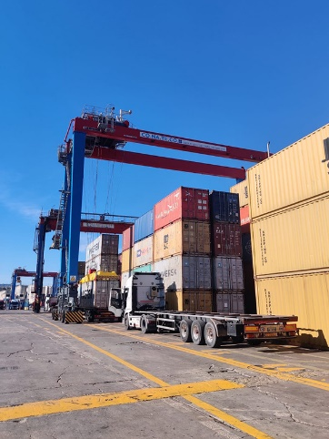
liebherr-conateco-1.jpg
Three new Liebherr RTGs at Conateco (Consorzio Napoletano Terminal Containers) in Naples (Italy).
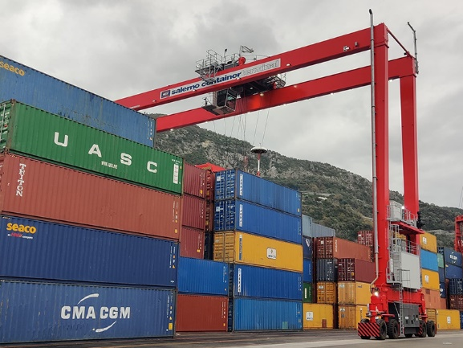
liebherr-salerno-1.jpg
A ten container wide Liebherr RTG at Salerno Container Terminal in Italy
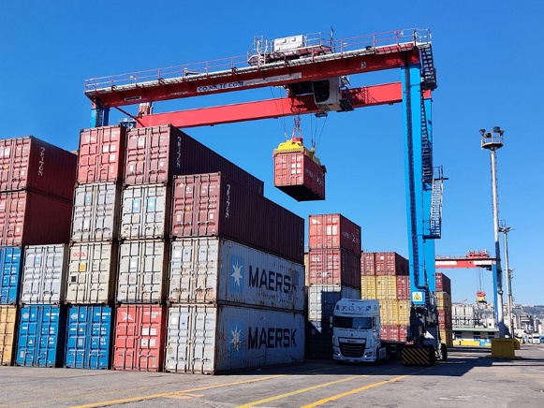
liebherr-conateco-2.jpg
Some of the new Liebherr RTGs at Conateco (Consorzio Napoletano Terminal Containers) in Naples (Italy)

Contact
Trevor O’Donoghue
Marketing Manager
Phone: +353 (0)64 6680459
E-mail: trevor.odonoghue@liebherr.com
Published by
Liebherr Container Cranes Ltd.
Killarney / Ireland
www.liebherr.com

